Building Capacity and Confidence in Gender Transformative Programming
A Virtual Learning Experience

Module 1 – Participant Resource Package

Table of Contents of Contents
Table of Contents
Training Principles 4
Session 1: Introduction 5
Activity 1 Instructions: Our Participation 5
Session 2: Gender 101 6
Key Terms 6
Activity 2 Instructions: Concepts and Terminology 6
Activity 2.1 - Concepts and Terminology 7
Annex 2a: Terminology Word Quiz – Activity 7
Annex 2b: Terminology Word Quiz Answer Key 10
Activity 2.2 - Compare and Contrast 13
Annex 2c: Gender Glossaries – Activity 13
Activity 2.2 - Compare and Contrast Group Work Instructions 17
Group Assignments 18
Session 3: Gender Equality and Change—Understanding Transformative Change 19
19
Activity 3.1 - Illustrating Gender Transformative Concepts 19
Annex 3a: Explanations for Gender Transformative Concepts – Worksheet 19
Annex 3b: Explanations for Gender Transformative Concepts 21
Activity 3.1 - Illustrating Gender Transformative Concepts Group Work Instructions 23
Group Assignments 23
Activity Instructions 24
Session 4: Gender Diversity 26
26
Activity 4.1 - Unpacking Non-Binary Gender Identity 26
Annex 4a: Important Definitions 26
LGBTTTQQIAA Guide 29
The Gender Elephant 30
Annex 4b: LGBT+ Inclusion in International Development Programming 31
Annex 4c: Tools 33
Annex 4d: Research/Editorial 34
Video & Relfection – Activity Instructions 35
Activity 4.2 Instructions: Gender Diversity and Development Work 36
Group Assignments 37
Session 5: Intersectionality 38
Activity 5.1 Instructions: Our Identities 38
Activity 5.1 - Power Walk Details 39
Annex 5a: Gender and Power - Power Walk 39
Power Walk Identities 39
39
Power Walk Statements 40
40
Activity 5.1 - Power Walk Activity Instructions 41
Activity Instructions 42

Training Principles
Training Principles

Principles of behaviour help to set the tone for your training. These are often developed in a participatory manner – asking everyone in the training to contribute to a list that outlines the kind of tone they expect from each other, from the facilitator, and from themselves. For a training on Gender Equality, it is especially important to set a tone of respect, inclusion, and acceptance.
These often include the following:

- Participation: You are your own best resource. Much of the content of the training will be coming from you. Each one of you brings a wealth of experience to the program. The workshop can only be successful if it is a two-way process and if everyone participates fully. Give everyone a chance to contribute and encourage others to do so.

- Respect Others: Respect each other, yourselves, and the trainer. Do not speak when someone else is speaking. Listen actively. The trainer will be facilitating the discussions with your assistance.

- Support an Inclusive Environment: Participants in this training must support an environment of inclusion, must respect diversity in all its forms, including gender diversity, religious diversity, ethnic and cultural diversity, social and economic diversity. Discrimination or exclusion of any kind will not be accepted.

- Agree to Disagree: During this workshop everyone must feel free to express opinions and concerns. Please see frank discussions about politics as healthy exchanges rather than personal attacks. There will be a tolerance of differences in approaches and strategies. Everyone should contribute to a safe/non-judgemental environment.

- Punctuality: Arrive on time to each workshop session. Arriving late is a sign of disrespect to the trainer and to your fellow participants.

- Minimize Disturbances: Cell phones should be turned off at the beginning of the workshop and should remain off until the end except during breaks. Avoid side conversations – if you are unclear about the topic being discussed or the instructions, please ask the facilitator to clarify.

- Ask Questions: There are no stupid questions. If you do have a question you don’t want to ask in front of others, ask it privately during a break. Please do not think any question you have is unimportant.

Session 1: Introduction
Session One

Activity 1 Instructions: Our Participation

- Participants are to click the below Sli.do link to join the “word cloud poll”. Sli.do link: [input link here]
- Participants are to think about three examples that describe the way they participate in group settings. For example, you could describe yourself a quiet, respectful and eager.
- Once in the Sli.do word cloud, populate 1 example at a time where prompted.
- You will have 3 minutes to independently brainstorm and populate your responses. Feel free to type more than 3 examples!
- Once you’re done populating your own examples, return to the Zoom call. The final word cloud will be screenshared by the hosts.

Note: Take it slow! Use this activity to become familiar with Sli.do and feel free to ask any question to the facilitator(s)!

Session 2: Gender 101
Session Two

Key Terms
SEX | The physical and biological characteristics that distinguish male, female, and intersex people. These include things like reproductive organs, hormones, chromosomes, etc.
GENDER | The socially constructed characteristics of women, men, girls, boys and gender diverse people– including the norms, roles, behaviours, activities, attributes, power and relationships that exist between them. These characteristics vary from society to society and are not fixed.

Activity 2 Instructions: Concepts and Terminology

- Independently, you are going to take 10 minutes and complete Annex 2a: Terminology Word Quiz.
- This quiz will not be marked as it is intended to make sure we’re all on the same page.
- You can use Annex 2b to check your work and test your own understanding.

Activity 2.1 - Concepts and Terminology
Session Two

Annex 2a: Terminology Word Quiz – Activity

 | MATCH | TERM
 |  | Gender
 |  | Gender equality
 |  | Gender unaware/blind
 |  | Gender neutral
 |  | Gender Responsive
 |  | Feminism
 |  | Empowerment
 |  | Sex
 |  | Gender Equity
 |  | Gender Sensitive
 |  | Gender Aware
 |  | Gender Transformative
 |  | Power
Session Two
DEFINITION

A. | A multidimensional social process that enables people to gain control over their lives. It often challenges existing power allocations and relations to give disadvantaged groups more power. With respect to women’s health, this concept has often meant, for example, increasing education opportunities and access to relevant information to enable women to make informed decisions about their health, improve self-esteem and equip them with communication and negotiation skills.
B. | Refers to equal chances or opportunities for women, men, girls, boys and gender diverse people, to access and control social, economic, and political resources, and protects these opportunities under law (i.e. health services, education or voting rights).
C. | The socially constructed characteristics of women, men, girls, boys and gender diverse people– including the norms, roles, behaviours, activities, attributes, power and relationships that exist between them. These characteristics vary from society to society and are not fixed.
D. | A policy or program that ignores gender norms, roles and relations and very often reinforces or aggravate gender-based discrimination.
E. | A policy or program that addresses the causes of gender-based health inequities by including specific ways to shift harmful gender norms, roles and relations with explicit intentions to change unequal power relations. The focus goes beyond improving the condition of women, girls and gender diverse individuals and seeks to improve their social position (i.e. how they are valued in society).
F. | The capacity of an individual to influence the actions, beliefs, or behaviour of others and exercise control over social and physical environments. It is perceived as legitimate by the social structure in which it operates.
G. | A policy or program that acknowledges the impact of gender norms, roles and relations but does not go beyond this surface-level acknowledgement to include remedial action.
H. | The physical and biological characteristics that distinguish male, female, and intersex people. These include things like reproductive organs, hormones, chromosomes, etc.
 | DEFINITION
I. | Refers to the different needs, preferences and interests of men, women, girls, boys and gender diverse people, which may mean that different treatment is needed to ensure equality of opportunity. Its overall objective is to reduce unjust and avoidable inequality between individuals that affects health status, access to health services and contributions to the health workforce.
J. | A range of social movements, political movements, and ideologies that aim to define, establish, and achieve the political, economic, personal, and social equality of the sexes. It incorporates the position that societies prioritize the male point of view, and that women are treated unjustly within those societies. Efforts to change that include fighting against gender stereotypes and establishing educational, professional, and interpersonal opportunities and outcomes for women that are equal to those for men.
K. | A policy or program that seeks to improve the daily conditions of women, girls and gender diverse people by addressing practical gender issues and needs. These policies or programs don’t address gender relations or improve the social position of girls, women and gender diverse individuals (i.e. how they are valued in society).
L. | A policy or program that goes beyond identifying gender issues or work under the “do no harm” principle to integrate measures for promoting gender equality and women’s empowerment, foster women’s inclusion and provide equal opportunities for women and men to derive social and economic benefits. Women and men’s experiences become fundamental elements in the design, implementation and monitoring evaluation processes or programs/policies.
M. | A policy or program that does not respond to gender-specific needs of individuals but seeks to do no harm in the way that messages/programming is framed. They fail to acknowledge the role of gender in their theory of change and by ignoring socio-economic and political gender inequalities they might, often unintentionally, reinforce inequalities.

Session Two

Annex 2b: Terminology Word Quiz Answer Key
Session Two

MATCH | TERM | DEFINITION
C | Gender | The socially constructed characteristics of women, men, girls, boys and gender diverse people– including the norms, roles, behaviours, activities, attributes, power and relationships that exist between them. These characteristics vary from society to society and are not fixed.
B | Gender Equality | Refers to equal chances or opportunities for women, men, girls, boys and gender diverse people, to access and control social, economic, and political resources, and protects these opportunities under law (i.e. health services, education or voting rights).
D | Gender Unaware/Blind | A policy or program that ignores gender norms, roles and relations and very often reinforces or aggravate gender-based discrimination.
M | Gender Neutral | A policy or program that does not respond to gender-specific needs of individuals but seeks to do no harm in the way that messages/programming is framed. They fail to acknowledge the role of gender in their theory of change and by ignoring socio-economic and political gender inequalities they might, often unintentionally, reinforce inequalities.
L | Gender Responsive | A policy or program that goes beyond identifying gender issues or work under the “do no harm” principle to integrate measures for promoting gender equality and women’s empowerment, foster women’s inclusion and provide equal opportunities for women and men to derive social and economic benefits. Women and men’s experiences become fundamental elements in the design, implementation and monitoring evaluation processes or programs/policies.
J | Feminism | A range of social movements, political movements, and ideologies that aim to define, establish, and achieve the political, economic, personal, and social equality of the sexes. It incorporates the position that societies prioritize the male point of view, and that women are treated unjustly within those societies. Efforts to change that include fighting against gender stereotypes and establishing educational, professional, and interpersonal opportunities and outcomes for women that are equal to those for men.
A | Empowerment | A multidimensional social process that enables people to gain control over their lives. It often challenges existing power allocations and relations to give disadvantaged groups more power. With respect to women’s health, this concept has often meant, for example, increasing education opportunities and access to relevant information to enable women to make informed decisions about their health, improve self-esteem and equip them with communication and negotiation skills.
H | Sex | The physical and biological characteristics that distinguish male, female, and intersex people. These include things like reproductive organs, hormones, chromosomes, etc.
I | Gender Equity | Refers to the different needs, preferences and interests of men, women, girls, boys and gender diverse people, which may mean that different treatment is needed to ensure equality of opportunity. Its overall objective is to reduce unjust and avoidable inequality between individuals that affects health status, access to health services and contributions to the health workforce.
G | Gender Sensitive | A policy or program that acknowledges the impact of gender norms, roles and relations but does not go beyond this surface-level acknowledgement to include remedial action.
K | Gender Aware | A policy or program that seeks to improve the daily conditions of women, girls and gender diverse people by addressing practical gender issues and needs. These policies or programs don’t address gender relations or improve the social position of girls, women and gender diverse individuals (i.e. how they are valued in society).
E | Gender Transformative | A policy or program that addresses the causes of gender-based health inequities by including specific ways to shift harmful gender norms, roles and relations with explicit intentions to change unequal power relations. The focus goes beyond improving the condition of women, girls and gender diverse individuals and seeks to improve their social position (i.e. how they are valued in society).
F | Power | The capacity of an individual to influence the actions, beliefs, or behaviour of others and exercise control over social and physical environments. It is perceived as legitimate by the social structure in which it operates.

Activity 2.2 - Compare and Contrast
Session Two

Annex 2c: Gender Glossaries – Activity

Group One Terms
EQUALITY

Definition #1 | The expression “equality between the sexes” is used to mean that women and men should have equal conditions for realizing their full rights and potential and making a contribution to the political, economic, social, and cultural evolution of their country, while benefiting equally  from such changes.
Definition #2 | Is the state or condition that affords women and men equal enjoyment of human rights, socially valued goods, opportunities, and resources.
EQUITY

Definition #1 | Gender equity means being fair to women and men alike. To ensure equity, it is frequently necessary to adopt measures that compensate for historic and social disadvantages that have prevented women and men from having equal opportunities. Equity leads to equality.
Definition #2 | Is the process of being fair to women and men. To ensure fairness, measures must be taken to compensate for historical and social disadvantages that prevent women and men from operating on a level playing field.
Session Two
FEMINIST PRINCIPLES

Definition #1 | A framework that shapes and guides approaches to work – with partners, programs, humanitarian work, policy and campaigns and organizational culture and behaviour. Examples include:  · Support transformative change  · Recognize power and privilege  · Put women’s rights actors at the centre of our work  · Honour context and complexity  · Celebrate diversity and challenge discrimination through an intersectional approach  · ‘Nothing about me without me’  · Do no harm  · Balance learning and accountability  · Support knowledge for transformative change  · Commit to organizational transformation
Definition #2 | Are a positive and inclusive use of power to build an organisation that is capable of changing the world. Feminist principles are embodied through behaviour at the workplace and the way we behave helps create a workplace culture. Examples include:  · Self-awareness  · Self-care and caring for others  · Dismantling bias  · Inclusion  · Sharing power  · Responsible and transparent use of power  · Accountable collaboration  · Respectful feedback  · Courage  · Zero tolerance
Group Two Terms
Session Two
Session Two

GENDER NORMS

Definition #1 | Refer to beliefs about women and men, boys and girls that are passed from generation to generation through the process of socialization. They change over time and differ in different cultures and populations. Gender norms lead to inequality if they reinforce: a) mistreatment of one group or sex over the other; b) differences in power and opportunities.
Definition #2 | Accepted attributes and characteristics of male and female gendered identity at a particular point in time for a specific society or community. They are the standards and expectations to which gender identity generally conforms, within a range that defines a particular society, culture and community at that point in time. Gender norms are ideas about how men and women should be and act. Internalized early in life, gender norms can establish a life cycle of gender socialization and stereotypes.
GENDER RELATIONS

Definition #1 | Refers to social relations between and among women and men that are based on gender norms and roles. Gender relations often create hierarchies between and among groups of men and women that can lead to unequal power relations, disadvantaging one group over another.
Definition #2 | A specific subset of social relations uniting men and women as social groups in a particular community. Gender relations intersect with all other influences on social relations – age, ethnicity, race, religion – to determine the position and identity of people in a social group. Since gender relations are a social construct, they can be changed.

Group Three Terms
Session Two

GENDER STEREOTYPES

Definition #1 | Images, beliefs, attitudes or assumptions about certain groups of women and men. Stereotypes are usually negative and based on assumed gender norms, roles and relations.
Definition #2 | Ascribing certain attributes, characteristics and roles to people based on their gender. Gender stereotypes can be negative (i.e., women are bad drivers, men can’t change diapers) and benign (i.e., women are better caregivers, men are stronger). Gender stereotyping becomes harmful when it limits a person’s life choices, such as training and professional path, and life plans. Compounded gender stereotypes occur when layered with stereotypes about other characteristics of the person, such as disability, ethnicity or social status.
EMPOWERMENT

Definition #1 | Empowerment is about women, men and gender diverse people taking control over their lives: setting their own agendas, gaining skills, building self-confidence, solving problems and developing self-reliance. No one can empower another: only the individual can empower themselves to make choices.
Definition #2 | Refers to increasing the personal, political, social or economic strength of individuals and communities. Empowerment of women and girls concerns women and girls gaining power and control over their own lives. It involves awareness-raising, building self-confidence, expansion of choices, increased access to and control over resources and actions to transform the structures and institutions which reinforce and perpetuate gender discrimination and inequality

Activity 2.2 - Compare and Contrast Group Work Instructions
Session Two

- To complete this activity, you will be divided into 3 groups. Please see the table below for your group assignments.
- Each group has been assigned 2 – 3 terms with 2 different glossaries provided for each term—see Annex 2c.
- As a group, you will need to read through the glossaries and compare and contrast their definitions from one glossary to the next.
- You will see that each glossary uses words/terms in a slightly different way. For example, you might notice some glossaries using gender unaware while others use gender blind.
- You will be moved into Zoom break out rooms according to the group assignments listed. You will have 15 minutes for this activity.
- In your groups have a critical discussion comparing the language of the definitions, but put your critical thinking caps on—is there a difference in the meanings here? Are the differences significant?
- Think about how you would define each term in your own words. Nominate 1 presenter for your group to share your own definitions for the assigned words. Feel free to have one person make notes on behalf of the group—totally up to your group!
- After 15 minutes, you will be brought back to plenary to present and discuss.

Group Assignments
Session Two

Group 1  (Group 1 terms) | Group 2  (Group 2 terms) | Group 3  (Group 3 terms)
- Participant Names | - Participant Names | - Participant Names

Session 3: Gender Equality and Change—Understanding Transformative Change
Session Three

Activity 3.1 - Illustrating Gender Transformative Concepts

Annex 3a: Explanations for Gender Transformative Concepts – Worksheet

What is transformative change?
Transformative change is defined as deep structural change achieved by addressing the root causes of gender equality.
Condition vs. Position | - Condition is the state of somebody’s being—it refers to the features of their physical or emotional state.  - Position is a person’s state in relation to other things or compared to someone else. The environment is needed to describe one’s position.  For example, the position of a “cup of coffee” is in your hands or on a table; but the condition of a “cup of coffee” is that it’s dark roast, it’s steaming hot, and it’s 10ounces. To describe the condition of the “cup of coffee” you don’t need to know where it is, but you need to understand its features. To describe the position of the “cup of coffee” you need to know where it is located—and that is in relation to other items.
Practical vs. Strategic Needs | - Practical needs describe those needs that are related to survival and safety: i.e. access to immediate needs like food, water, shelter, work, etc.  - Strategic needs or interests describe those elements that are required to improve one’s position: they often involve decision making power or control over resources.
Access to vs.  Control over resources | - Access refers to the ability to use resources, and even benefit from them (for example, access to cash or transportation, healthcare because there is a healthcare clinic nearby)  - Control over resources refers to the decision-making power attached to how and when those resources are used, by whom, etc.
Session Three

Annex 3b: Explanations for Gender Transformative Concepts
Session Three

What is transformative change?
Transformative change is defined as deep structural change achieved by addressing the root causes of gender equality.

Condition vs. Position | - Condition refers to a person’s state of being. While improving the conditions/daily needs of women and girls is beneficial it is more of a short-term solution because there has been no attempt to address social norms, attitudes, behaviours or social systems in which these conditions exist. As a result, unequal gender and power relations will still persist despite the outward appearance or improvement of women/girls’ daily needs.  - Position refers to the value or status of women and girls in society. This concept is representative of gender transformative change because it seeks to transform the inherent structures that influence power dynamics that effect their social position/value/status in society. This will ultimately shift unequal power relations that influence both visible and invisible structures/norms that impact women’s social position.
Practical vs. Strategic Needs | - Practical needs are the needs of women or men that relate to responsibilities and tasks associated with their traditional gender roles. Responding to practical needs can improve the quality of life but does not challenge gender divisions or men’s and women’s positions in society. Practical needs generally involve issues of condition or access, i.e. access to immediate needs like food, water, shelter, work, etc.  - Strategic needs concern the position of women and men in relation to each other in a given society. Strategic interests may involve decision making power or control over resources. Addressing strategic gender interests assists women and men to achieve greater gender equality and change existing gender roles and stereotypes. Gender interests generally involve issues of position, control and power and relate to status in society, i.e. access to employment, inheritance, mobility, political or social participation – based on gender.
Access to vs. Control over resources | - Access in this case indicates that unequal power dynamics are still prevalent, as nothing is done to transform the power dynamics and structures that serve to reinforce gendered inequalities that come with accessing resources. While gender inequalities might be lessened with policies that give women and other marginalized identities accessing resources it isn’t truly transformative change because they are not able to actively control and make decisions regarding the resources without interference from governing bodies/other people in positions of power and access can easily be revoked.  - Control over resources is the concept that illustrates transformative change because this concept is about transforming power dynamics by shifting the power to groups/individuals ensuring the ability to make their own choices about when/how/where to use resources vs. only having access.
Session Three

Activity 3.1 - Illustrating Gender Transformative Concepts Group Work Instructions
Session Three

Group Assignments

Group 1  Condition vs. Position | Group 2  Practical vs. Strategic | Group 3  Access to vs. Control Over Resources
Mural link: | Mural link: | Mural link:
- Participant Names | - Participant Names | - Participant Names

Activity Instructions
Session Three
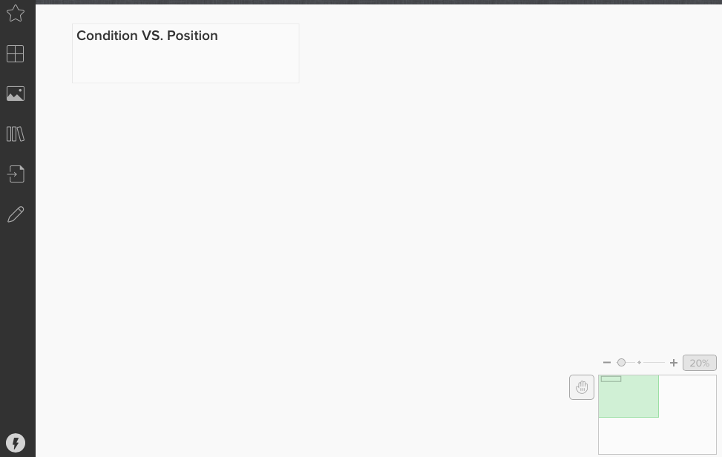
- For this activity, you will be divided into 3 groups. Please see the table above for your group assignments.
- You have 25 minutes to agree how you can, without words, illustrate your assigned concept. Reflect on what you have learned and brainstorm how each of these concepts illustrate gender transformative change.
- Your assigned concept is listed above, and you can find more about your concept to get you started via Annex 3a.
- When you click the Mural link, you should see a virtual whiteboard that looks like the picture beside (but with your assigned concept).
- Each group is assigned their own “virtual whiteboard” utilizing Mural to illustrate your concept. Using this tool, you can draw a picture, use symbols or create an idea tableau that shows how this concept illustrates gender transformative change.
- You will be moved into Zoom break-out rooms according to the group assignments listed. As a group, you will each enter your assigned mural link and together, you will illustrate your assigned concept.
- Think about how your concept relates to power and what kind of power. Use the below definitions of power in the “Dig In” box below to support your discussion.
- After 15 minutes, you will be brought back to plenary. Each group will have an opportunity to briefly show and discuss your group’s illustration. Consider nominating someone to take the lead for your group.
  - Explain why this concept is important to understanding gender equality
  - And how this concept is illustrative of gender transformative change.

Dig in! Explore how these concepts have a relationship to power:

- Power over people, resources and decisions
- Power to act and to realize one’s aspirations
- Power with others that comes out of cooperation and collaboration
- Power within that comes from a sense of self-worth and self-knowledge

Session Three

Remember! This activity is your first-time using Mural. Take time to play around with Mural’s many interactive features! Have fun playing around and engaging with your group members. Take time to get comfortable with this platform. Don’t hesitate to reach out to your facilitator(s) if you have any questions or need any support!

Note: see Annex 3b for a full explanation of these concepts.

Session 4: Gender Diversity

Session Four

Activity 4.1 - Unpacking Non-Binary Gender Identity

Annex 4a: Important Definitions

Ally | A person who confronts heterosexism, sexism, homophobia, biphobia, transphobia and heterosexual privilege in themselves and others out of concern for the well-being of 2SLGBTQ+ people.
Asexuality | Generally characterized by not feeling sexual attraction or a desire for partnered sexuality. Asexuality is distinct from celibacy, which is the deliberate abstention from sexual activity.
Bisexual | A person whose primary sexual and affectional orientation is toward people of the same and other genders, or towards people regardless of their gender.
Cisgender | The prefix cis- means "on this side of" or "not across." A term used to call attention to the privilege of people who are not transgender.
Cross Dresser | A word to describe a person who dresses, at least partially, as a member of a gender other than their assigned sex; carries no implications of sexual orientation.
Drag | An artform and important part of queer culture that allows people to express themselves through makeup, performance, attire, dance, and music. Drag is often a way for a person to explore gender, whether through a critical or playful lens. A person of any gender can perform as a Drag King, Queen, or Thing.
Gay | Session Four  A sexual orientation toward people of the same gender.
Gender Expression | How one expresses oneself, in terms of dress, mannerisms and/or behaviors that society characterizes as "masculine" or "feminine."
Genderqueer | A person whose gender identity and/or gender expression falls outside of the dominant societal norm for their assigned sex, is beyond genders, or is some combination of them.
Heterosexuality | A sexual orientation in which a person feels physically and emotionally attracted to people of a gender other than their own.
Homosexual/Homosexuality | An outdated term to describe a sexual orientation in which a person feels physically and emotionally attracted to people of the same gender.
Intersex | People who, without medical intervention, develop primary or secondary sex characteristics that do not fit “neatly” into society's definitions of male or female. Many visibly intersex people are mutilated in infancy and early childhood by doctors to make the individual’s sex characteristics conform to society’s idea of what normal bodies should look like. Intersex people are relatively common, although society's denial of their existence has allowed very little room for intersex issues to be discussed publicly.
Lesbian | A woman whose primary sexual orientation is toward people of the same gender.
2SLGBTQ+ | Abbreviation for Two Spirit, Lesbian, Gay, Bisexual, Transgender, Queer (or Questioning), and the plus represents those gender identities that aren’t included in the acronym.
Pansexual | Terms used to describe people who have romantic, sexual or affectional desire for people of all genders and sexes.
Nonbinary | A gender identity that embraces full universe of expressions and ways of being that resonate with an individual. It may be an active resistance to binary gender expectations and/or an intentional creation of new unbounded ideas of self within the world.
Queer | This can include, but is not limited to, gay, lesbian, bisexual, transgender, intersex and asexual people. This term has different meanings to different people. Some still find it offensive, while others reclaim it to encompass the broader sense of history of the gay rights movement. Can also be used as an umbrella term like LGBT, as in "the queer community."
Sexuality | The components of a person that include their biological sex, sexual orientation, gender identity, sexual practices, etc.
Sexual Orientation | An enduring emotional, romantic, or sexual attraction. Sexual orientation is fluid. Asexuality is also considered a sexual orientation (See above definition of asexuality).
Transgender | Used most often as an umbrella term, some commonly held definitions: 1. Someone whose gender identity or expression does not fit (dominant-group social constructs of) assigned birth sex and gender. 2. A gender outside of the man/woman binary. 3. Having no gender or multiple genders.
Transsexual | A person who lives full-time in a gender different than their assigned birth sex and gender. Some pursue hormones and/or surgery while others do not. Sometimes used to specifically refer to trans people pursuing gender or sex confirmation.
Transvestite | This is an outdated and problematic term due to its historical use as a diagnosis for medical/mental health disorders. Cross Dresser has replaced transvestite, see above definition.
Session Four

LGBTTTQQIAA Guide
Session Four
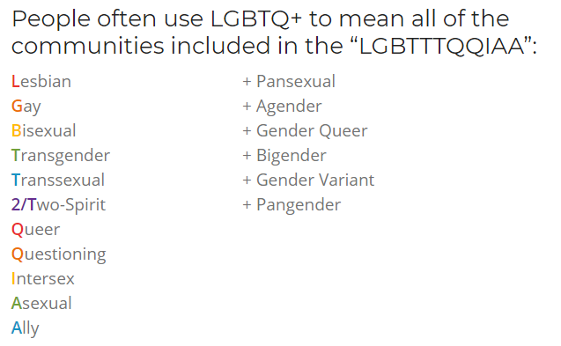

The Gender Elephant
Session Four
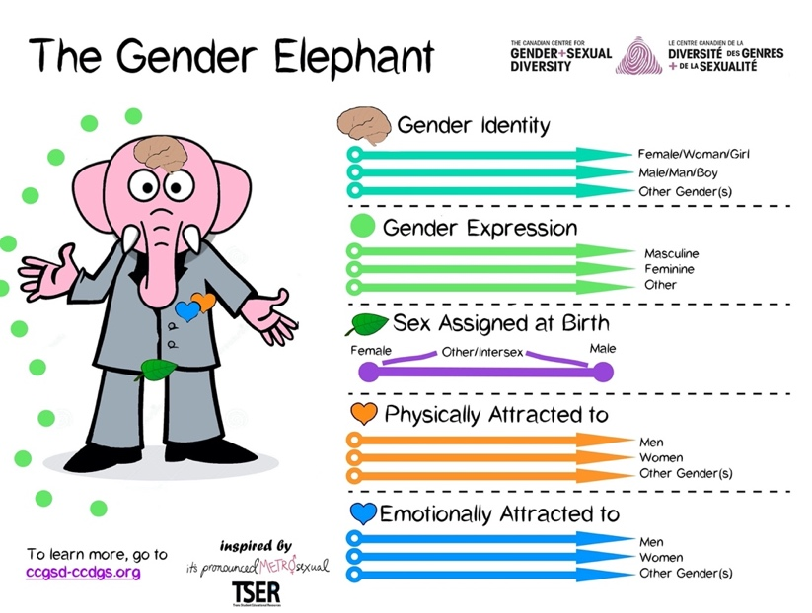

Annex 4b: LGBT+ Inclusion in International Development Programming
Session Four
Directly taken from: https://www.ukaiddirect.org/wp-content/uploads/2017/03/LGBT-Inclusion-Checklist-UK-Aid-Connect.pdf

Programme Design

Analyse how the issues addressed by your programme potentially affect LGBT+ communities and consider relevant interventions or activities

Address LGBT+ inclusion in your Business Case or programme proposal

Widen the scope of your programme to address related specific issues that LGBT+ people face

Ensure your programme does not unintentionally perpetuate exclusion

- Does your understanding of, and approach to, gender equality and social inclusion take LGBT+ people into account?
- Does your operational definition of ‘gender’, ‘women’ or ‘men’ exclude trans people or the wider LGBT+ community?
- Does the programme include normative assumptions about families, relationships and other factors that exclude LGBT+ people?

Consultation

Consult with LGBT+ organisations and movements, who know the context, in the design phase

Build opportunities to keep consulting with LGBT+ organisations/movements throughout the lifecycle of the programme, in order to monitor ongoing impact

- The LGBT+ community is a very diverse one. Are you engaging with a representative movement—in particular, one that includes the voices of women and trans communities?

Session Four
Partnership
Partner directly with LGBT+ organisations and movements in programme countries, where possible
Provide direct support and funding to LGBT+ organisations and movements
Create opportunities through the programme to improve the evidence base on LGBT+ inclusion
Build in opportunities to support LGBT+ advocacy (nationally, regionally and/or internationally), where appropriate
Staff Sensitivity
Proactively ensure that your colleagues and delivery partners to not discriminate against LGBT+ people in policy or in practice, or perpetuate homophobia, biphobia and transphobia
Create opportunities through the programme to increase the sensitivity of staff and delivery partners to sexual orientation and gender identity
Empower LGBT+ staff working on the programme by building a supportive and inclusive environment
Do No Harm
Conduct a robust risk analysis to ensure that planned activities do not inadvertently harm LGBT communities, and adjust plans accordingly

- Is there a risk of backlash? Can activities be modified to reduce this risk?
- Remember that ‘do no harm’ is not the same as ‘do nothing’. Even in the most challenging contexts, there may be small, discrete steps you can take. Doing nothing to support LGBT+ communities can in fact reinforce their discrimination.
Ensure the security of any LGBT+ partners (physical, digital and emotional)

Annex 4c: Tools
Session Four

Daniels, Mannion and UK Aid Direct. LGBT+ Inclusion in International Development Programming: A checklist for UK Aid Connect proposals (2017).
https://www.ukaiddirect.org/wp-content/uploads/2017/03/LGBT-Inclusion-Checklist-UK-Aid-Connect.pdf

Egale. LGBTQI2S Glossary of Terms.
https://egale.ca/awareness/glossary-of-terms/

Global Affairs Canada: The human rights of lesbian, gay, bisexual, transgender, queer, 2-spirit and intersex persons.
https://www.international.gc.ca/world-monde/issues_development-enjeux_developpement/human_rights-droits_homme/rights_lgbti-droits_lgbti.aspx?lang=eng

IPPF Humanitarian. LGBTIQ+ Inclusion in Humanitarian Action (2019).
https://www.ippf.org/sites/default/files/2019IPPFHumanitarian_LGBTICapabilityStatement.pdf

Park, Andrew and Lucas Ramon Mendos. Guiding Principles on the Inclusion of Lesbian, Gay, Bisexual, Transgender, and Intersex (LGBTI) People in Development Policy and Programs (November 2018).
https://www.rfsl.se/wp-content/uploads/2018/11/RFSL_Guiding-Principles_final_digital.pdf

DCHA/DRG/HR. Suggested Approaches for Integrating Inclusive Development Across the Program Cycle and in Mission Operations (July 2018).
https://usaidlearninglab.org/sites/default/files/resource/files/additional_help_for_ads_201_inclusive_development_180726_final_r.pdf

Lee Badgett, M.V. and Randall Sell. A Set of Proposed Indicators for the LGBTI Inclusion Index (March 2019).
https://www.undp.org/content/undp/en/home/librarypage/hiv-aids/lgbti-index.html

United Nations General Assembly. Resolution adopted by the Human Rights Council on 20 June 2016. 32/2 Protection against violence and discrimination based on sexual orientation and gender identity (July 2016).
https://www.un.org/en/ga/search/view_doc.asp?symbol=A/HRC/RES/32/2

USAID. LGBT Vision for Action: Promoting and Supporting the Inclusion of Lesbian, Gay, Bisexual, and Transgender Individuals (March 2020).
https://www.usaid.gov/sites/default/files/documents/1874/LGBT_Vision.pdf

Annex 4d: Research/Editorial
Session Four

Bergenfielf, Rachel and Alice Miller. Queering International Development? An Examination of New ‘LGBT Rights’ Rhetoric, Policy, and Programming among International Development Agencies (March 2014). LGBTQ Policy Journal, Harvard Kennedy School.
https://papers.ssrn.com/sol3/papers.cfm?abstract_id=2514066

JMIR Public Health Surveill. Population Size Estimation of Gay and Bisexual Men and Other Men Who Have Sex with Men Using Social Media-Based Platforms (February 2018).
https://pubmed.ncbi.nlm.nih.gov/29422452/#affiliation-1

Mills, Elizabeth.‘Leave No One Behind’: Gender, Sexuality and the Sustainable Development Goals (October 2015).
https://opendocs.ids.ac.uk/opendocs/bitstream/handle/20.500.12413/7104/ER154_LeaveNoOneBehindGenderSexualityandtheSDGs.pdf

Park, Andrew and Lucas Ramon Mendos. For All: The Sustainable Development Goals and LGBTI People (February 2019).
https://www.rfsl.se/wp-content/uploads/2019/04/FINAL_FORALL_RFSL_2019.pdf

Poushter, Jacob and Nicholas O. Kent. Pew Research Center. The Global Divide on Homosexuality Persists: But increasing acceptance in many countries over past two decades (June 2020)
https://www.pewresearch.org/global/wp-content/uploads/sites/2/2020/06/PG_2020.06.25_Global-Views-Homosexuality_FINAL.pdf

Sexual and Reproductive Health Matters, Volume 28, 2020 – Issue 1. Regional legal and policy instruments for addressing LGBT exclusion in Africa (January 2020).
https://www.tandfonline.com/doi/full/10.1080/26410397.2019.1698905

Video & Relfection – Activity Instructions
Session Four

- Follow this link to an article from the Guardian’s Global Development Professionals network and take a moment on your own computer to choose 2 videos to watch from the selection: https://www.theguardian.com/global-development-professionals-network/2016/feb/12/seven-videos-that-will-give-you-hope-about-lgbti-rights-around-the-world
- Reflect:
  - How did these videos make you feel?
  - What is the first emotion that came to mind?
- We will come back together in plenary for a group reflection and discussion.

Activity 4.2 Instructions: Gender Diversity and Development Work

- To complete this activity, you will be divided into 3 groups. Please see the table below for your group assignments.
- You have 15 minutes to review and discuss how the LGBT+ Inclusion in International Development Programming: A checklist for UK Aid Connect proposals’ (Annex 4b) might apply to your own work.
- In your groups, discuss the following questions:
  - As you go through the checklist, can you identify actions that your organization already takes?
  - Which of these would be a challenge in your programming – and why?
  - Which of these actions could you do consistently or at least more often? What tools would help you include more of these actions in your programming?
- When you return back to plenary, bring at least one idea for how you could integrate activities from the checklist into your work – and how it would add value to your programming.

Group Assignments
Session Four

Group 1 | Group 2 | Group 3
- Participant Names | - Participant Names | - Participant Names

Session Five

Session 5: Intersectionality

Activity 5.1 Instructions: Our Identities

- Let’s reflect on our own identities. Think about some words you would use to describe your identity.

- Click the below Sli.do link to join the “word cloud poll”.

- Sli.do link: [insert link]

- Once in the Sli.do word cloud, populate 1 example at a time, where prompted.

- You will have 3 minutes to independently brainstorm and populate your responses. Feel free to type as many responses as you’d like!

- Once you’re done populating your own examples, return to the Zoom call. The final word cloud will be screenshared by the hosts.

Activity 5.1 - Power Walk Details
Session Five

Annex 5a: Gender and Power - Power Walk

Power Walk Identities

- A girl of 15, just married
- A boy of 18, just married
- The first son of a shop-owner in a large city, aged 17
- The youngest daughter of 7 children in a poor, rural farming
family, aged 9
- 22-year-old, single mother of 2, with no schooling
- A 9-year-old boy, orphaned by HIV/AIDS
- The only boy in a family of female children, aged 7
- The only girl in a family of male children, aged 7

- A rural young male who is physically disabled
- An urban young female who is blind
- A religious leader from a rural village
- The foreign head of a local NGO
- A male adolescent who is gay
- A 40-year-old transgender adult
- A young female adult who is a lesbian
- A 45 year old male police officer
- A university educated woman, 25 years old

 | Power Walk Statements
1 | “I will choose who and when I marry”
2 | “I am likely to receive equal attention and time from my teachers in school”
3 | “I can walk safely on my own at night”
4 | “I can access primary health services if/when I need them”
5 | “I do not need permission to go to the doctor/health clinic.”
6 | “My family prioritizes my education”
7 | “I am encouraged to speak my opinion”
8 | “I expect to participate in community decision-making when I am older”
9 | “When resources are low my health and well-being is my family’s priority”
10 | “It is expected that I will attend and complete school”
11 | “I can afford the basic necessities in life/provide for my family”
12 | “I do not want children – I am able to access contraception easily and with no stigma”
13 | “I do not want children – I share household decision making power with my partner and we are in agreement about using contraception to prevent pregnancy”
14 | “I am not afraid that people in my life might physically hurt me”
15 | “I have never felt degraded, controlled, humiliated or intimidated by someone’s words or actions towards me”
Session Five

Activity 5.1 - Power Walk Activity Instructions
Session Five

Active Participants | Observers
If your name is listed as an active participant, login to the following MURAL Link: (insert link)  - Next to your name below is an assigned “identity” in brackets.  - Once in Mural, look for the sticky note that has your assigned identity written on it.  - During this activity, think as the identity/person you’re assigned.  - The facilitator is going to read out a variety of different statements.  - If the statement is likely to be true for your identity, you should move your assigned sticky note on Mural one space forward on the grid.  - If the statement is likely to be false for your identity, you should move your assigned sticky note on MURAL one space backward on the grid.  - If you are unsure, keep the sticky note in the same place.  - Reminder! You are to move your sticky note based on the identity assigned, NOT based on what you believe is right or wrong. | If your name is listed as an observer, watch the Zoom shared screen as an observer. Do not login to the Mural link.  Pay close attention and take notes on what you’re observing!
- Name (assigned identity i.e. A girl of 15, just married) | - Name

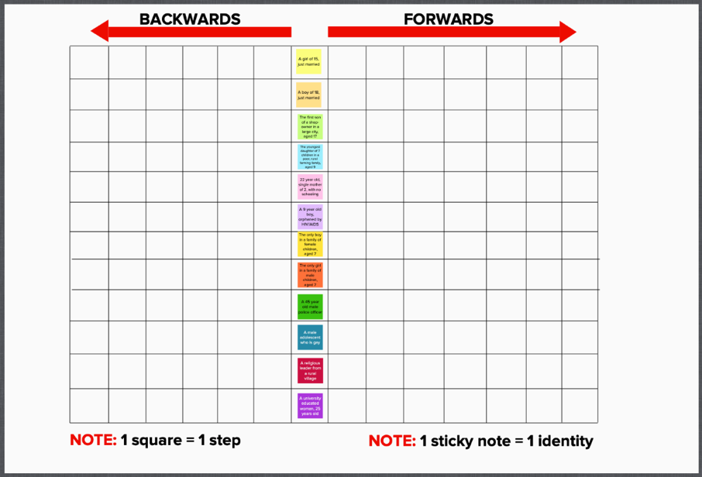
Activity Instructions
Session Five

- Login to Mural.
- You should see a graphic that looks like this (but with your training’s assigned identities) ----------------------->
- As a participant, read these activity instructions to ensure you understand how this activity works.
- Think as the identity/person you’re assigned.
- The facilitator is going to read out one statement at a time.
- If the statement is likely to be true for your identity, you should move your assigned sticky note on MURAL one space forward on the grid.
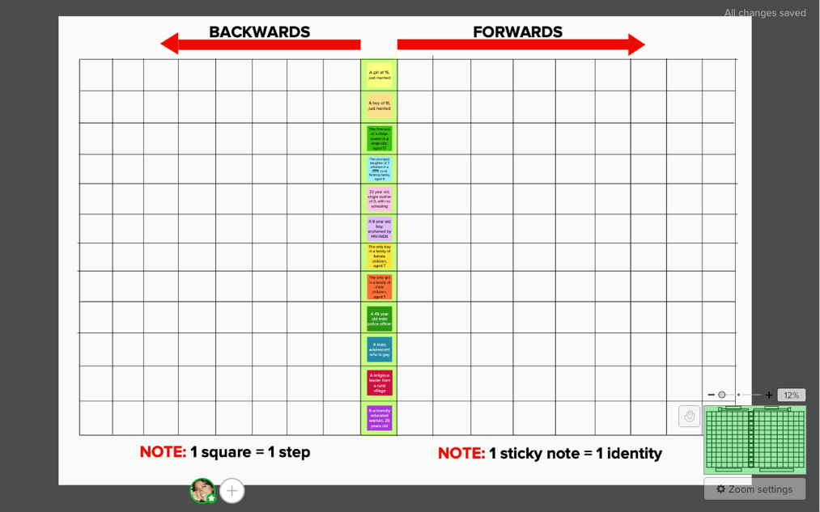
- If the statement is likely to be false for your identity, you should move your assigned sticky note on MURAL one space backward on the grid.
- If you are unsure, keep the sticky note in the same place.
- You should see a graphic that looks similar to the bottom picture ------------------------------->
Tip! If you’re an active player, zoom out so that you can see the full whiteboard!

Zoom features

Adapted from: https://www.ndi.org/sites/default/files/Sample-Workshop-Groundrules.pdf
World Health Organization https://www.who.int/gender-equity-rights/knowledge/glossary/en/
World Health Organization https://www.who.int/gender-equity-rights/knowledge/glossary/en/
World Health Organization https://www.who.int/gender-equity-rights/knowledge/glossary/en/
https://www.who.int/gender-equity-rights/knowledge/glossary/en/
World Health Organization https://www.who.int/gender/mainstreaming/GMH_Participant_GenderAssessmentScale.pdf
Rutgers https://www.rutgers.international/sites/rutgersorg/files/Manuals/Rutgers-GTA-guide-to-theory.pdf
Gender and Environment Resource Centre https://genderandenvironment.org/2015/08/stop-being-so-sensitive-the-shift-from-gender-sensitive-to-gender-responsive-action/
https://en.wikipedia.org/wiki/Feminism
World Health Organization https://www.who.int/gender-equity-rights/knowledge/glossary/en/
World Health Organization https://www.who.int/gender-equity-rights/knowledge/glossary/en/
https://www.who.int/gender-equity-rights/knowledge/glossary/en/
World Health Organization https://www.who.int/gender/mainstreaming/GMH_Participant_GenderAssessmentScale.pdf
http://downtozeroplatform.com/dtz/files/Plan%20Netherlands%20Gender%20Equality%20Programma%20Criteria.pdf
http://downtozeroplatform.com/dtz/files/Plan%20Netherlands%20Gender%20Equality%20Programma%20Criteria.pdf
OECD https://www.oecd.org/site/oecdgfd/39447872.pdf
Association Québécoises des organismes de coopération international (AQOCI) Gender and Development Training Kit
Johns Hopkins https://gender.jhpiego.org/analysistoolkit/gender-concepts-and-definitions/
Association Québécoises des organismes de coopération international (AQOCI) Gender and Development Training Kit
Johns Hopkins https://gender.jhpiego.org/analysistoolkit/gender-concepts-and-definitions/
Oxfam Canada https://www.oxfam.ca/publication/oxfam-canadas-feminist-principles/
Action Aid https://www.actionaid.org.uk/about-us/how-we-practise-feminism-at-work
World Health Organization Glossary of Terms and Tools
UNICEF Gender Glossary and Terms
World Health Organization Glossary of Terms and Tools
UNICEF Gender Glossary and Terms
World Health Organization Glossary of Terms and Tools
UNICEF Gender Glossary and Terms
UNESCO’s Gender Mainstreaming Implementation Framework
UNICEF Gender Glossary and Terms
Economic and Social Commission for Western Asia
CEDPA: Mobilizing for Equity: Gender and Reproductive Health Considerations http://www.nzdl.org/gsdlmod?e=d-00000-00---off-0cdl--00-0----0-10-0---0---0direct-10---4-------0-0l--11-en-50---20-about---00-0-1-00-0--4----0-0-11-10-0utfZz-8-10&cl=CL2.19&d=HASHf0f5085aa2803c9757ee6b.12.3&gt=1
CEPDA: Mobilizing for Equity: Gender and Reproductive Health Considerations http://www.nzdl.org/gsdlmod?e=d-00000-00---off-0cdl--00-0----0-10-0---0---0direct-10---4-------0-0l--11-en-50---20-about---00-0-1-00-0--4----0-0-11-10-0utfZz-8-10&cl=CL2.19&d=HASHf0f5085aa2803c9757ee6b.12.3&gt=1
CEPDA: Mobilizing for Equity: Gender and Reproductive Health Considerations http://www.nzdl.org/gsdlmod?e=d-00000-00---off-0cdl--00-0----0-10-0---0---0direct-10---4-------0-0l--11-en-50---20-about---00-0-1-00-0--4----0-0-11-10-0utfZz-8-10&cl=CL2.19&d=HASHf0f5085aa2803c9757ee6b.12.3&gt=1
Economic and Social Commission for Western Asia
CEDPA: Mobilizing for Equity: Gender and Reproductive Health Considerations http://www.nzdl.org/gsdlmod?e=d-00000-00---off-0cdl--00-0----0-10-0---0---0direct-10---4-------0-0l--11-en-50---20-about---00-0-1-00-0--4----0-0-11-10-0utfZz-8-10&cl=CL2.19&d=HASHf0f5085aa2803c9757ee6b.12.3&gt=1
CEPDA: Mobilizing for Equity: Gender and Reproductive Health Considerations http://www.nzdl.org/gsdlmod?e=d-00000-00---off-0cdl--00-0----0-10-0---0---0direct-10---4-------0-0l--11-en-50---20-about---00-0-1-00-0--4----0-0-11-10-0utfZz-8-10&cl=CL2.19&d=HASHf0f5085aa2803c9757ee6b.12.3&gt=1
CEPDA: Mobilizing for Equity: Gender and Reproductive Health Considerations http://www.nzdl.org/gsdlmod?e=d-00000-00---off-0cdl--00-0----0-10-0---0---0direct-10---4-------0-0l--11-en-50---20-about---00-0-1-00-0--4----0-0-11-10-0utfZz-8-10&cl=CL2.19&d=HASHf0f5085aa2803c9757ee6b.12.3&gt=1
CEPDA: Mobilizing for Equity: Gender and Reproductive Health Considerations http://www.nzdl.org/gsdlmod?e=d-00000-00---off-0cdl--00-0----0-10-0---0---0direct-10---4-------0-0l--11-en-50---20-about---00-0-1-00-0--4----0-0-11-10-0utfZz-8-10&cl=CL2.19&d=HASHf0f5085aa2803c9757ee6b.12.3&gt=1
https://lgbt.ucsf.edu/glossary-terms
Outsaskatoon.ca
https://ok2bme.ca/resources/kids-teens/what-does-lgbtq-mean/
https://www.doyoutools.org/breaking-the-box

