Building Capacity and Confidence in Gender Transformative Programming
A Virtual Learning Experience

Module 2 – Facilitator’s Guide

Table of Contents
Table of Contents
Session 6: Gender in the Project Cycle 4
Process 5
Session 7: Problem Analysis from a Gender Perspective 8
Process 9
Annexes 15
Annex 7a: Health Programming Problem Examples 15
Annex 7b: Problem Tree Examples on Mural 16
Session 8: Understanding a Rights-Based Approach to Gender Equality 17
Process 18
Annexes 25
Annex 8a: Positive/Negative Rights 25
Annex 8b: Human Rights Normative Framework 27
Annex 8c: Rights-based or Instrumentalist? Vote with your picture! 28
Session 9: A Holistic Approach—Understanding the environmental factors of inequality 29
Process 30
Session 10: Towards Design for Gender Equality: Gender Aware and Gender Transformative Theories of Change and Logic Models 34
Process 35
Annexes 39
Annex 10a: Results Based Management Refresher 40
Annex 10b: Gender Equality Outcome Examples 42
Annex 10c: Logic Model Handout 43
Annex 10d: Blank Logic Model Example 44
Session 11: Implementation—Planning for Transformative Change 45
Process 46
Table of Contents
Annexes 51
Table of Contents
Annex 11a: Project Case Studies for Implementation Exercise 51
Annex 11b: Global Affairs Canada’s Gender Equality Marker 55

Session Six

Session 6: Gender in the Project Cycle
Learning Objective | Participants understand the basic points of the project cycle that will be used for the training, and how it applies to their work.
Key Messages | - Regardless of your organization’s mandate, a project cycle is a universal and practical approach to understanding the processes within which gender equality and feminist approaches can be integrated.  - The journey through this training will be hands-on and practical, requiring everyone’s active participation.
Facilitator’s Notes | - Refer to the “tech guide” for detailed instructions on how to use MURAL
Duration | 25 minutes
Activities | - Introduction (5 minutes)  - Activity 1: Gender in the Project Cycle (15 minutes)  - Wrap-up (5 minutes)
Resources | - Participant Resource Package  - PowerPoint
Technology | - PowerPoint presentation  - Zoom  - MURAL
Session Six

Process
Session Six

# | Facilitator Steps | Technology Support
 | Welcome participants to Module 2 of training. Take 5 minutes to debrief module 1 sessions. Ask 2 - 3 participants to share their key take away from module 1. | - Turn on Zoom gallery view to allow everyone to see each other during the welcome and recap.  - If this is the first session of the day, consider hosting a virtual icebreaker to get module 2 started!
Activity 1: Gender in the Project Cycle

 | Explain to participants: Now that a shared understanding and vernacular has been established, the rest of the training will be spent on exploring what these concepts look like in their practical application. For this purpose, the training will take a project cycle approach. While there are countless models for the ‘project cycle’, they for the most part take a consistent form. Here we will be following a simple project cycle:  1. Planning and Design  2. Implementation  3. Monitoring, Evaluation and Learning | - Start the PowerPoint and share the screen. Follow along with the facilitator and go through the slides using the cues from the facilitator when to switch slides.  - Let the facilitator introduce the session, explain the session objectives and key messages to the participants.
 | Explain that within each of these areas, we will explore how to strengthen the transformative nature of programming, introducing tools and examples throughout:  - Planning and Design. These sessions will explore problem analysis from a gender perspective, rights-based and instrumentalist approaches, taking a holistic approach, and designing transformative programming with gender equality outcomes.  - Implementation. This session will ask participants to examine different aspects that are key to effective implementation (resources, skills, time) from a gender perspective, exploring the needs, challenges and risks associated with gender transformative programming.  - Monitoring, Evaluation, Accountability and Learning. These sessions will introduce participants to the spectrum of gender equality integration into MEAL, from gender sensitive through to feminist MEAL. They will be introduced to the Gender Based Analysis Plus (GBA+), design indicators for GE outcomes, and explore how data can be collected and used for gender transformative programming. | Session Six  - Progress through accompanying slide(s)
 | Invite participants to ask questions about the project cycle approach being used for the training, including if any clarification is needed. After taking questions, ask participants to go to Activity 6.1 in their Participant Resource Package where they will find the activity instructions, along with the accompanying Mural link. The Mural link is also posted in the Zoom chat.  On Mural, participants will see the diagram of the “Project Cycle”. Participants are to choose an “icon” or a sticky-note with their name to identify themselves. Participants are to move their icon/sticky-note to the part of the project cycle where they do most of their work, and another icon/sticky-note to the part they are most interested in learning about gender transformative programming.  Note: Ask any of those whose roles do not fit in the project cycle to grab a post-it note and write in their position. Ask them how they feel the training applies to their work. As a facilitator, make sure to check in with these participants to help them apply what their learning to their own roles and responsibilities within their organization. | - Progress through accompanying slide(s)  - Post the Mural link in the Zoom chat  - Act as tech support for anyone having difficulty navigating Mural and the instructions  - Mural Note: When preparing this Mural page—consider virtually drawing the “Project Cycle” directly into the Mural rather than copying and pasting a picture. If the project cycle picture is copy and pasted into the MURAL, there is a chance it can be moved around by participants and their sticky notes can get stuck behind the photo.
 | After everyone has made their marks, have a brief discussion about where the experience is in the room, and where the interest lies. | - Turn on Zoom gallery view for the brief discussion  - Progress through accompanying slide(s)
Session Six

Session 7: Problem Analysis from a Gender Perspective
Session Seven
Learning Objective | To become comfortable with the application of a gender lens, and the identification of ‘root causes’.
Key Messages | - In order to design gender transformative programming, we need to have a deep understanding of the gendered nature of the problem, right down to the root causes.  - Revising our conceptual understanding of gender inequality can help us to explore these root causes.
Facilitator’s Notes | - Refer to the “tech guide” for detailed instructions on how to use MURAL  - Ensure the Participant Resource Package is populated and ready for group work
Duration | 50 minutes
Activities | - Introduction (15 minutes)  - Activity 1: Problem Trees (30 minutes)  - Wrap-up (5 minutes)
Resources | - Participant Resource Package  - PowerPoint
Technology | - PowerPoint presentation  - Zoom  - MURAL

Process
Session Seven

# | Facilitator Steps | Technology Support
 | Ask participants to recall the sessions from day 1 on concepts and terminology. Ask for someone to recall and share the definition of ‘gender transformative’ programming (to address the root causes of gender-related problems and gender equality).  As with the design of any project or program, the very first essential step is to have a comprehensive understanding of the problem that is being addressed – sometimes called a ‘situation analysis’ or ‘problem analysis’. Explain that in this session, participants will focus in on a problem analysis from a gender perspective. | - Start the PowerPoint and share the screen.  - Progress through the accompanying slide(s).  - Follow the cues from the Facilitator when to switch slides.
 | Ask participants who amongst them has used a ‘problem tree analysis’ before? If any have, ask them to share a brief overview, then introduce the following explanation:  Problem Tree Analysis is central to many forms of planning. Problem tree  analysis is a group exercise that helps to find solutions by mapping out causes  and effects around an issue.  - The first step is to discuss and agree the problem or issue to be analyzed.  The problem or issue is written in the center of the flip chart and becomes  the ‘trunk’ of the tree. This becomes the ‘focal problem’.  - Next, the group identifies the causes of the focal problem, these become  the roots, and then identify the consequences, which become the branches.  For this exercise, the focus will be on the roots or causes of the problem.  - The heart of the exercise is the discussion, debate and dialogue that is  generated as factors are arranged and re-arranged, often forming  sub-dividing roots and branches.  - The problem tree can be converted into an objectives tree by rephrasing  each of the problems into positive desirable outcomes – as if the problem  had already been solved. In this way, root causes are turned into root  solutions. | - Progress through the accompanying slide(s)  - While the facilitator is hosting this discussion, consider using this time to set up the Zoom break-out rooms with the pre-determined groups (see page X of the Participant Resource Package).  Tip! Make sure to save these groupings which will be helpful because they will be returning to these same groups for future activities.  Session Seven
 | Explain to participants: one of the most important aspects of the Problem Tree exercise is that it allows for analysis of multiple driving factors, and that it forces the analysis down to the ‘root causes’ (literally!).  Tip! To get to the bottom of the root, participants need to keep asking ‘why?’ at every level, until the problem is brought down to the core causes. | - Progress through accompanying slide(s)
 | Ask participants to take approximately 3 minutes to themselves to brainstorm 1 – 2 gender-related problem that identifies a negative outcome or effect  For example, an organization that works in adolescent health might choose:  ‘High rates of teenage pregnancy amongst girls’ as a problem.  Or an organization that works in maternal newborn and child health (MNCH) might say ‘High unmet need for post-partum family planning.’  As a facilitator, make sure that these are high-level problems – meaning that the problem is one that identifies a negative outcome or effect in people’s lives. If they are having difficulty coming up with problems, provide them with one or direct them to the list of examples provided in Annex 7a. | - Progress through accompanying slide(s)
Session Seven
Activity 1: Problem Trees

 | Explain that this activity will take 30 minutes and participants will be divided into groups where they must agree on one problem that they are going to work with to build their Problem Trees.  Direct participants to Activity 7.1 of their Participant Resource Package. On this page, they will see the groups they’re assigned to for this activity. They will also find the Mural link assigned to their group. Let participants know that they will automatically be moved to Zoom Breakout Rooms according to the groups assigned.  For this activity, they will be using the Mural to create their Problem Trees online. Mural will allow participants to use post-it notes so that they can re-arrange and re-write their ‘causes’ throughout the discussion, and they can also use colours and symbols to help organize their thoughts.  Guide participants to Activity 7.1 in their Participant Resource Package for complete activity instructions.  Explain that participants will have to add context to their problem in order to build their analysis. They can choose a location, some of the contextual elements, etc. Where they come across contextual questions, they can agree on an approach to their analysis that allows them to move forward.  Tip! To ensure smooth and timely transitions into break-out group work use pre-determine groups for each activity. For this activity in particular, groups are able to choose their problem instead of having one assigned to them - this can help promote more active participation, and a richer result! | - Progress through accompanying slide(s)  - Ensure the Zoom break-out rooms are ready for the activity
 | Explain for this group exercise, participants should focus on the gender-related causes of their problems, and/or be sure to include the gendered aspects of any causes that they do identify. While it is important to explore the ‘branches’ or consequences of the problem, today we’re going to focus on the causes, or ‘roots’ of the problem.  For example, high rates of teenage pregnancy are driven by many factors or causes – these can include factors like insufficient supply of contraceptives or poor knowledge of sexual and reproductive health of adolescent girls and boys. Participants should examine what the gendered aspects of these causes are – for example, limited accessibility to contraceptives specifically for adolescent girls, and the gendered myths and stigma about pregnancy prevention and contraception.  Remind participants of some of the concepts explored in the first session. To help explore the gendered aspects of each problem, they can ask themselves:  - Does the position of women and girls influence this problem?  - What strategic or practical needs are absent and contributing to this problem?  - How is intersectionality contributing these causes and to the problem?  Guide participants to Annex 7b for an example of what their problem tree can look like in Mural. | Session Seven  - Maintain accompanying slide(s) before moving participants to Zoom break-out rooms
 | Remind participants that the facilitator will be “popping in” to their groups to provide support, but if they need immediate attention there is a “help” button that they can hit to signal they need help immediately. | Session Seven  - Once the facilitator has provided activity instructions and all participants are on the same page, move participants into their Zoom break-out rooms (it will take a few seconds for participants to all move from the main room to the break-out rooms)  Tip! Watch the alert in the main plenary that means that someone has hit the help button.
 | Wait a few minutes before popping into the first group – to determine which group to visit first (if the help button has not been pressed) have all the links for the Murals open. Monitor progress on these and if a group seems to be struggling with where to start, go to that group first.  When visiting the different groups, help participants by clearing any confusion and kick-starting their discussion with ‘why?’ for each cause in each ‘root system’ – there is almost always several sub-causes for a cause!  Don’t hesitate to help groups organize their thoughts and think of the main causes and sub-causes to get them on the right track. | - The facilitator needs to be manually moved to the different break-out rooms  - While the group activity is running, monitor the call for any technology problems, or anyone seeking support, etc. and move the facilitator according to the needs of each group
 | After 30 minutes, regardless of how far groups get, close the Zoom break-out rooms and bring everyone back to the main plenary. | - Close the breakout room groups  - Bring everyone back to plenary  - Display the accompanying PowerPoint slide and progress through slide(s) as cued by the Facilitator
 | When participants return to the main plenary, explain they will have more time to work with their problem trees over the following sessions.  Close with the key messages:  - In order to design gender transformative programming, we need to have a deep understanding of the gendered nature of the problem, right down to the root causes.  - Revising our conceptual understanding of gender inequality can help us to explore these root causes. | - Progress through accompanying slide(s)
Session Seven

Annexes
Session Seven

Annex 7a: Health Programming Problem Examples

- High levels of teenage pregnancy amongst rural, out-of-school girls in region X of country X.

- High levels of sexual and gender-based violence amongst women sex workers in X city.

- High prevalence of malnutrition amongst female children in region X of country X.

- High levels of HIV infection amongst male prostitutes in X community.

- High levels of maternal mortality amongst women residents in X refugee camp.

Annex 7b: Problem Tree Examples on Mural
Session Seven

Blank example
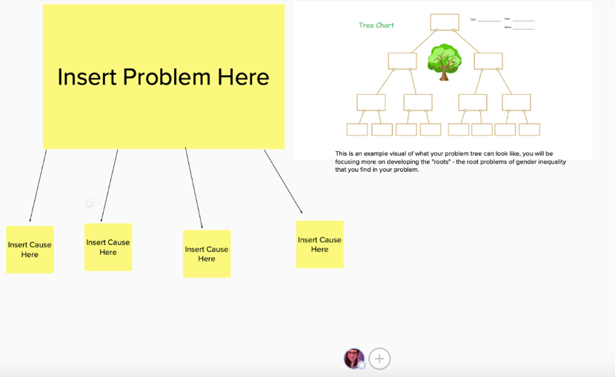

Complete example
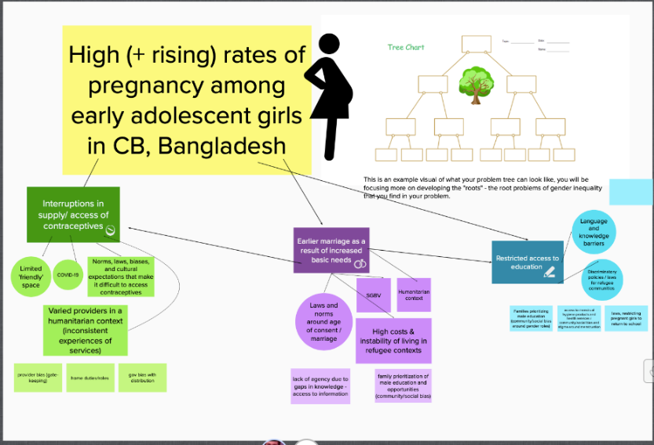

Session 8: Understanding a Rights-Based

Session 8: Understanding a Rights-Based Approach to Gender Equality
Session Eight
Learning Objective | Participants should have a strong understanding of what is meant by a ‘rights-based approach’ and an ‘instrumentalist approach’.
Key Messages | - Gender transformative programming should always reflect a rights-based approach; but we must also understand the instrumentalist rationale for gender equality programming.  - A human rights-based approach to programming demands that human rights are the core rationale for any intervention, but it also demands that human rights principles guide all stages of implementation.
Facilitator’s Notes | - Refer to the “tech guide” for detailed instructions on how to use MURAL  - Ensure the Participant Resource Package is populated and ready for group work
Duration | 55 minutes
Activities | - Introduction (20 minutes)  - Activity 1: Human Rights-Based Approach vs. Instrumentalist Approach (15 minutes)  - Activity 2: Problem Statement (15 minutes)  - Wrap-up (5 minutes)
Resources | - Participant Resource Package  - PowerPoint  - Detached sheet of paper & dark marker/pen
Technology | - PowerPoint presentation  - Zoom  - Mural

Process
Session Eight

# | Facilitator Steps | Technology Support
 | Ask participants whether they have heard of a ‘human rights-based approach’ to programming or development. Ask for any volunteers to describe how they would define a rights-based approach, where they have heard of it, or how it applies to their work. | - Start the PowerPoint and share the screen.  - Progress through the accompanying slide(s).  - Follow the cues from the Facilitator when to switch slides.
 | Ask participants to think about how they define ‘rights’. In plenary, ask for as many synonyms for rights as they group can think of. These might include ‘entitlements’, ‘agency’, ‘choice’, ‘power’, etc.  Explain that rights can be defined as: Rights are legal, social, or ethical principles of freedom or entitlement; that is, rights are the fundamental normative rules about what is allowed of people or owed to people according to some legal system, social convention, or ethical theory. (Stanford Encyclopedia of Philosophy)  Explain that some rights can be described as ‘positive’ and ‘negative’ rights – ask participants for examples of each (for facilitators, examples can be found in Annex 8a). | - Progress through accompanying slide(s)
 | Explain to participants that they can find some of the normative frameworks that describe what rights people have in Annex 8b and introduce the following normative frameworks: Universal declaration of Human Rights (UN); CRC; CEDAW. | - Progress through accompanying slide(s)
 | Explain that a human rights-based approach to programming and development puts human rights at the heart of both the ‘why’ and the ‘how’ of development programming. First, we’ll examine the ‘why’: the fulfillment of human rights as the core rationale for a development initiative.  The UN defines a human rights-based approach as:  “A human rights-based approach is a conceptual framework for the process of human development that is normatively based on international human rights standards and operationally directed to promoting and protecting human rights. It seeks to analyse inequalities which lie at the heart of development problems and redress discriminatory practices and unjust distributions of power that impede development progress.” – FAQ on HRBA, OHCHR, pg. 16  According to GAC:  “A human rights-based approach to international assistance is a tool to help countries meet their human rights obligations and assist people in knowing their human rights and the processes available to claim them. In doing so, it seeks to achieve equitable and sustainable results. It reinforces a feminist approach, as human rights are at the foundation of gender equality and the empowerment of women and girls.” | Session Eight  - Progress through accompanying slide(s)
 | Explain to participants that a ‘human rights-based’ approach can sometimes be more easily understood when contrasted with an ‘instrumentalist’ approach.  An instrumentalist approach can be understood by asking:  “if this problem is solved, what additional external benefits will be seen by others (i.e., community, economy, etc.)”?  An instrumentalist approach to gender equality sees it as a means to the achievement of other goals, such as economic development or sustainable peace and security. An instrumentalist approach to gender equality has often been used to gain support from a wider constituency. Ask participants if they can think of some examples.  - “When you educate a girl, national GDP increases by XX %”;  - “Maternal and infant mortality rates decrease when women have agency to make health-related decisions.”  - “When women can own and run businesses, the whole economy grows”;  - “Sustainable peace is more achievable when women are active participants in discussions”  The UN Office for the High Commission on Human Rights describes it like this:  “There are two main rationales for a human rights-based approach: (a) the intrinsic rationale, acknowledging that a human rights-based approach is the right thing to do, morally or legally; and (b) the instrumental rationale, recognizing that a human rights-based approach leads to better and more sustainable human development outcomes. In practice, the reason for pursuing a human rights-based approach is usually a blend of these two.” – FAQ on HRBA, OHCHR, pg. 16  Session Eight  In plenary, ask the group to rephrase the instrumentalist statements from the slide to express a rights-based approach without losing the instrumental benefits of gender equality.  For example:  - “When you educate a girl, national GDP increases by XX% “When a girl’s right to education is fulfilled, the benefits can go beyond her as an individual and will not contribute to the economic health of the whole community and country.”  - “Maternal and infant mortality rates decrease when women have agency to make health-related decisions.” à “Every woman has the right to make decisions related to her health. This build agency and empowerment and is also shown to reduce maternal and infant mortality rates.” | Session Eight  - Progress through accompanying slide(s)
Activity 1: Human Rights-Based Approach vs. Instrumentalist Approach

 | Take a moment to make sure that all participants understand:  - The difference between an instrumentalist approach and a human rights-based approach;  - That the two are not mutually exclusive.  We’re going to take 10 minutes for an interactive activity to help explore the meaning of human rights-based approach vs. instrumentalist approach.  Ask participants to get 2 detached sheets of paper (preferably blank) and a writing utensil (preferably a black or dark marker). On one sheet of paper, participants are to draw an ‘instrument’ of their choosing (for example: a guitar or a trumpet). On the other sheet of paper, participants are to draw a picture that signifies human rights (for example: the peace symbol or a dove).  Give participants 5 minutes to stand/stretch and complete their drawings. Guide participants to Activity 8.1 for detailed instructions in their Participant Resource Package (if needed). | - Post the drawing directions in the Zoom chat for participants to reference  - Have Zoom in gallery view for this activity
 | Once all participants have completed their drawings, explain to participants that we are going to read out different statements. As each statement is read out, participants are to decide if the statement takes a human rights-based approach or an instrumentalist approach. Repeat the statement 2 or 3 times. Example statements can be found in Annex 8c.  Participants are to hold the drawing of their instrument up to the camera if they believe the statement takes an instrumentalist approach, or they are to hold the drawing of their human rights symbol to the camera if they believe the statement takes a human rights-based approach.  You can use 4-5 statements for this exercise. After each statement, the facilitator should ask a participant to explain their ‘vote’, and then ensure that everyone understands why the statement takes an ‘instrumentalist’ or ‘rights based’ approach to gender equality. | - Ensure Zoom is on gallery view  Session Eight  - As the facilitator reads out a statement, type the same statement into the chat  discussion to ensure participants feel prepared to respond
 | The group should have a good understanding of the ‘why’ – and how to understand human rights as a core or intrinsic rationale for development programming – they will now discuss the relevance of a human rights-based approach to the ‘how’ of development programming.  Explain to participants: a defining feature of a human rights-based approach is that the realization of rights is not only at the core of the rationale for an intervention, but its principles must guide all stages of implementation.  Equality and non-discrimination: All individuals are equal as human beings and entitled to human rights, without discrimination of any kind.  Participation and inclusion: All individuals are entitled to active, free, and meaningful participation in, contribution to, and enjoyment of civil, political, economic, social, and cultural development. The voices and interests of affected individuals are taken into account on issues that concern them and the development of their society.  Transparency and accountability: Individuals have access to information on policies, decisions and use of funds, and are empowered to hold those who have a duty to act accountable. State and non-State actors comply with their applicable obligations and responsibilities.  (https://www.international.gc.ca/world-monde/issues_development-enjeux_developpement/priorities-priorites/human_rights-droits_personne.aspx?lang=eng) | - Progress through accompanying slide(s)
 | In plenary, ask participants to brainstorm for a moment and share thoughts on how these principles are particularly relevant for gender transformative programming – and if possible, share examples from their own work. Explain that you will return to these principles on in a later session. | Session Eight  - Progress through accompanying slide(s)  - Consider turning on Zoom gallery view for the plenary discussion if the PowerPoint is not needed
Activity 2: Problem Statement

 | Ask the groups to return to their problem analysis – have they taken a ‘human rights-based approach’ to their analysis?  What rights are associated with the gender-related problem you identified?  For their main problem statement, ask them to identify what ‘rights’ are being insufficiently fulfilled or violated. Give them 15 minutes to discuss and make any changes or additions to their problem. | - Move participants to the Zoom break-out rooms according to Activity 8.2 instructions in their Participant Resource Guide (these are the same groups used in session 7: problem trees)
 | Close this session by re-visiting the key messages:  - Gender transformative programming should always reflect a rights-based approach; but we must also understand the instrumentalist rationale for gender equality programming.  - A human rights-based approach to programming demands that human rights are the core rationale for any intervention, but it also demands that human rights principles guide all stages of implementation. | - Progress through accompanying slide(s)
Session Eight

Annexes
Session Eight

Annex 8a: Positive/Negative Rights

“Philosophers and political theorists make a distinction between negative and positive rights. A negative right is a right not to be subjected to an action of another person or group; negative rights permit or oblige inaction. A positive right is a right to be subjected to an action or another person or group; positive rights permit or oblige action.”

In other words, negative rights require no action on anyone’s behalf – the duty is in the absence of action. Positive rights require the action of a duty-bearer, usually the state.

Take the Universal Declaration of Human Rights as an example.

NEGATIVE RIGHTS

Article 4 | No one shall be held in slavery or servitude; slavery and the slave trade shall be prohibited in all their forms.
Article 13 (1,3) | Everyone has the right to freedom of movement and residence within the borders of each State. Everyone has the right to leave any country, including his own, and to return to his country.
Article 18 | Everyone has the right to freedom of thought, conscience and religion; this right includes freedom to change his religion or belief, and freedom, either alone or in community with others and in public or private, to manifest his religion or belief in teaching, practice, worship and observance.

Session Eight
POSITIVE RIGHTS

Article 8 | Everyone has the right to an effective remedy by the competent national tribunals for acts violating the fundamental rights granted him by the constitution or by law.
Article 21 (1) | Everyone has the right to take part in the government of his country, directly or through freely chosen representatives.
Article 26 (1) | Everyone has the right to education. Education shall be free, at least in the elementary and fundamental stages. Elementary education shall be compulsory. Technical and professional education shall be made generally available and higher education shall be equally accessible to all on the basis of merit.

Annex 8b: Human Rights Normative Framework
Session Eight
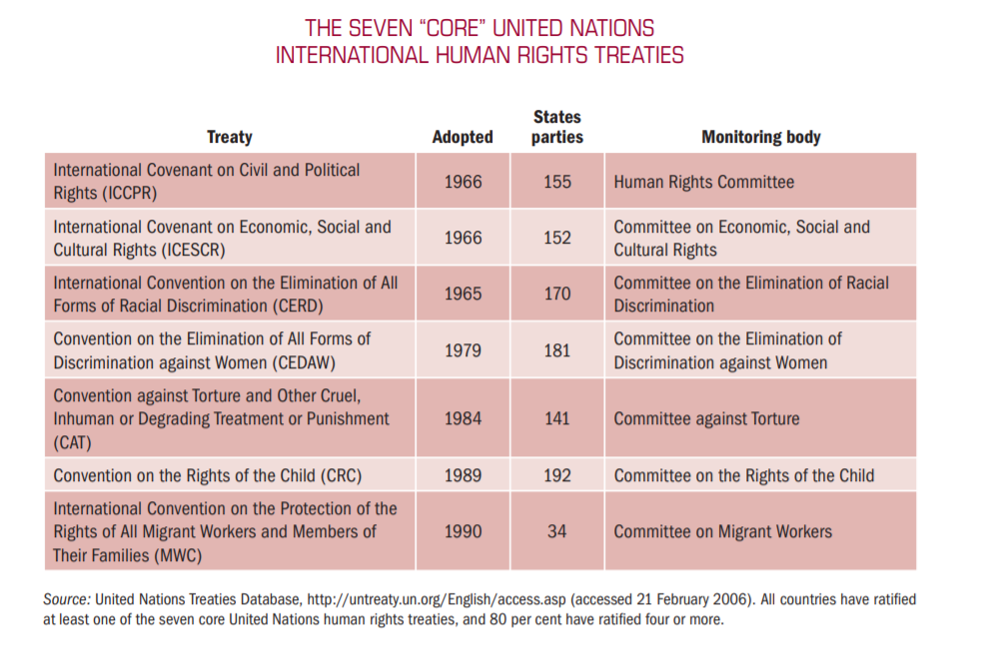

Session Eight

Annex 8c: Rights-based or Instrumentalist? Vote with your picture!

- “Women will decide whether, when, how many and with whom to have children”
- “Inheritance laws must be equal for men and women for women to achieve economic development”
- “When women can own and run businesses, the whole economy grows”;
- “Women’s unpaid labour must be recognized in economic analysis and planning”

- “Sustainable peace is more achievable when women are active participants in discussions”

Session 9: A Holistic Approach—Understanding the environmental factors of inequality
Session Nine
Learning Objective | Participants should recognize gender-related power dynamics between key stakeholders that support inequality.
Key Messages | - Gender inequality is about relational power - or 'position' (discussed in early sessions on terminology/concepts). This makes it necessary to understand power dynamics - both in terms of stakeholders who serve as barriers to empowerment, and those who are allies for empowerment.
Facilitator’s Notes | - Ensure the Participant Resource Package is populated and ready for group work
Duration | 1 hour
Activities | - Introduction (30 minutes)  - Activity 1: Understanding the environmental factors of inequality (20 minutes)  - Plenary (30 minutes)  - Wrap-up (5 minutes)
Resources | - Participant Resource Package  - PowerPoint
Technology | - PowerPoint presentation  - Zoom  - Mural

Process
Session Nine

# | Facilitator Steps | Technology Support
 | Ask participants to recall some of the conversations they had in the first sessions about power and gender equality.  Explain that here we’re going to discuss:  - What were some of the ways we understand the relationship between gender inequality and power?  - How is gender inequality sustained? Who is involved?  Guide the brainstorm session by probing the group to consider the enabling environment for inequality, including the people, the systems and the social norms that sustain inequality. | - Start the PowerPoint and share the screen.  - Progress through the accompanying slide(s).  - Follow the cues from the Facilitator when to switch slides.  - Capture the brainstorm discussion in a Mural; share the screen so that participants can see the discussion being captured live (the tech support should be owning the mural link and capturing the participants discussion--with the screen shared folks can see the discussion happening in real time)
 | 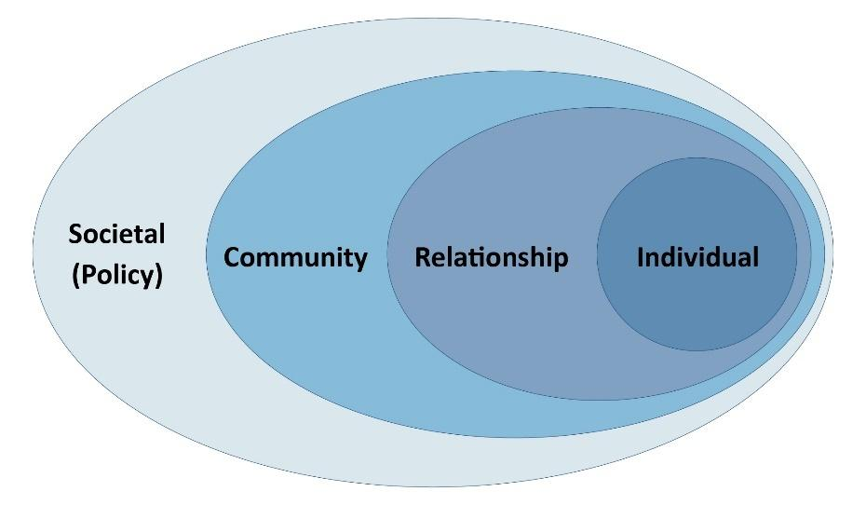  Introduce the socio-ecological model as a way of analyzing and organizing different ‘levels’ of influence, and how environmental factors shape and are shaped by social phenomena, like gender inequality. | - Progress through accompanying slide(s)  - Re-create this graphic in Mural. The facilitator will lead a brainstorm discussion, the tech support will capture these ideas in sticky notes that can be placed on the graphic accordingly.
 | Explain that this model is often used in public health and development programming, and more broadly as a social analysis tool in many sectors. The model can be presented using different terms for each level, or with greater detail or ‘sub-levels’, however the purpose is the same: to place the individual at the center of the analysis and to examine the various influencing factors surrounding the individual. Briefly, invite participants to share their own experience using similar models in their work.  Share the following explanations for the different levels:  - Individual. This refers to the primary subject or focus of your project or study. Sometimes, in the language of human rights, this would be referred as the ‘rights holder’.  - Relationship. This level includes those people with whom the individual has a direct relationship – it is sometimes called ‘interpersonal’. It can include spouses or partners, children and other family members, friends and colleagues. Most often, factors at this level describe family or household dynamics.  - Community. This level extends into the surrounding community and includes social norms and institutions that define and shape community interactions. This can include religious institutions and cultural norms, commercial activity and educational activities.  - Societal (Policy). This level refers to the governance and systems established to provide services, write and enforce laws, protect and defend rights, etc. In the language of human rights, this level would refer to the state as the ‘legal duty-bearer’.  Engaging men and boys! Engagement of men and boys is essential for gender transformative programming. Men and boys can be seen as both beneficiaries of gender transformative change, and as instrumental partners in gender transformative change for women and girls. Men and boys suffer from deep-seated gender norms related to toxic masculinity, including violence, risky behaviour, poor health and lack of emotional connectedness. | Session Nine  - Progress through accompanying slide(s)  - While the facilitator is explaining this information, share the Mural link that captures their discussion on the socio-ecological model with the participants—the facilitator will bring attention to this, so go along with their cues!
Session Nine
Activity 1: Understanding the environmental factors of inequality

 | Ask the groups to return again to their ‘Problem Trees’ and apply this model to their analysis. They should ask themselves:  - What specific factors within the household and within interpersonal relationships are affecting different ‘root systems’ in our Problem Tree? Have we captured those factors?  - How do community institutions and social norms at the community level either support equality or create barriers to the fulfillment of rights? Have we captured these specific elements in our Problem Tree?  - How do government institutions and policy influence our problem? What systems-level factors influence this problem, and have we captured those in our analysis?  Give groups about 20 minutes to discuss and revise their analysis. Remind participants that they can find their group members and activity instructions on in Activity 9.1 of their Participant Resource Guide.  During this time, the facilitator should enter each group and spend some time walking through the analysis and helping each group to answer the following questions:  - Have the ‘root causes’ of the Problem been unearthed?  - Does it reflect a rights-based approach to gender equality?  - Are factors at all levels being adequately considered in the analysis?  - Has the role of men and boys been articulated explicitly? | - Progress through accompanying slide(s)  - Move participants into their Zoom break-out groups from session 7: problem trees  - Weave the facilitator in and out of the break-out rooms to ensure participants are on track
 | After 20 minutes, bring everyone back together. Each group can nominate one person in their group to share:  - 1 part of their root system that addresses RIGHTS  - 1 part of their root system that addresses an enabling environment  - 1 part of their root system that looks at how gender intersects with other factors of identity to contribute to the issue.  Reminder! the purpose is to build analysis skills, not to achieve a perfect analysis!  Take about 20 minutes for each group to share. | - End Zoom break-out rooms and bring everyone back to plenary  - Share the problem tree for each group as they share their 3 points.
 | To close the session, congratulate each group on their analysis and explain that in the next sessions, they will continue to work with their Problem Trees to invert their analyses into gender transformative Logic Models. | - Progress through accompanying slide(s)
Session Nine

Session 10: Towards Design for Gender Equality: Gender Aware and Gender Transformative Theories of Change and Logic Models
Session Ten
Learning Objective | Participants will gain practical experience building a Logic Model with gender equality outcomes.
Key Messages | - A logic model or Theory of Change is a response to a good Problem Analysis.  - Every logic model should be at least gender aware, and many can be gender transformative.
Facilitator’s Notes | - Facilitators should be sure to review the Global Affairs Canada 2016 Results Based Management Guide, in particular those sections related to the tools used in this training: logic model, outcome statements, PMF and indicators.
Duration | 70 minutes
Activities | - Introduction (35 minutes)  - Activity 1: Logic Models (30 minutes)  - Wrap-up (5 minutes)
Resources | - Participant Resource Package  - PowerPoint  - Pre-created logic models in Google Sheets
Technology | - PowerPoint presentation  - Google Sheets  - Zoom

Process
Session Ten

# | Facilitator Steps | Technology Support
 | Explain to the group that in this session they will take all the concepts, discussions and analysis that they explored in Module 1: Concepts and Terminology and convert their Problem Tree Murals into gender aware or gender transformative logic models.  First, to ensure that everyone is working from the same foundation, the group will be guided through a brief refresher in results-based management (RBM) tools (see Annex 10a). Most participants will already be familiar with the basic principles of RBM but explain that it is important that everyone has a similar basic understanding and familiarity with terms. This should take 20 minutes. | - Start the PowerPoint and share the screen.  - Progress through the accompanying slide(s).  - Follow the cues from the Facilitator when to switch slides.
 | Before groups launch into creating their Logic Models, it is important that they have a good understanding of how to design a gender equality outcome statement or result statement.  What elements does a gender equality outcome statement have?  - GE outcome statements explicitly describe an improvement or positive change related to gender equality  - GE outcomes statements do not merely refer to ‘women and men’ or add ‘including girls’ to the stated result.  Session Ten  Note: there is some debate about whether adding ‘especially women’ to a result statement qualifies it as a GE outcome. In these cases, it may be more useful to look at the nature of the result itself and whether it has the potential to empower beneficiaries.  For example, the latter of the two following statements may more effectively qualify as a GE outcome than the former because of the nature of the change it describes.  - Improved access, especially for adolescent girls, to nutritionally diverse food sources.  - Increased decision-making power at the household level for adolescents, especially girls, related to food purchasing and consumption.  Why is this important throughout the LM?  - Because it formalizes the intention of the project to affect positive change towards gender equality.  - Because elements that are included in outcome statements determine the monitoring and evaluation design of a project, the budget of the project, and the management design of a project.  Basically, explicit GE outcomes ensure accountability for GE results.  Ask the group if they can give some examples of GE outcomes, and provide some examples from Annex 10b if needed. | - Progress through the accompanying slide(s)
Session Ten
Activity 1: Logic Models

 | Explain that each group will now take their Problem Tree analysis and build a logic model that describes a project or program to respond to their problem analysis.  Direct each group to the Logic Model Handout (Annex 10c) that has been included in their Participant Resource Package.  Instruct the groups to only focus on the top three levels of the LM: Ultimate Outcome, Intermediate Outcomes, Immediate Outcomes – and to identify some activities for only one Immediate Outcome stream.  Ask groups to keep the following in mind:  - Keep in mind the lessons from Module 1: What is gender transformative change? How can the design reflect a human rights-based approach? How can the change be sustained – at the household, community and systemic level?  - Begin with the Ultimate Outcome, then design toward that goal, level by level.  Assumptions about context, partners and scope will need to be made to fill in gaps. Typically, detailed research and consultations would be conducted, and budget or timeline parameters would be provided – so groups should agree on their assumptions in order to build their project design. Groups should not get too caught up on these missing pieces – rather they should focus on strong logic and design.  Reminder! The groups that they should not be concerned if their LM isn’t complete – it takes more time to design a good project! The value of this exercise is in the analysis, the discussion, and moving towards a greater understanding of how to strengthen gender equality within project design. | - Progress through the accompanying slide(s)
 | Explain that this activity will take approximately 30 minutes and groups will be put back into their Zoom break-out groups from Session 7 – when they designed their Problem Trees.  They will be using a blank Logic Model created on Google Sheets (see Annex 10d) to create their own Logic Models responding to their analysis of their Problem Tree. They can find the links to the Google Sheet and Problem Trees in their Participant Resource Package. | Session Ten  - Progress through the accompanying slide(s)  - Note: participants have been granted editor access to the Google Sheets using the email provided for this training. Ensure participants are logged out of their personal Gmail accounts in order to access and edit this Google Sheet. If they are having trouble logging out, ask that they request access. Keep an eye on your email for these requests and quickly approve their request so they can access the Google Sheet!
 | Remind participants that the facilitator will be “popping in” to their Zoom break-out groups to provide support, but if they need immediate attention there is a “help” button that they can hit to signal they need help immediately.  Wait a few minutes before popping into the first group. To determine which group to visit first (if the help button has not been pressed) have all the links for the Murals open and monitor progress on these. If a group seems to be struggling with where to start, go there first. | - When ready, move participants into their Zoom break-out groups (using the saved groups from session 7)  - It will take a few seconds for participants to all move from the main room to the Zoom break-out rooms.  - Watch the alert in the main plenary that means that someone has hit the help button.  - The facilitator will need to be manually moved into the Zoom break-out rooms  - While the group activity is running, monitor the call for any technology problems, groups asking for help, etc. and move the facilitator around
 | After 30 minutes, regardless of how far groups get, bring everyone back to plenary.  Close the session by explaining that in the sessions to come, they will have a chance to work with each other to strengthen their logic models and make them more gender transformative. | - Close the Zoom break-out groups and bring everyone back to plenary  - Progress through accompanying slide(s)
Session Ten

Annexes
Session Ten

Annex 10a: Results Based Management Refresher

What is Results Based Management?

RBM is a widely recognized approach to program/project management that emerged as a response to what was seen as an over-emphasis in development programming on activities rather than end results. RBM requires that you look beyond activities and outputs to focus on actual results (outcomes): the changes created by your programming and to which it has contributed.

The focus on activities at the expense of results is what management scholar Peter Drucker, in 1954, referred to as the “activity trap.”

Instead, Results-Based Management requires that you look beyond activities and outputs to focus on actual results (outcomes): the changes to which your programming contributed.

By establishing clearly defined expected results, assessing risk, collecting information to assess progress on them on a regular basis during implementation, and making timely adjustments, practitioners can manage their projects and programs better in order to maximize the achievement of results.

(https://www.international.gc.ca/world-monde/assets/pdfs/funding-financement/results_based_management-gestion_axee_resultats-guide-en.pdf)

The framework for RBM follows three principles, each with an associated tool:

- Knowing where you want to be, and plotting your path (Logic Model and Theory of Change)
- Knowing where you are along the journey (Performance Measurement Framework)
- Monitoring and adjusting what you do to ensure you reach your destination (Evidence Based Planning and Management).

A logic model is a visual depiction of the theory of change for a specific project, reflecting the series of changes that are critical to achieving project outcomes. It depicts the logical connections between the planned outputs and the expected outcomes that the project aims to achieve or contribute to. The Logic Model’s pyramid structure enables us to illustrate the complex nature of a program or project. Different intermediate outcomes represent different “pathways” leading to the same ultimate outcome.
Session Ten

Each level of the logic model explains the cause and effect relationship which is expected to occur within the project. In other words: if this set of outputs are accomplished, then this immediate outcome will be achieved; if these immediate outcomes are achieved, then this intermediate outcome will be achieved, and so on until the ultimate outcome level.

This relationship between different levels of results is called the ‘results chain’. Different organizations use different terminology to refer to different levels of outcomes, but generally they follow the same logic. Here we are using Global Affairs Canada’s guidance and terminology.

Each level of results should reflect the same types of change or outcomes, and these are described below. In addition, it is important to note that the further towards the ‘top’ or ultimate outcome of a project, the less control the project has over the achievement of the outcome. For example, a project has a HIGH level of control over the achievement of outputs – they are a completed activity for which the project is solely responsible and can occur in the short-term. However, intermediate level outcomes refer to changes in practice or behaviour, which is influenced by many external factors and individual preferences and opportunities, and ultimate outcomes are changes in state and occur over a longer period. The project will only contribute to the achievement of the ultimate outcome.
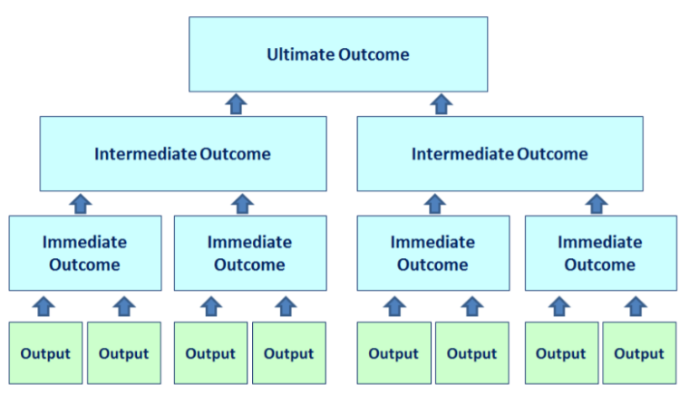

Annex 10b: Gender Equality Outcome Examples
Session Ten

Ultimate Outcome | Improved realization of the right to quality MNCH care for women, in poor rural areas of X, Y, and Z regions.
Intermediate Outcome | Strengthened local government policy commitments and programs to prevent and respond to gender-based violence and rights violations in selected rural communities.
 | Increased meaningful participation of women in community-level health system decision making.
 | Increased agency among adolescent girls related to sexual and reproductive healthcare and decision-making.
Immediate Outcome | Strengthened skills in advocacy, negotiation, and management for participation in democratic or community management bodies for women’s rights organizations.
 | Increased knowledge of and capacity for supporting women’s political rights amongst men and boys.
 | Increased knowledge of adolescent girls and boys about sexual and reproductive health and rights, including consent, contraceptives, gender-based violence and gender equality.

Annex 10c: Logic Model Handout
Session Ten
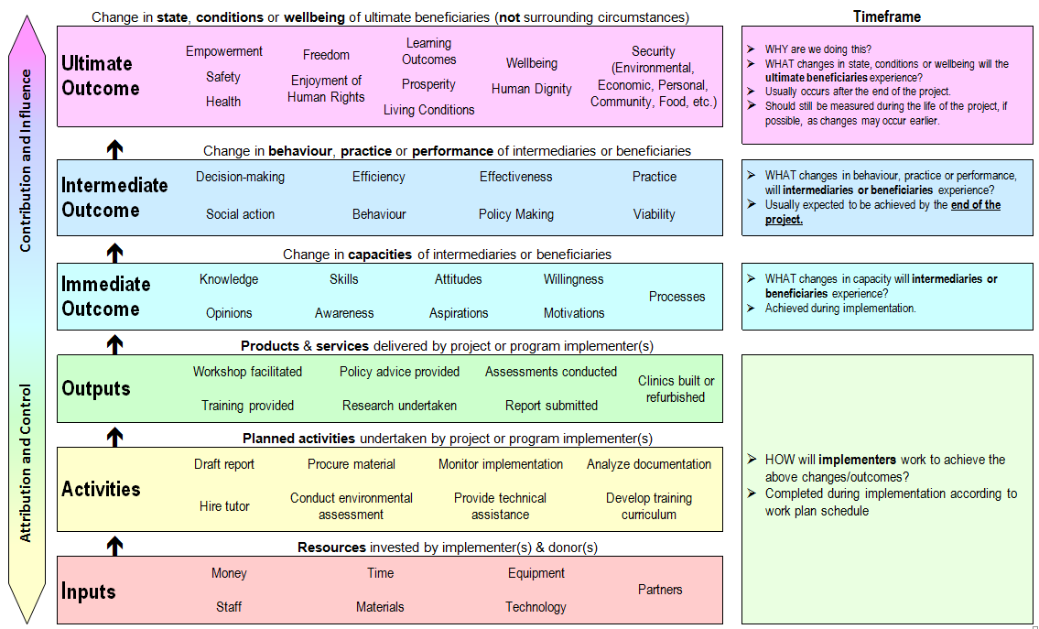

Annex 10d: Blank Logic Model Example
Session Ten
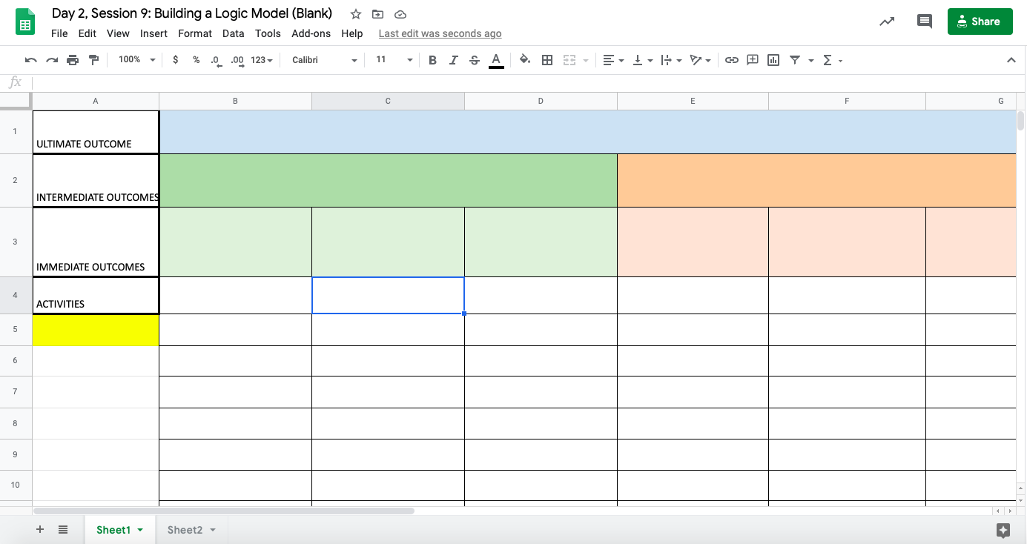

Session 11: Implementation—Planning for Transformative Change
Session Eleven
Learning Objective | Participants should understand the implications (needs, challenges and risks) of gender transformative programming for key areas of implementation.
Key Messages | - Achieving change in attitudes, social norms, and behaviours, takes time, skills and investment.  - The risks of poorly implementing gender transformative programming cause unintentional harm to women and girls.  - Supporting the implementation of gender transformative programming requires a collaborative effort between budget managers, program managers, and technical staff.
Facilitator’s Notes | - Take the time to explain Activity 1 and ensure folks are on the same page as to avoid confusion and make the most out of their learning
Duration | 85 minutes
Activities | - Introduction (5 minutes)  - Activity 1: Planning for Transformative Change (30 minutes)  - Activity 2: Refine our logic models (30 minutes)  - Wrap-up (20 minutes)
Resources | - Participant Resource Package  - PowerPoint
Technology | - PowerPoint presentation  - Zoom  - Mural

Process
Session Eleven

# | Facilitator Steps | Technology Support
 | Explain to the group that you will now be exploring some of the needs and challenges of implementing gender transformative programs.  Ask who in the room has participated in the development of a Project Implementation Plan (PIP)? Many participants will be familiar with this document, some others may not.  Ask participants to explain what are some of the pieces of information essential for a PIP?  Explain: The ‘PIP’ is the document created by an organization after a project has been approved. It asks the team to revisit and validate the original project design, to update and adjust as needed, and to create a detailed plan as to how, when and with what resources each outcome will be achieved. | - Start the PowerPoint and share the screen.  - Progress through the accompanying slide(s).  - Follow the cues from the Facilitator when to switch slides.
 | Refer participant’s to Session 11 in their Participant Resource Package where they will find a sample of a PIP contents page.  Explain that to simplify for this exercise, you will focus on three elements of implementation planning:  - budget;  - workplan/timeline;  - human resources.  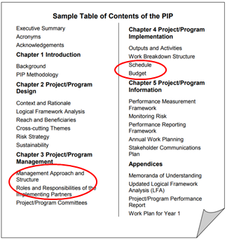  Session Eleven | - Ensure Zoom gallery view in plenary is on for this group discussion
Activity 1: Implementation—Planning for Transformative Change

 | Next, present the considerations for the three elements of implementation planning that they will be working with (these can be left up on the screen during the activity):  - Budget: What are some of the budgetary requirements and challenges in making sure this project is gender transformative?  - Workplan/timeline: What kind of change is expected? How does that happen and how long does it take?  - Human Resources: What are the skills needed? How can the project ensure sufficient skills to make sure the transformative objectives are achieved?  Facilitators Note: These elements are usually connected! Participants shouldn’t feel pressured for their discussions to stay in neat categories. For example, the need for expertise in social and behaviour change communication has implications for human resources, budget – and even timelines, when considering the trainings needed for staff at the beginning of a project. | - Progress through accompanying slide(s)
 | Share the case studies and explain that each group will be reviewing a case study of a gender transformative program. Explain that in their groups, they will:  - Consider their project design and in particular, pick out at least 3 gender transformative elements: activities or parts of the intervention that really make it transformative. (for example, an advocacy campaign or training)  - Under the headings ‘Needs’ and ‘Risks’, each group will identify some of the needs and risks associated with ensuring sufficient budget, time and skilled human resources required to successfully execute their gender transformative project.  Introduce the 2 case studies project designs (Annex 11a) that they’ll be working with.  Before they get started on their work, ask participants to recall the discussion we had on Day 1 about a rights-based approach being equally important to implementation and processes. Show them the box from Session 7 and ask them to ensure they integrate these discussions into their analysis.  Equality and non-discrimination: All individuals are equal as human beings and entitled to human rights, without discrimination of any kind.  Participation and inclusion: All individuals are entitled to active, free, and meaningful participation in, contribution to, and enjoyment of civil, political, economic, social, and cultural development. The voices and interests of affected individuals are taken into account on issues that concern them and the development of their society.  Transparency and accountability: Individuals have access to information on policies, decisions and use of funds, and are empowered to hold those who have a duty to act accountable. State and non-State actors comply with their applicable obligations and responsibilities.  (https://www.international.gc.ca/world-monde/issues_development-enjeux_developpement/priorities-priorites/human_rights-droits_personne.aspx?lang=eng) | Session Eleven  - Progress through accompanying slide(s)
 | Ask groups to nominate a note-taker for their group – or if they prefer, they can all contribute to the Mural at the same time. Give each group 20 minutes to discuss and take notes.  In order to execute this activity, direct participants to Activity 11.1 in their Participant Resource Package. They will find which group they’re in along with which case study they’re assigned. They will find the case studies in Annex 11a of their Participant Resource Package.  As the facilitator, move between the groups to support the groups, but also to take some notes and prepare for to present your insights and interpretation in the next step. | Session Eleven  - Move participants to their Zoom break-out rooms based on the pre-determined groups  - Keep an eye out for participants who are in need of help to assist with inquiries  - Move the facilitator in and out of the 3 groups to ensure participants are on the right track.  - Share the Mural links in the Zoom chat
 | Bring the groups back to plenary. As the facilitator, bring up each MURAL in turn and provide some insights based on the following questions: What are some of the similar needs/risks across the different projects?  Finally, ask the group to consider: Based on the complex interconnection between these implementation elements for GT programming, whose responsibility is gender equality throughout project implementation? | Session Eleven  - Progress through accompanying slide(s)
Activity 2: Let’s refine our Logic Models!

 | Give each group 30 minutes to go back into their Problem Tree/Logic Model groups. They will be automatically moved into their groups using the Zoom break-out room feature.  Within their groups, they are going to have 30 minutes to further flesh out their logic models based on this session. Guide participants to Activity 11.2 in their Participant Resource Package, along to Annex 11b where they will find Global Affairs Canada’s Gender Equality Marker to help further refine their Logic Model.  Remind participants that they do not have to create a full logic model, but just to carry down one stream into activities! | - Progress through accompanying slide(s)  - (Note: it is advised to put a break of some sort – lunch or 15 minutes – between these 2 group activities)
 | Close the session by returning to the key messages:  - Achieving change in attitudes, social norms, and behaviours, takes time, skills and investment.  - The risks of poorly implementing gender transformative programming is the potential to cause unintentional harm to women and girls, and perpetuate gender discriminatory norms.  - Supporting the implementation of gender transformative programming requires a collaborative effort between budget managers, program managers, and technical staff. | - Progress through accompanying slide(s)

Annexes
Session Eleven
Session Eleven

Annex 11a: Project Case Studies for Implementation Exercise

Case Study #1

Project Name | My Choice for My Life
Location | Amhara and SNNPR, Ethiopia | Implementing Organization and Partners | Plan International (Ethiopia and Canada) & 2 local NGOs
Duration | 5 years | Budget | $8,190,000 CAD
Ultimate Outcome | Contribute to the reduction of child early forced marriage and poor sexual reproductive health outcomes for adolescent girls and boys, in the targeted regions in Amhara and SNNPR
Project Description | MC4ML takes a gender transformative approach by targeting the gender-related root causes of CEFM and poor SRH outcomes for adolescent girls and boys, with a particular focus on girls. It takes a three-streamed approach for the achievement of the ultimate outcome by:  - building the agency of adolescent girls to use SRH services and delay marriage;  - improving the quality, gender-responsiveness and adolescent friendliness of SRH services and protection services;  - enhancing institutional responsiveness to the SRHR and protection needs of adolescent girls and boys.  In order to build agency and improve gender responsiveness of services and systems, the project relies heavily not only on targeting and building the knowledge and capacity of individual adolescent girls, but also on creating an enabling environment for transformative change by working with communities and institutional stakeholders to change social norms related to ASRHR and CEFM, and in particular gender equality.  - Activities to support these objectives target a variety of stakeholders with trainings and engagement to transform attitudes and practices related to gender equality and in support of adolescent girls’ agency.  - This includes prolonged engagement through training of girls themselves on life skills and ASRHR, and adolescent boys on positive masculinities and ASRHR.  - Parents and caregivers are engaged and participate in supportive programs to create an enabling environment for girls’ rights, as well as religious and community leaders.  - A social behaviour change communication (SBCC) strategy will be developed to support the design and production of targeted and accessible gender transformative messages and materials that address gender inequality, ASRHR, and early marriage.  - Health serve providers and those in the child protection system receive training and supportive supervision to improve the delivery of services and referral mechanisms.  - Health and protection system data management will be strengthened to provide stronger evidence-based decisions, greater accountability, and provide more accurate information to advocate for more gender responsive policy and implementation.
Session Eleven

Session Eleven
Case Study #2

Project Name | SHE SUCCEEDS: Empowering young Palestinian women entrepreneurs in the agriculture sector
Location | West Bank & Gaza Strip | Implementing Organization and Partners | Save the Children (SC), MA’AN Development Center,  Palestinian Agriculture Relief Committee (PARC)
Duration | 4 years | Budget | $8,000,000 CAD
Ultimate Outcome | Enhanced economic empowerment and increased prosperity for low-income young women ages 15-29 in the West Bank and Gaza
Project Description | This gender-transformative project responds to the gender-based social, economic and institutional barriers which hinder young women’s entrepreneurship opportunities in the agriculture sector. The project works to advance gender equality through the following three pillars for economic empowerment:  SHE LEARNS reduces the educational gender-based barriers to entrepreneurship faced by young women.  - This pillar builds young women’s transferable life skills and self-efficacy in business, as well as technical skills and knowledge on agri-based entrepreneurship and green innovations.  - Entrepreneurship training programs in secondary schools, TVETs, universities, and informal community-based organizations are strengthened to be gender-responsive and practice-based.  - This includes strengthening entrepreneurship curricular materials; building the capacity of local educators on gender-responsive pedagogies and to self-reflect on their own gender-biases and be critically aware of gender barriers for young women entrepreneurs; establishing gender-responsive Enterprise Units with TVETs and universities; and developing improvement plans with educational institutions to ensure young women’s meaningful participation in entrepreneurship training programs.  - Examples of improvement plans include establishing child care facilities, establishing gender equality policies, and mobilizing young women’s representation in governance structures.  SHE CONNECTS addresses the gender-based economic and financial barriers to entrepreneurship faced by female youth and strengthens the sustainable business development, green innovations and income generation of young women and female-led cooperatives.  - This is achieved by increasing young women’s and female-led cooperatives’ access and control of diversified financial and productive assets, and strengthening the gender-responsiveness of entrepreneurship extension services and linkages to local and international markets.  - Activities include assessing and strengthening local agri-incubators’ operations and staffing capacities, as well as establishing child care facilities; recruiting female staff; and coordinating a gender-matched mentorship and support groups with successful women entrepreneurs as role models.  SHE LEADS shifts the gender-based social and institutional barriers to entrepreneurship faced by female youth.  - Young women and young men are enabled to identify and respond to key gender-based barriers and discriminatory gender norms themselves.  - The project conducts a social norms diagnostic to identify key discriminatory norms and behaviours against young women’s business development and the gatekeepers who reinforce these norms.  - Community-based gender equality champions and youth advocacy groups are established to lead social behaviour change communication activities with targeted family and community gatekeepers, including strong engagement of men and boys.  - At the same time, youth advocacy groups partner with SC to develop national advocacy campaigns targeting the Chambers of Commerce and other government stakeholders to strengthen an institutional business enabling environment by addressing gender stereotypes and barriers to female entrepreneurship.  - Campaigns focus on improving the gender-responsiveness of COC’s business registration & licensing processes; young women’s membership and leadership; and their gender units.  - The project has also instituted a Female Youth Committee (FYC) as part of its governance structure to enable young women participants’ leadership and voice in the project implementation, monitoring and learnings.
Session Eleven

Annex 11b: Global Affairs Canada’s Gender Equality Marker
Session Eleven

Tool 9: Gender Equality Coding for Initiatives
(taken directly from GAC’s website)

GAC’s Feminist International Assistance Policy (FIAP) commits that by 2021-22, no less than 95 percent of Canada’s bilateral international development assistance initiatives will target or integrate gender equality and the empowerment of women and girls. This includes 15 percent of investments specifically targeting gender equality and the empowerment of women and girls, with the remaining 80 percent integrating these goals across all international assistance efforts.
This tool provides further information on GAC’s Gender Equality (GE) coding framework and the internal GE assessment form.
GAC’s Gender Equality coding framework assigns a GE code in relation to a project’s intended contribution to advancing gender equality and the empowerment of women and girls.
GAC’s GE codes cover a spectrum from GE-0 to GE-3 (see table below). GAC GE coding requirements and definitions are based on results-based management (RBM) logic and practice, including the theory of change. Gender Equality results or outcomes are measurable changes that explicitly address a reduction in gender inequality, or an improvement in gender equality between women and men, boys and girls.
Each proposed project is assessed using GAC’s internal Gender Equality Assessment Form as an initial step in the due diligence process. A GE code is assigned using the table below.

Gender Equality Code | Explanation of GE coding:
GE-3 | Targeted - Gender equality is the principal objective of the initiative: The initiative was designed specifically to address gender inequalities and would not otherwise be undertaken. All outcomes in the logic model are gender equality outcomes.
GE-2 | Fully integrated -There is at least one intermediate gender equality outcome which will achieve observable changes in behaviour, practice, or performance that will contribute to gender equality.
GE-1 | Partially integrated - There is at least one gender equality outcome at the immediate outcome level which will achieve a change in skills, awareness, or knowledge that contributes to gender equality.
GE-0 | None - There are no gender equality outcomes.
Session Eleven
Session Eleven
The types of change associated with each gender equality code are aligned to the levels of change in GAC’s Results Based Management logic model.
A gender equality specific and targeted project (GE 3) means that all the outcomes at all levels are exclusively focussed on addressing gender inequalities to advance women’s and girls’ equal participation with men in decision-making; to support the full realization of women’s and girls’ human rights; and/or to reduce gender inequalities in access to and control over resources and benefits of development.
A gender equality fully integrated project (GE 2) means that the project has identified at least one intermediate outcome that aims to achieve long term transformational change for gender equality that will be sustained after the project ends.
A gender equality partially integrated project (GE 1) means that the project has identified at least one immediate outcome that aims for short term changes in gender equality related to knowledge, awareness or skills. These changes are not expected to be sustainable over the long term.
Since initiatives are assessed at the proposal stage, a project can be strengthened after approval when developing the Project Implementation Plan (PIP). The GE Assessment Form often includes suggested follow-up actions to strengthen GE in the project. In many cases, however, an initiative designed to integrate gender equality cannot be strengthened to become one that specifically targets gender inequalities without a redesign of the initiative.
International Reporting on Gender Equality
Session Eleven

The OECD-DAC analyzes its member’s (bilateral development assistance agencies) level of investments that promote gender equality. The OECD-DAC relies on reporting from members that use a gender equality coding or marker system. GAC’s GE codes are rolled up for annual international reporting to OECD-DAC as part of the GAC’s accountability process.

The following table shows how GAC GE coding is mapped to OECD GE policy marker:

GAC GE Policy Marker
GE-03 Targeted | Targeted - Gender equality is the principal objective of the initiative: The initiative was designed specifically to address gender inequalities and would not otherwise be undertaken. All outcomes in the logic model are gender equality outcomes.
GE-02 Full Integration | Fully integrated -There is at least one intermediate gender equality outcome which will achieve observable changes in behaviour, practice, or performance that will contribute to gender equality.
GE-01 Partial Integration | Partially integrated - There is at least one gender equality outcome at the immediate outcome level which will achieve a change in skills, awareness, or knowledge that contributes to gender equality.
GE-0 None | No gender equality outcomes
OECD DAC GE Policy Marker
GE-02 Principal | Gender equality is the main objective of the project/program and is fundamental in its design and expected results. The project/program would not have been undertaken without this objective.
GE-01 Significant | Gender equality is an important and deliberate objective, but not the principal reason for undertaking the project/program.
GE-0 Not Targeted | The project/program has been screened against the gender marker but has not been found to target gender equality.
For more information on the minimum standards for the gender equality policy marker, refer to OECD.

http://www.globalization101.org/negative-vs-positive-rights/
https://www.ohchr.org/EN/UDHR/Documents/UDHR_Translations/eng.pdf
2016, Global Affairs Canada: Results Based Management Guide (https://www.international.gc.ca/world-monde/assets/pdfs/funding-financement/results_based_management-gestion_axee_resultats-guide-en.pdf)
http://www.appian.ca/Appian%20Library/PIP%20Guide.pdf
https://www.international.gc.ca/world-monde/funding-financement/gender_equality_toolkit-trousse_outils_egalite_genres.aspx?lang=eng#tool_9

