Building Capacity and Confidence in Gender Transformative Programming
A Virtual Learning Experience

Module 2 – Participant Resource Package

Table of Contents
Table of Contents
Session 6: Gender in the Project Cycle 4
Activity 6.1 Instructions: Gender in the Project Cycle 4
Project Cycle Diagram 4
Session 7: Problem Analysis from a Gender Perspective 5
Problem Tree Analysis 5
Activity 7.1 Instructions: Problem Tree 6
Annex 7a: Health Programming Problem Examples 8
Annex 7b: Problem Tree Examples on Mural 9
Session 8: Understanding a Rights-Based Approach to Gender Equality 10
Annex 8a: Positive/Negative Rights 10
Annex 8b: Human Rights Normative Framework 12
Human Rights-based Approach 13
Activity 8.1 Instruments: Rights-based or Instrumentalist? Vote with your picture! 14
Activity Instructions 14
Annex 8c: Rights-based or Instrumentalist? Vote with your picture! 16
Activity 8.3 Instructions: Problem Statement 17
Session 9: A Holistic Approach - Understanding the environmental factors of inequality 18
The socio-ecological model 18
Activity 9.1 Instructions: Understanding the environmental factors of inequality 20
Session 10: Towards Design for Gender Equality—Gender Aware and Gender Transformative Theories of Change and Logic Models 22
Annex 10a: Results Based Management Refresher 22
Gender Equality Outcomes 24
Annex 10b: Gender Equality Outcome Examples 25
Activity 10.1 Instructions: Building a Logic Model 26
Table of Contents
Annex 10c: Logic Model Handout 28
Table of Contents
Annex 10d: Blank Logic Model Example 29
Session 11: Implementation—Planning for Transformative Change 30
Activity 11.1: Implementation Instructions—Planning for Transformative Change 31
Annex 11a: Project Case Studies for Implementation Exercise 34
Activity 11.2: Let’s refine our Logic Model! 38
Annex 11b: Global Affairs Canada’s Gender Equality Marker 39

Session 6: Gender in the Project Cycle
Session Six

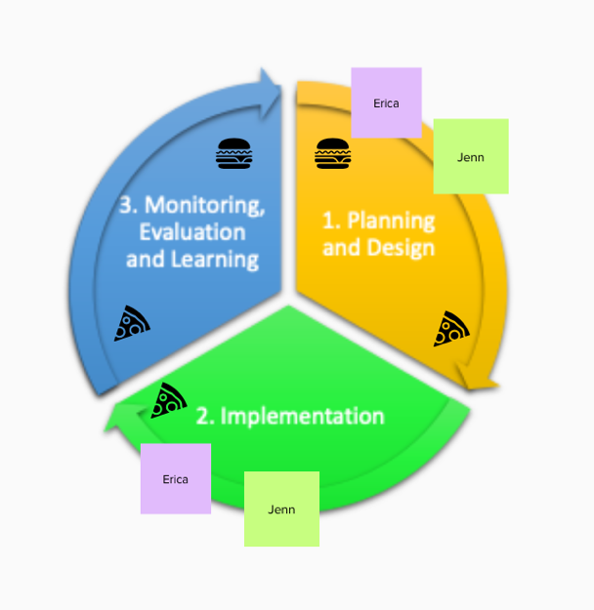
Activity 6.1 Instructions: Gender in the Project Cycle

- Plenary activity: go to the following Mural link: [insert Mural link]
- You will find a MURAL that looks similar to this ------------>
- Once online, choose an icon or sticky-note to represent yourself on Mural.
- Move your icon or sticky-note to the part of the project cycle where you do most of your work.
- Move a second of the same icon or sticky-note to the part where you are most interested in learning about gender transformative programming.

Note: If your role does not fit into the project cycle, grab a sticky-note and write your position on it. Think about how the training applies to your work.

Project Cycle Diagram
Session Six
Session Six

Session 7: Problem Analysis from a Gender Perspective
Session Seven

Problem Tree Analysis

Problem Tree Analysis is central to many forms of planning. Problem tree analysis is a group exercise that helps to find solutions by mapping out causes and effects around an issue.

- The first step is to discuss and agree the problem or issue to be analyzed. The problem or issue is written in the center of the flip chart and becomes the ‘trunk’ of the tree. This becomes the ‘focal problem’.
- Next, the group identifies the causes of the focal problem, these become the roots, and then identify the consequences, which become the branches. For this exercise, the focus will be on the roots or causes of the problem.
- The heart of the exercise is the discussion, debate and dialogue that is generated as factors are arranged and re-arranged, often forming sub-dividing roots and branches.
- The problem tree can be converted into an objectives tree by rephrasing each of the problems into positive desirable outcomes – as if the problem had already been solved. In this way, root causes are turned into root solutions.
Tip! To get to the bottom of the root, participants need to keep asking ‘why?’ at every level, until the problem is brought down to the core causes.

Activity 7.1 Instructions: Problem Tree
Session Seven

- Take approximately 3 minutes to yourself to brainstorm 1 – 2 gender-related problem that identifies a negative outcome or effect. See Annex 7a for examples.
    - For example, an organization that works in adolescent health might choose: ‘high rates of teenage pregnancy amongst girls’ as a problem.
    - For example, an organization that works in maternal newborn and child health might say ‘high unmet need for post-partum family planning.’
    - Make sure these are high-level problems, meaning that the problem is one that identifies

This activity will take 30 minutes, and you will be divided into groups where you must agree on one problem that you are going to work with to build your Problem Trees. You will automatically move into Zoom break-out rooms based on the assigned groups below:

Group 1 | Group 2 | Group 3
MURAL link: [insert Mural link] | MURAL link: [insert Mural link] | MURAL link: [insert Mural link]
- Populate Participant Names | - Populate Participant Names | - Populate Participant Names

- For this activity, you will be using the interactive digital tool MURAL to create your Problem Trees online. You will have approximately 30 minutes for this activity.
Session Seven
- MURAL allows you to use post-it notes so that you can re-arrange and re-write your ‘causes’ throughout the discussion, and you can also use colours and symbols to help organize your thoughts.
Session Seven
    - You will have to add context to your problem in order to build your analysis. You can choose a location, some of the contextual elements, etc.
    - Where you come across contextual questions, you can agree on an approach to your analysis that allows your group to move forward.

Tip! Focus on the gender-related causes of the problems’ or consequences of the problem. This activity focuses on the causes, or ‘roots’ of the problem. For example, high rates of teenage pregnancy are driven by many factors or causes – these can include factors like insufficient supply of contraceptives or poor knowledge of sexual and reproductive health of adolescent girls and boys. Examine what the gendered aspects of these causes are – for example, limited accessibility to contraceptives specifically for adolescent girls, and the gendered myths and stigma about pregnancy prevention and contraception.

- To help explore the gendered aspects of each problem, ask yourself:
    - Does the position of women and girls influence this problem?
    - What strategic or practical needs are absent and contributing to this problem?
    - How is intersectionality contributing these causes and to the problem?

Remember! The facilitator will be “popping in” to your groups to provide support, but if you need immediate attention there is a “help” button you can press to signal immediate support.

Annex 7a: Health Programming Problem Examples
Session Seven

- High levels of teenage pregnancy amongst rural, out-of-school girls in region X of country X.

- High levels of sexual and gender-based violence amongst women sex workers in X city.

- High prevalence of malnutrition amongst female children in region X of country X.

- High levels of HIV infection amongst male prostitutes in X community.

- High levels of maternal mortality amongst women residents in X refugee camp.

Annex 7b: Problem Tree Examples on Mural
Session Seven

Blank Example  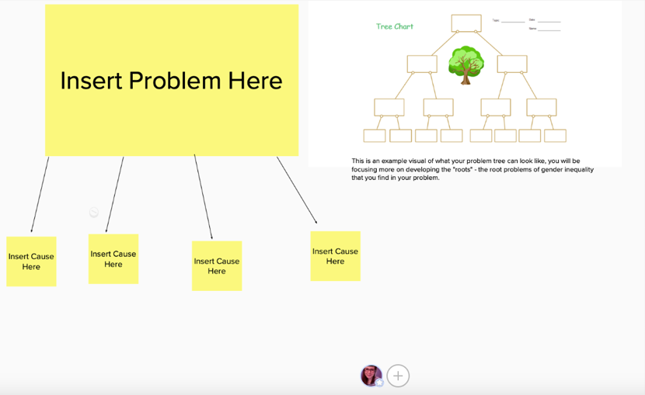 | Complete Example  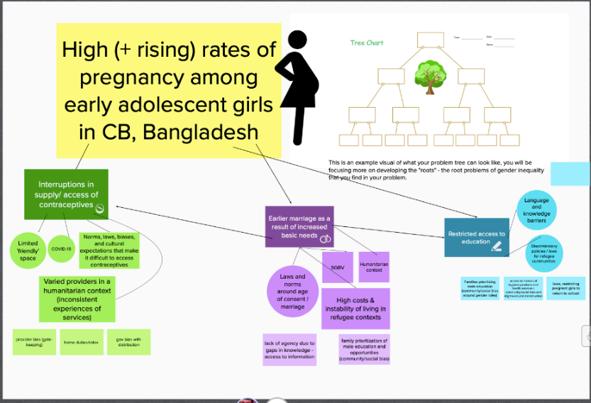

Session 8: Understanding a Rights-Based Approach to Gender Equality

Session Eight
Session Eight
Rights | Rights are legal, social, or ethical principles of freedom or entitlement; that is, rights are the fundamental normative rules about what is allowed of people or owed to people according to some legal system, social convention, or ethical theory.

Annex 8a: Positive/Negative Rights

“Philosophers and political theorists make a distinction between negative and positive rights. A negative right is a right not to be subjected to an action of another person or group; negative rights permit or oblige inaction. A positive right is a right to be subjected to an action or another person or group; positive rights permit or oblige action.”

In other words, negative rights require no action on anyone’s behalf – the duty is in the absence of action. Positive rights require the action of a duty-bearer, usually the state.

Take the Universal Declaration of Human Rights as an example.

NEGATIVE RIGHTS

Article 4 | No one shall be held in slavery or servitude; slavery and the slave trade shall be prohibited in all their forms.
Article 13 (1,3) | Everyone has the right to freedom of movement and residence within the borders of each State. Everyone has the right to leave any country, including his own, and to return to his country.
Article 18 | Everyone has the right to freedom of thought, conscience and religion; this right includes freedom to change his religion or belief, and freedom, either alone or in community with others and in public or private, to manifest his religion or belief in teaching, practice, worship and observance.
Session Eight

POSITIVE RIGHTS

Article 8 | Everyone has the right to an effective remedy by the competent national tribunals for acts violating the fundamental rights granted him by the constitution or by law.
Article 21 (1) | Everyone has the right to take part in the government of his country, directly or through freely chosen representatives.
Article 26 (1) | Everyone has the right to education. Education shall be free, at least in the elementary and fundamental stages. Elementary education shall be compulsory. Technical and professional education shall be made generally available and higher education shall be equally accessible to all on the basis of merit.

Annex 8b: Human Rights Normative Framework
Session Eight

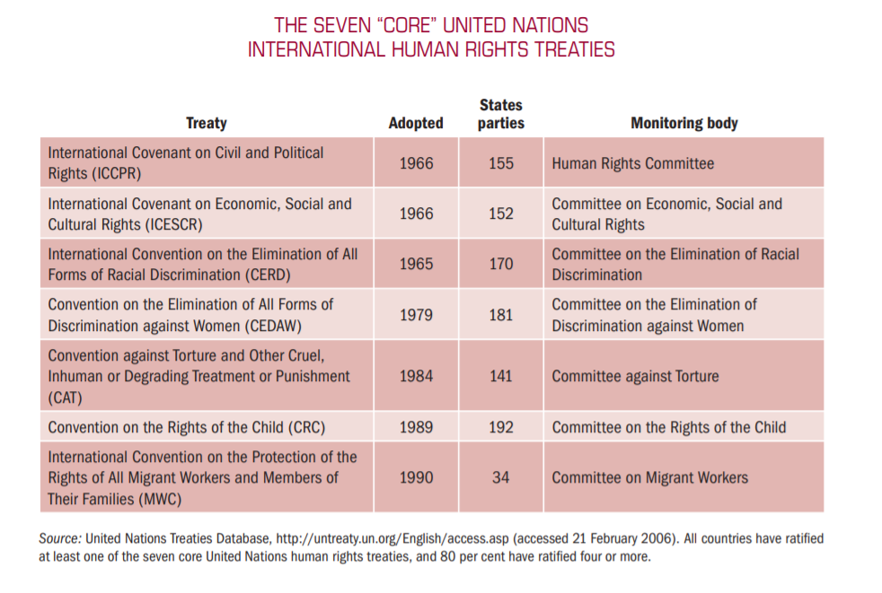
Session Eight

Human Rights-based Approach

The UN defines a human rights-based approach as:

“A human rights-based approach is a conceptual framework for the process of human development that is normatively based on international human rights standards and operationally directed to promoting and protecting human rights. It seeks to analyse inequalities which lie at the heart of development problems and redress discriminatory practices and unjust distributions of power that impede development progress.” – FAQ on HRBA, OHCHR, pg. 16
According to GAC:

“A human rights-based approach to international assistance is a tool to help countries meet their human rights obligations and assist people in knowing their human rights and the processes available to claim them. In doing so, it seeks to achieve equitable and sustainable results. It reinforces a feminist approach, as human rights are at the foundation of gender equality and the empowerment of women and girls.”

Instrumentalist Approach

An instrumentalist approach can be understood by asking:

“if this problem is solved, what additional external benefits will be seen by others (i.e., community, economy, etc.)”?

An instrumentalist approach to gender equality sees it as a means to the achievement of other goals, such as economic development or sustainable peace and security. An instrumentalist approach to gender equality has often been used to gain support from a wider constituency. Ask participants if they can think of some examples.

- “When you educate a girl, national GDP increases by XX %”;
- “Maternal and infant mortality rates decrease when women have agency to make health-related decisions.”
- “When women can own and run businesses, the whole economy grows”;
- “Sustainable peace is more achievable when women are active participants in discussions”
The UN Office for the High Commission on Human Rights describes it like this:

“There are two main rationales for a human rights-based approach: (a) the intrinsic rationale, acknowledging that a human rights-based approach is the right thing to do, morally or legally; and (b) the instrumental rationale, recognizing that a human rights-based approach leads to better and more sustainable human development outcomes. In practice, the reason for pursuing a human rights-based approach is usually a blend of these two.” – FAQ on HRBA, OHCHR, pg. 16

Activity 8.1 Instruments: Rights-based or Instrumentalist? Vote with your picture!
Session Eight

Activity Instructions

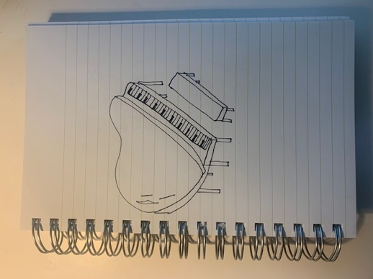
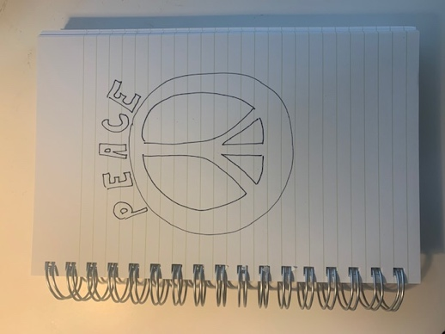
- We’re going to take 10 minutes for an interactive activity to help explore the meaning of human rights-base approach vs. instrumentalist approach.

- Get two detached sheets of paper (preferably blank) and a writing utensil (preferably a black or dark marker).

- On one sheet of paper, draw an ‘instrument’ of your choice (for example: a guitar or a trumpet)

- On the other sheet of paper, draw a picture that signifies human rights (for example: a dove or the peace symbol)

- Take 5 minutes to complete your drawings. Take this time to also stand/stretch/etc.

- Once complete, the facilitator is going to read out different statements.

- As each statement is read out loud, you are to decide if the statement takes a human rights-based approach or an instrumentalist approach.

- Hold the drawing of either the human rights-based approach or the instrumentalist approach to the camera depending on the approach you believe the statement takes:

- If you believe the statement takes an instrumentalist approach, hold up the drawing of the instrument to the camera.
- If you believe the statement takes a human rights-based approach, hold up the drawing of the human rights symbol to the camera.

Session Eight
Session Eight

A defining feature of a human rights-based approach is that the realization of rights is not only at the core of the rationale for an intervention, but its principles must guide all stages of implementation

Equality and non-discrimination: All individuals are equal as human beings and entitled to human rights, without discrimination of any kind.

Participation and inclusion: All individuals are entitled to active, free, and meaningful participation in, contribution to, and enjoyment of civil, political, economic, social, and cultural development. The voices and interests of affected individuals are taken into account on issues that concern them and the development of their society.

Transparency and accountability: Individuals have access to information on policies, decisions and use of funds, and are empowered to hold those who have a duty to act accountable. State and non-State actors comply with their applicable obligations and responsibilities.

(https://www.international.gc.ca/world-monde/issues_development-enjeux_developpement/priorities-priorites/human_rights-droits_personne.aspx?lang=eng)

Annex 8c: Rights-based or Instrumentalist? Vote with your picture!
Session Eight

- “Women will decide whether, when, how many and with whom to have children”
- “Inheritance laws must be equal for men and women for women to achieve economic development”
- “When women can own and run businesses, the whole economy grows”;
- “Women’s unpaid labour must be recognized in economic analysis and planning”

- “Sustainable peace is more achievable when women are active participants in discussions”

Activity 8.3 Instructions: Problem Statement
Session Eight

- You will be moved into your groups from the earlier Problem Trees activity via the Zoom break-out session feature. See below:

Group 1 | Group 2 | Group 3
MURAL link: [insert Mural link] | MURAL link: [insert Mural link] | MURAL link: [insert Mural link]
- Populate Participant Names | - Populate Participant Names | - Populate Participant Names

- Have a discussion as a group and think about the following questions:
  - Have you taken a ‘human rights-based’ approach to your analysis?
  - What rights are associated with the gender-related problem you identified?
  - For your main problem statement, identify what ‘rights’ are being insufficiently fulfilled or violated.

- Take 10 minutes to discuss and make any changes or additions to your group’s problem via the MURAL link provided.

Session 9: A Holistic Approach - Understanding the environmental factors of inequality
Session Nine

The socio-ecological model

A way to analyze and organize different ‘levels’ of influence, and how environmental factor shape and are shaped by social phenomena, like gender inequality.

This model is often used in public health and development programming, and more broadly as a social analysis tool in many sectors. The model can be presented using different terms for each level, or with greater detail or ‘sub-levels’, however the purpose is the same: to place the individual at the center of the analysis and to examine the various influencing factors surrounding the individual. Briefly, invite participants to share their own experience using similar models in their work.
Session Nine

Explanations for the different levels:

- Individual. This refers to the primary subject or focus of your project or study. Sometimes, in the language of human rights, this would be referred as the ‘rights holder’.

- Relationship. This level includes those people with whom the individual has a direct relationship – it is sometimes called ‘interpersonal’. It can include spouses or partners, children and other family members, friends and colleagues. Most often, factors at this level describe family or household dynamics.

- Community. This level extends into the surrounding community and includes social norms and institutions that define and shape community interactions. This can include religious institutions and cultural norms, commercial activity and educational activities.

- Societal (Policy). This level refers to the governance and systems established to provide services, write and enforce laws, protect and defend rights, etc. In the language of human rights, this level would refer to the state as the ‘legal duty-bearer’.

Engaging men and boys! Engagement of men and boys is essential for gender transformative programming. Men and boys can be seen as both beneficiaries of gender transformative change, and as instrumental partners in gender transformative change for women and girls. Men and boys suffer from deep-seated gender norms related to toxic masculinity, including violence, risky behaviour, poor health and lack of emotional connectedness.

Activity 9.1 Instructions: Understanding the environmental factors of inequality
Session Nine

- Participants are to return to their “Problem Trees” and apply this model to their analysis.

- You will be moved into a Zoom break-out room based on your “Problem Tree” groups from earlier sessions. See below:

Group 1 | Group 2 | Group 3
MURAL link: [insert Mural link] | MURAL link: [insert Mural link] | MURAL link: [insert Mural link]
- Populate Participant Names | - Populate Participant Names | - Populate Participant Names

- Ask yourself:
    - What specific factors within the household and within interpersonal relationships are affecting different ‘root systems’ in our Problem Tree? Have we captured those factors?
    - How do community institutions and social norms at the community level either support equality or create barriers to the fulfillment of rights? Have we captured these specific elements in our Problem Tree?
    - How do government institutions and policy influence our problem? What systems-level factors influence this problem, and have we captured those in our analysis?

- Take 20 minutes to discuss and revise your group’s analysis.

- After 20 minutes, everyone will be moved back to plenary. Nominate one member in your group to share:
Session Nine

    - 1 part of their root system that addresses RIGHTS
    - 1 part of their root system that addresses an enabling environment
    - 1 part of their root system that looks at how gender intersects with other factors of identity to contribute to the issue

Session 10: Towards Design for Gender Equality—Gender Aware and Gender Transformative Theories of Change and Logic Models
Session Ten

Annex 10a: Results Based Management Refresher

What is Results Based Management?

RBM is a widely recognized approach to program/project management that emerged as a response to what was seen as an over-emphasis in development programming on activities rather than end results. RBM requires that you look beyond activities and outputs to focus on actual results (outcomes): the changes created by your programming and to which it has contributed.

The focus on activities at the expense of results is what management scholar Peter Drucker, in 1954, referred to as the “activity trap.” Instead, Results-Based Management requires that you look beyond activities and outputs to focus on actual results (outcomes): the changes to which your programming contributed. By establishing clearly defined expected results, assessing risk, collecting information to assess progress on them on a regular basis during implementation, and making timely adjustments, practitioners can manage their projects and programs better in order to maximize the achievement of results.

(https://www.international.gc.ca/world-monde/assets/pdfs/funding-financement/results_based_management-gestion_axee_resultats-guide-en.pdf)

The framework for RBM follows three principles, each with an associated tool:

- Knowing where you want to be, and plotting your path (Logic Model and Theory of Change)
- Knowing where you are along the journey (Performance Measurement Framework)
- Monitoring and adjusting what you do to ensure you reach your destination (Evidence Based Planning and Management).
A logic model is a visual depiction of the theory of change for a specific project, reflecting the series of changes that are critical to achieving project outcomes. It depicts the logical connections between the planned outputs and the expected outcomes that the project aims to achieve or contribute to. The Logic Model’s pyramid structure enables us to illustrate the complex nature of a program or project. Different intermediate outcomes represent different “pathways” leading to the same ultimate outcome.
Session Ten
Each level of the logic model explains the cause-and-effect relationship which is expected to occur within the project. In other words: if this set of outputs are accomplished, then this immediate outcome will be achieved; if these immediate outcomes are achieved, then this intermediate outcome will be achieved, and so on until the ultimate outcome level.

This relationship between different levels of results is called the ‘results chain’. Different organizations use different terminology to refer to different levels of outcomes, but generally they follow the same logic. Here we are using Global Affairs Canada’s guidance and terminology.

Each level of results should reflect the same types of change or outcomes, and these are described below. In addition, it is important to note that the further towards the ‘top’ or ultimate outcome of a project, the less control the project has over the achievement of the outcome. For example, a project has a HIGH level of control over the achievement of outputs – they are a completed activity for which the project is solely responsible and can occur in the short-term. However, intermediate level outcomes refer to changes in practice or behaviour, which is influenced by many external factors and individual preferences and opportunities, and ultimate outcomes are changes in state and occur over a longer period. The project will only contribute to the achievement of the ultimate outcome.

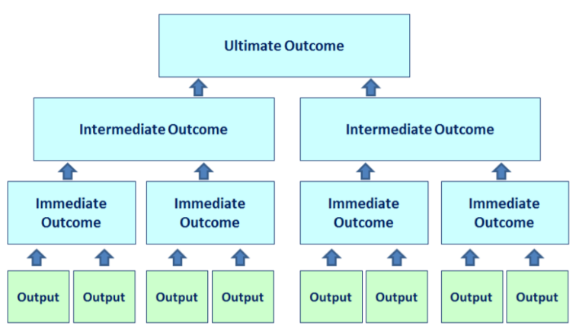

Gender Equality Outcomes
Session Ten

What elements does a gender equality outcome statement have?

- GE outcome statements explicitly describe an improvement or positive change related to gender equality
- GE outcome statements do not merely refer to ‘women and men’ or add ‘including girls’ to the stated result

Note: there is some debate about whether adding ‘especially women’ to a result statement qualifies it as a GE outcome. In these cases, it may be more useful to look at the nature of the result itself and whether it has the potential to empower beneficiaries. For example, the latter of the two following statements may more effectively qualify as a GE outcome than the former because of the nature of the change it describes.

- Improved access, especially for adolescent girls, to nutritionally diverse food sources.
- Increased decision-making power at the household level for adolescents, especially girls, related to food purchasing and consumption.

Why is this important throughout the Logic Model?

- Because it formalizes the intention of the project to affect positive change towards gender equality.
- Because elements that are included in outcome statements inform the monitoring and evaluation design of a project, the budget of the project, and the management design of a project.

Explicit GE outcomes ensure accountability for GE results. See the below table, Annex 10b, for some examples.

Annex 10b: Gender Equality Outcome Examples
Session Ten

Ultimate Outcome | - Improved realization of the right to quality MNCH care for women, in poor rural areas of X, Y, and Z regions.
Intermediate Outcome | - Strengthened local government policy commitments and programs to prevent and respond to gender-based violence and rights violations in selected rural communities.
 | - Increased meaningful participation of women in community-level health system decision making.
 | - Increased agency among adolescent girls related to sexual and reproductive healthcare and decision-making.
Immediate Outcome | - Strengthened skills in advocacy, negotiation, and management for participation in democratic or community management bodies for women’s rights organizations.
 | - Increased knowledge of and capacity for supporting women’s political rights amongst men and boys.
 | - Increased knowledge of adolescent girls and boys about sexual and reproductive health and rights, including consent, contraceptives, gender-based violence and gender equality.

Activity 10.1 Instructions: Building a Logic Model
Session Ten

- Find your group assignments:

Group 1 | Group 2 | Group 3
Google Sheet Link:  [insert google sheet link]  Problem Tree MURAL link:  [insert Mural link] | Google Sheet Link:  [insert google sheet link]  Problem Tree MURAL link:  [insert Mural link] | Google Sheet Link:  [insert google sheet link]  Problem Tree MURAL link:  [insert Mural link]
- Populate Participant Names | - Populate Participant Names | - Populate Participant Names

- Each group will now take their problem tree analysis and build a logic model that describes a project or program to respond to your problem analysis.

- Please see Annex 10c for an example of a Logic Model.

- As a group, you are to only focus on the top three levels of the LM: Ultimate Outcome, Intermediate Outcomes, Immediate Outcomes.

- Identify some activities for only one immediate outcome stream.
Session Ten

- Keep the following in mind:
Session Ten
  - The lessons from Module 1: What is gender transformative change?
  - How can the design reflect a human rights-based approach?
  - How can the change be sustained – at the household, community and systemic level?
  - Begin with the Ultimate Outcome, then design toward that goal, level by level

Note: Assumptions about context, partners and scope will need to be made to fill in gaps. Typically, detailed research and consultations would be conducted, and budget or timeline parameters would be provided – so as a group, you should agree on the assumptions in order to build your project design. Don’t get caught up on these missing pieces – focus on strong logic and design.

Reminder! Do not be concerned if your LM isn’t complete – it takes more time to design a good project! The value of this exercise is in the analysis, the discussion, and moving towards a greater understanding of how to strengthen gender equality within project design.

- This activity will take approximately 30 minutes and you will be moved back into your Zoom break-out group from session 7 where you designed your problem tree.

- You will use the blank Logic Model found on the Google Sheet link provided for your group above (see an example via Annex 10d) to create your own Logic Models responding to your analysis of the problem tree.

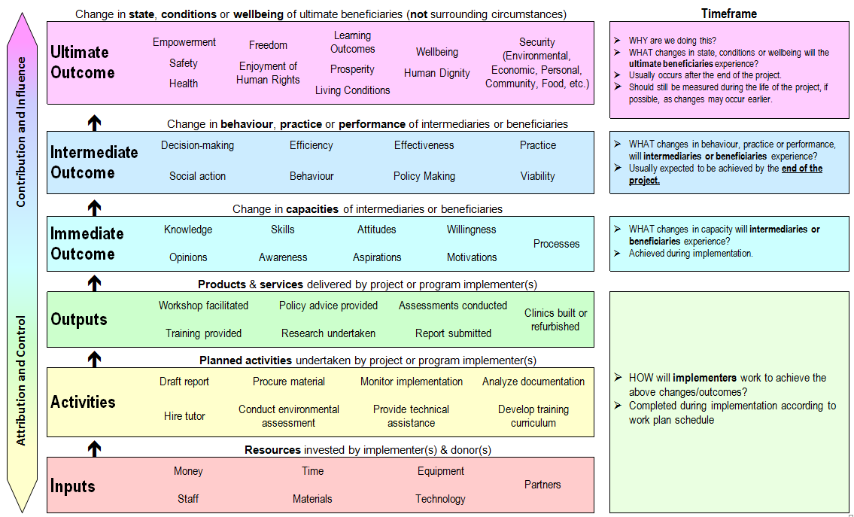
Annex 10c: Logic Model Handout
Session Ten

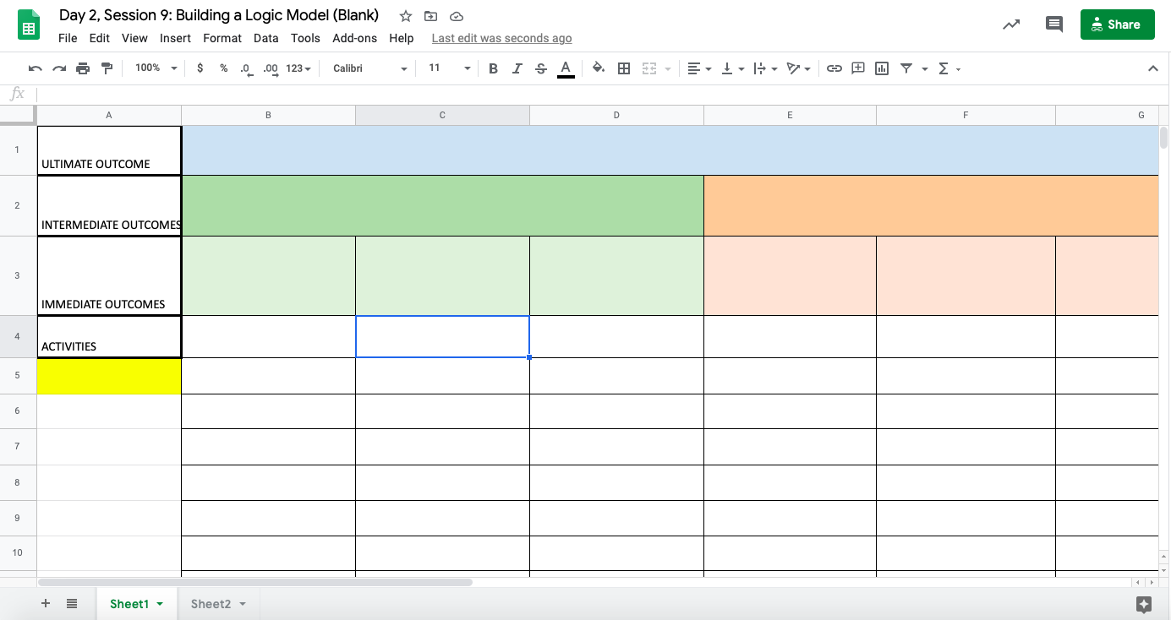
Annex 10d: Blank Logic Model Example
Session Ten

Session 11: Implementation—Planning for Transformative Change
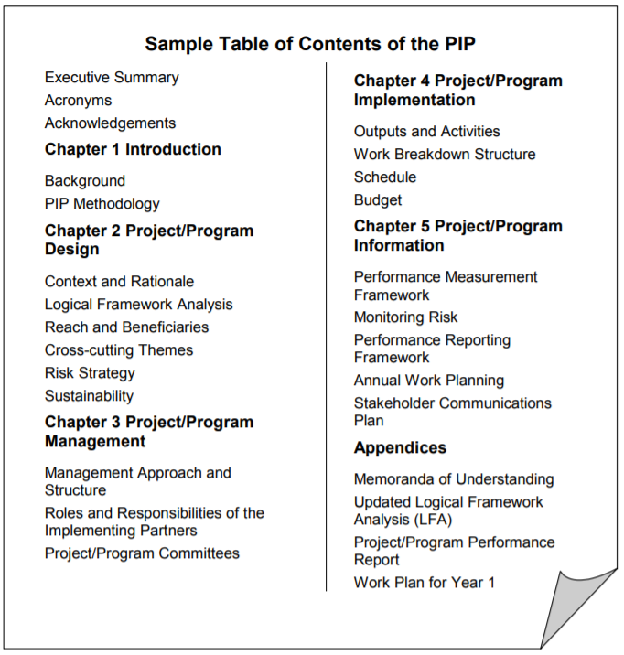
Session Eleven

Activity 11.1: Implementation Instructions—Planning for Transformative Change
Session Eleven

There are two case studies found below. Each group will be reviewing a case study of a gender transformative program.

- You will be moved into a Zoom break-out room based on the group assignments below:
Group 1 | Group 2
Case Study #1  MURAL link: [insert Mural link] | Case Study #2  MURAL link: [insert Mural link]
- Populate Participant Names | - Populate Participant Names

- In your group, you will consider case study project design and in particular the gender transformative elements.

- Consider the project design of your assigned case study and pick out at least 3 gender transformative elements: activities or parts of the intervention that really make it transformative (for example, an advocacy campaign or training).
- Under the headings “Needs” and “Risks”, you will identify some of the needs and risks associated with ensuring sufficient budget, time and skilled human resources required to successfully execute their gender transformative project.
Session Eleven

- Consider the three elements of implantation planning:

- Budget: What are some of the budgetary requirements and challenges in making sure this project is gender transformative?

- Workplan/timeline: What kind of change is expected? How does that happen and how long does it take?

- Human Resources: What are the skills needed? How can the project ensure sufficient skills to make sure the transformative objectives are achieved?

Note: These elements are usually connected! Don’t feel pressured for your discussions to stay in neat categories. For example, the need for expertise in social and behaviour change communication has implications for human resources, budget – and even timelines, when considering the trainings needed for staff at the beginning of a project.

- Before you go to your break-out rooms, think about the discussion around a “rights-based” approach being equally important to implementation and processes. Ensure you integrate those discussions into your analysis (see below).

Equality and non-discrimination: All individuals are equal as human beings and entitled to human rights, without discrimination of any kind.

Participation and inclusion: All individuals are entitled to active, free, and meaningful participation in, contribution to, and enjoyment of civil, political, economic, social, and cultural development. The voices and interests of affected individuals are taken into account on issues that concern them and the development of their society.

Transparency and accountability: Individuals have access to information on policies, decisions and use of funds, and are empowered to hold those who have a duty to act accountable. State and non-State actors comply with their applicable obligations and responsibilities.

(https://www.international.gc.ca/world-monde/issues_development-enjeux_developpement/priorities-priorites/human_rights-droits_personne.aspx?lang=eng)

- Nominate a note taker for your group—of if you prefer, you can all contribute to your group’s brainstorm notes. Click the Google Doc link for a guided brainstorm template to capture your group’s discussion.
Session Eleven

- Each group will have 30 minutes to discuss and take notes.
Session Eleven

- After 30 minutes, you will go back to plenary and discuss your work as a group. You will discuss the similar needs/challenges/risks across the different projects.

Annex 11a: Project Case Studies for Implementation Exercise
Session Eleven

Case Study #1

Project Name | My Choice for My Life
Location | Amhara and SNNPR, Ethiopia | Implementing Organization and Partners | Plan International (Ethiopia and Canada) & 2 local NGOs
Duration | 5 years | Budget | $8,190,000 CAD
Ultimate Outcome | Contribute to the reduction of child early forced marriage and poor sexual reproductive health outcomes for adolescent girls and boys, in the targeted regions in Amhara and SNNPR
Project Description | MC4ML takes a gender transformative approach by targeting the gender-related root causes of CEFM and poor SRH outcomes for adolescent girls and boys, with a particular focus on girls. It takes a three-streamed approach for the achievement of the ultimate outcome by:  - building the agency of adolescent girls to use SRH services and delay marriage;  - improving the quality, gender-responsiveness and adolescent friendliness of SRH services and protection services;  - enhancing institutional responsiveness to the SRHR and protection needs of adolescent girls and boys.  In order to build agency and improve gender responsiveness of services and systems, the project relies heavily not only on targeting and building the knowledge and capacity of individual adolescent girls, but also on creating an enabling environment for transformative change by working with communities and institutional stakeholders to change social norms related to ASRHR and CEFM, and in particular gender equality.  - Activities to support these objectives target a variety of stakeholders with trainings and engagement to transform attitudes and practices related to gender equality and in support of adolescent girls’ agency.  - This includes prolonged engagement through training of girls themselves on life skills and ASRHR, and adolescent boys on positive masculinities and ASRHR.  - Parents and caregivers are engaged and participate in supportive programs to create an enabling environment for girls’ rights, as well as religious and community leaders.  - A social behaviour change communication (SBCC) strategy will be developed to support the design and production of targeted and accessible gender transformative messages and materials that address gender inequality, ASRHR, and early marriage.  - Health serve providers and those in the child protection system receive training and supportive supervision to improve the delivery of services and referral mechanisms.  - Health and protection system data management will be strengthened to provide stronger evidence-based decisions, greater accountability, and provide more accurate information to advocate for more gender responsive policy and implementation.
Session Eleven

Session Eleven
Case Study #2

Project Name | SHE SUCCEEDS: Empowering young Palestinian women entrepreneurs in the agriculture sector
Location | West Bank & Gaza Strip | Implementing Organization and Partners | Save the Children (SC), MA’AN Development Center,  Palestinian Agriculture Relief Committee (PARC)
Duration | 4 years | Budget | $8,000,000 CAD
Ultimate Outcome | Enhanced economic empowerment and increased prosperity for low-income young women ages 15-29 in the West Bank and Gaza
Project Description | This gender-transformative project responds to the gender-based social, economic and institutional barriers which hinder young women’s entrepreneurship opportunities in the agriculture sector. The project works to advance gender equality through the following three pillars for economic empowerment:  SHE LEARNS reduces the educational gender-based barriers to entrepreneurship faced by young women.  - This pillar builds young women’s transferable life skills and self-efficacy in business, as well as technical skills and knowledge on agri-based entrepreneurship and green innovations.  - Entrepreneurship training programs in secondary schools, TVETs, universities, and informal community-based organizations are strengthened to be gender-responsive and practice-based.  - This includes strengthening entrepreneurship curricular materials; building the capacity of local educators on gender-responsive pedagogies and to self-reflect on their own gender-biases and be critically aware of gender barriers for young women entrepreneurs; establishing gender-responsive Enterprise Units with TVETs and universities; and developing improvement plans with educational institutions to ensure young women’s meaningful participation in entrepreneurship training programs.  - Examples of improvement plans include establishing childcare facilities, establishing gender equality policies, and mobilizing young women’s representation in governance structures.  SHE CONNECTS addresses the gender-based economic and financial barriers to entrepreneurship faced by female youth and strengthens the sustainable business development, green innovations and income generation of young women and female-led cooperatives.  - This is achieved by increasing young women’s and female-led cooperatives’ access and control of diversified financial and productive assets and strengthening the gender-responsiveness of entrepreneurship extension services and linkages to local and international markets.  - Activities include assessing and strengthening local agri-incubators’ operations and staffing capacities, as well as establishing childcare facilities; recruiting female staff; and coordinating a gender-matched mentorship and support groups with successful women entrepreneurs as role models.  SHE LEADS shifts the gender-based social and institutional barriers to entrepreneurship faced by female youth.  - Young women and young men are enabled to identify and respond to key gender-based barriers and discriminatory gender norms themselves.  - The project conducts a social norms diagnostic to identify key discriminatory norms and behaviours against young women’s business development and the gatekeepers who reinforce these norms.  - Community-based gender equality champions and youth advocacy groups are established to lead social behaviour change communication activities with targeted family and community gatekeepers, including strong engagement of men and boys.  - At the same time, youth advocacy groups partner with SC to develop national advocacy campaigns targeting the Chambers of Commerce and other government stakeholders to strengthen an institutional business enabling environment by addressing gender stereotypes and barriers to female entrepreneurship.  - Campaigns focus on improving the gender-responsiveness of COC’s business registration & licensing processes; young women’s membership and leadership; and their gender units.  - The project has also instituted a Female Youth Committee (FYC) as part of its governance structure to enable young women participants’ leadership and voice in the project implementation, monitoring and learnings.
Session Eleven

Activity 11.2: Let’s refine our Logic Model!
Session Eleven

- You will be moved into your problem tree groups via Zoom break-out room based on the group assignments below:

Group 1 | Group 2 | Group 3
Google Sheet Link:  [insert google sheet link]  Problem Tree MURAL link:  [insert Mural link] | Google Sheet Link:  [insert google sheet link]  Problem Tree MURAL link:  [insert Mural link] | Google Sheet Link:  [insert google sheet link]  Problem Tree MURAL link:  [insert Mural link]
- Populate Participant Names | - Populate Participant Names | - Populate Participant Names

- You will have 30 minutes as a group to further flesh out your Logic Models based on this session.

- Use Annex 11b: Global Affairs Canada’s Gender Equality Marker to help further refine your Logic Model.

- Remember you do not need to create a full logic model! You just need to carry down one stream into activities.

Annex 11b: Global Affairs Canada’s Gender Equality Marker
Session Eleven

Tool 9: Gender Equality Coding for Initiatives
(taken directly from GAC’s website)

GAC’s Feminist International Assistance Policy (FIAP) commits that by 2021-22, no less than 95 percent of Canada’s bilateral international development assistance initiatives will target or integrate gender equality and the empowerment of women and girls. This includes 15 percent of investments specifically targeting gender equality and the empowerment of women and girls, with the remaining 80 percent integrating these goals across all international assistance efforts.
This tool provides further information on GAC’s Gender Equality (GE) coding framework and the internal GE assessment form.
GAC’s Gender Equality coding framework assigns a GE code in relation to a project’s intended contribution to advancing gender equality and the empowerment of women and girls.
GAC’s GE codes cover a spectrum from GE-0 to GE-3 (see table below). GAC GE coding requirements and definitions are based on results-based management (RBM) logic and practice, including the theory of change. Gender Equality results or outcomes are measurable changes that explicitly address a reduction in gender inequality, or an improvement in gender equality between women and men, boys and girls.
Each proposed project is assessed using GAC’s internal Gender Equality Assessment Form as an initial step in the due diligence process. A GE code is assigned using the table below.

Gender Equality Code | Explanation of GE coding:
GE-3 | Targeted - Gender equality is the principal objective of the initiative: The initiative was designed specifically to address gender inequalities and would not otherwise be undertaken. All outcomes in the logic model are gender equality outcomes.
GE-2 | Fully integrated -There is at least one intermediate gender equality outcome which will achieve observable changes in behaviour, practice, or performance that will contribute to gender equality.
GE-1 | Partially integrated - There is at least one gender equality outcome at the immediate outcome level which will achieve a change in skills, awareness, or knowledge that contributes to gender equality.
GE-0 | None - There are no gender equality outcomes.
Session Eleven
Session Eleven
The types of change associated with each gender equality code are aligned to the levels of change in GAC’s Results Based Management logic model.
A gender equality specific and targeted project (GE 3) means that all the outcomes at all levels are exclusively focussed on addressing gender inequalities to advance women’s and girls’ equal participation with men in decision-making; to support the full realization of women’s and girls’ human rights; and/or to reduce gender inequalities in access to and control over resources and benefits of development.
A gender equality fully integrated project (GE 2) means that the project has identified at least one intermediate outcome that aims to achieve long term transformational change for gender equality that will be sustained after the project ends.
A gender equality partially integrated project (GE 1) means that the project has identified at least one immediate outcome that aims for short term changes in gender equality related to knowledge, awareness or skills. These changes are not expected to be sustainable over the long term.
Since initiatives are assessed at the proposal stage, a project can be strengthened after approval when developing the Project Implementation Plan (PIP). The GE Assessment Form often includes suggested follow-up actions to strengthen GE in the project. In many cases, however, an initiative designed to integrate gender equality cannot be strengthened to become one that specifically targets gender inequalities without a redesign of the initiative.
International Reporting on Gender Equality

The OECD-DAC analyzes its member’s (bilateral development assistance agencies) level of investments that promote gender equality. The OECD-DAC relies on reporting from members that use a gender equality coding or marker system. GAC’s GE codes are rolled up for annual international reporting to OECD-DAC as part of the GAC’s accountability process.

The following table shows how GAC GE coding is mapped to OECD GE policy marker:

GAC GE Policy Marker
GE-03 Targeted | Targeted - Gender equality is the principal objective of the initiative: The initiative was designed specifically to address gender inequalities and would not otherwise be undertaken. All outcomes in the logic model are gender equality outcomes.
GE-02 Full Integration | Fully integrated -There is at least one intermediate gender equality outcome which will achieve observable changes in behaviour, practice, or performance that will contribute to gender equality.
GE-01 Partial Integration | Partially integrated - There is at least one gender equality outcome at the immediate outcome level which will achieve a change in skills, awareness, or knowledge that contributes to gender equality.
GE-0 None | No gender equality outcomes
OECD DAC GE Policy Marker
GE-02 Principal | Gender equality is the main objective of the project/program and is fundamental in its design and expected results. The project/program would not have been undertaken without this objective.
GE-01 Significant | Gender equality is an important and deliberate objective, but not the principal reason for undertaking the project/program.
GE-0 Not Targeted | The project/program has been screened against the gender marker but has not been found to target gender equality.

For more information on the minimum standards for the gender equality policy marker, refer to OECD.
Session Eleven

Stanford Encyclopedia of Philosophy
http://www.globalization101.org/negative-vs-positive-rights/
https://www.ohchr.org/EN/UDHR/Documents/UDHR_Translations/eng.pdf
2016, Global Affairs Canada: Results Based Management Guide (https://www.international.gc.ca/world-monde/assets/pdfs/funding-financement/results_based_management-gestion_axee_resultats-guide-en.pdf)
https://www.international.gc.ca/world-monde/funding-financement/gender_equality_toolkit-trousse_outils_egalite_genres.aspx?lang=eng#tool_9

