Building Capacity and Confidence in Gender Transformative Programming
A Virtual Learning Experience

Module 3 – Participant Resource Package

Table of Contents
Table of Contents
Session 12: Gender Based Analysis 4
Activity 12.1 Instructions: Gender Based Analysis 5
Annex 12a: Gender Analysis Frameworks 6
Annex 12b: Gender Analysis Domains 8
Annex 12c: Gender Analysis Resources 9
Session 13: MEAL - From Gender Sensitive to Gender Transformative and Feminist 10
Activity 13.1 Instructions: MEAL Across the Gender Equality Spectrum 11
Annex 13a: MEAL on a Gender Equality Spectrum 12
Annex 13b: Oxfam’s 2017 Discussion Paper: Applying Feminist Principles to Program Monitoring, Evaluation, Accountability and Learning 13
Session 14: Quality Indicators for Gender Equality Outcomes 14
Global Affairs Canada’s RBM Guide: 14
Annex 14a: Indicators 14
Activity 14.1 Instructions: Quality Indicators for Gender Equality Outcomes 16
Session 15: Data Collection Tools and Sources for Gender Equality Indicators 17
Activity 15.1 Instructions: Data Sources and Methodologies 17
Annex 15a: Data Sources and Data Collection Methodologies 19
Annex 15b: Resource List of Tools 20
Session 16: Accountability - Data for Whom? Using GE Data to Strengthen Programming and Women’s/Girl’s Participation 21
Activity 16.1 Instructions: Accountability Discussion 22
Discussion questions: 22
Activity 16.1: Instructions - Downward Accountability Discussion 23
Annex 16b: Downward Accountability Case Study 24
Activity 16.2: Upward and Horizontal Accountability Discussion 28
Session 17: Wrap Up 29
Activity 17.1: Reflection 29
Table of Contents
Activity 17.2: Training Evaluation 30

Session 12: Gender Based Analysis
Session Twelve
All gender analysis frameworks have different domains of inquiry, but ultimately, the goal is to understand the reality and gender dynamics of the target group – it is a situation analysis that is focused on the examination of the role of gender in particular.

Gender Analysis Frameworks provide step-by-step methodologies for conducting gender analysis. A thorough gender analysis should reflect the ways in which all other cross-cutting issues (age, environment, ethnicity, rights) also impact on women, men and gender diverse people.
(reference to annex and associated links)

There are a number of key historical gender-analysis frameworks. Historically these have been evolving. We have created Annex 12a with key frameworks you can reference.

Common domains you will often see used by various organizations and institutions pull from all of these frameworks, and might include:

- Roles & responsibilities
- Social norms/gender norms
- Participation and decision making
- Access to/control over resources
- Systemic/institutional norms

Historically, a lot of these frameworks didn’t look at intersectionality effectively. Which is where Global Affairs Canada’s Gender-Based Analysis Plus (GBA+) comes in. Global Affairs Canada defines Gender-based analysis (GBA+) as an analytical process used to assess how diverse groups of women, men and non-binary people may experience policies, programs and initiatives.⁶ The “plus” in GBA+ acknowledges that GBA+ goes beyond biological (sex) and socio-cultural (gender) differences. GBA+ considers many identity factors, such as race, ethnicity, religion, age, and mental or physical disability.⁷ Recall our discussion in Session 4 on intersectionality.

For more information on GBA+, including videos and examples, visit: https://cfc-swc.gc.ca/gba-acs/index-en.html

Activity 12.1 Instructions: Gender Based Analysis
Session Twelve

- Participants are to go back to their problem analysis and discuss:
  - Do the problems identified in their problem analysis fit into these domains?
  - Can they see how this framework analysis would help identify different areas of inequality?
  - And how can it help in turn, to inform programmatic responses?

- Take 20 minutes to connect with your groups via Zoom break-out rooms and discuss the above questions. See the table below for a reminder of your group assignments and the Mural link to your problem tree.

Group assignments:

Group 1 | Group 2 | Group 3
Problem Tree MURAL link:  [insert Mural link] | Problem Tree MURAL link:  [insert Mural link] | Problem Tree MURAL link:  [insert Mural link]
- Populate Participant Names | - Populate Participant Names | - Populate Participant Names

- Refer to Annex 12b for the list of 5 domains.

Annex 12a: Gender Analysis Frameworks
Session Twelve

Source: https://www.equilo.io/gender-analysis

There are a number of key historical gender-analysis frameworks. Historically these have been evolving. We have created this Annex 12awith key frameworks you can reference.

Historical Gender-Analysis Frameworks:

Harvard Analytical Framework | Objective: To demonstrate there is an economic rationale for investing in women as well as men; to map the work of women and men in the community and highlight differences.  Strengths: Collects and organizes information about gender division of labour; distinguishes between access and control over resources.  Limitations: Tends to oversimplify, based on tick box approach; ignores other inequalities such as race, class and ethnicity.
Moser Framework  (Gender Planning Framework – Caroline Moser) | Objective: Focus on strategic gender needs and concentrate on gender inequalities and how to address these at programme and policy level.  Strengths: Makes all work visible through the concept of triple roles; distinguishes between practical gender needs (those that relate to women’s daily life) and strategic gender needs (those that potentially transform the current situation).  Limitations: Framework does not mention other inequalities like class, race and ethnicity; looks at separate, rather than inter-related activities of women and men; framework is static and does not examine change over time.
Social Relations Framework  (Naila Kabeer IDS) | Objective: Analyze gender inequalities in the distribution of resources, responsibilities and power; analyze the relationships between people, their relationships to resources and activities and how these are reworked through institutions; to emphasize the human well-being as the final goal of development.  Strengths: Conceptualizes gender as central to development thinking and not an add-on; highlights interactions between inequalities (race, class, ethnicity)  Centers analysis on institutions and highlights their political aspects.  Limitations: Since it looks at all inequalities, the focus on gender can be lost.
Women’s Empowerment Framework | Objective: To achieve women’s empowerment by enabling women to achieve equal control over factors of production and participate equally in the development process.  Strengths: Articulates empowerment as essential element of development; enables assessment of interventions based on grounds of empowerment; aims to change attitudes.  Limitations: Framework profiles are statis and do not take account of change over time; ignores other forms of inequality.
Session Twelve

Annex 12b: Gender Analysis Domains
Session Twelve

Roles & responsibilities

Refers to how gender shapes the way people spend their work and leisure time and how they relate to each other in the distribution of roles within households, at work and within the community. This usually includes productive, reproductive and community labour, and can also include what people are expected NOT to do, in addition to the behaviours and activities that they are expected to do.

Social norms/gender norms

Gender norms are social norms defining acceptable and appropriate actions for women and men in a given group or society. They are embedded in formal and informal institutions, nested in the mind, and produced and reproduced through social interaction

Participation and decision making

Refers to the nature of and degree to which an individual exercises agency in their lives and in their community, as well as the physical and figurative decision-making spaces to which they are allowed access. This usually reflects a scale – where participation is important but the power to make or contribute to decisions (at the household and community level) is optimal.

Access to/control over resources

The role of gender in determining a person’s ability or freedom to benefit from and use a variety of resources, from financial resources to public services, including access to and control over things like information, transportation, and land. Key to this is the difference between access to and control of.

Systemic/institutional norms

This refers to the policy and institutional environment that has been shaped by, and in turn contributes to, the realization of rights, prevailing gender norms, and the achievement (or absence) of gender justice and equality. This can include constitutional and legislative elements at the national level, but can also refer to the functioning of systems and institutions down to the community level as well.

Annex 12c: Gender Analysis Resources
Session Twelve

Engendering Transformational Change: Save the Children Gender Equality Program Guidance & Toolkit. Save the Children. 2014.
https://resourcecentre.savethechildren.net/sites/default/files/documents/genderequalitytoolkit_es_20final.pdf

Ten Gender Analysis Frameworks & Tools to Aid with Health Systems Research. UK Aid. 2015.
https://ringsgenderresearch.org/wp-content/uploads/2018/07/Ten-Gender-Analysis-Frameworks-and-Tools-to-Aid-with-HSR.pdf

Global Affairs Canada Gender Analysis
https://www.international.gc.ca/world-monde/funding-financement/gender_analysis-analyse_comparative.aspx?lang=eng

Jhpiego Gender Analysis Toolkit for Health Systems
https://gender.jhpiego.org/analysistoolkit/gender-analysis-framework/

Oxfam Guide to Gender Analysis Frameworks
https://www.ndi.org/sites/default/files/Guide%20to%20Gender%20Analysis%20Frameworks.pdf

Equilo Gender Analysis
https://www.equilo.io/gender-analysis

Cascape Manual on Gender Analysis Tools
https://agriprofocus.com/upload/CASCAPE_Manual_Gender_Analysis_Tools_FINAL1456840468.pdf

Session 13: MEAL - From Gender Sensitive to Gender Transformative and Feminist
Session Thirteen
Monitoring | is normally the systematic assessment of a programme’s performance over time. It involves the ongoing collection and review of data to provide programme managers and other stakeholders with indications of progress against programme plans and towards programme objectives.
Evaluation | takes place at a particular point in time but complements ongoing monitoring activities by providing more in depth, objective assessments of the relevance, efficiency, effectiveness, impact and sustainability of programmes. Formative evaluations are carried out during the life of the programme with a focus on improvement; summative evaluations take place towards the end of the programme and are used to judge its overall merit, worth or effectiveness.
Accountability | mechanisms include crucial information sharing to project or organization stakeholders about the delivery of services, the use of resources, and the achievement of outcomes. This includes project donors, partners and beneficiary or participants communities. Accountability to government or donors is sometimes referred to as ‘upward accountability’, accountability mechanisms targeting beneficiary groups or communities is referred to ‘downward accountability’, and ‘horizontal accountability’ refers to sharing and learning activities with partners, colleagues, peer organizations and stakeholders.
Learning | activities are deliberate efforts to use project data (qualitative/quantitative/formal/informal/observational) to reflect on and improve upon programmatic and operational approaches. This often involves specific research initiatives.

Activity 13.1 Instructions: MEAL Across the Gender Equality Spectrum
Session Thirteen

- For this activity, you are split into 3 groups (break-out rooms). Please see your group assignments below.

Group 1: Evaluation | Group 2: Accountability | Group 3: Learning
Google Doc Link: [insert link] | Google Doc Link: [insert link] | Google Doc Link: [insert link]
- Insert participant names | - Insert participant names | - Insert participant names

- You will find a table (similar to the one shown on the PowerPoint screen) with the top row (monitoring) filled out already.

- As a group, you are to fill in the cells of this table with the characteristics that you think the component of MEAL you’re assigned (evaluation, accountability or learning) would have across the Gender Equality Spectrum. See Annex 13a as an example for monitoring.
  - You will also find a copy of Oxfam’s Feminist Principles of Monitoring, Evaluation, Learning and Accountability in Annex 13b to support your discussion

- Think about the process and consider the MEAL outcomes and process. You will have about 20 minutes to complete your grid.

Annex 13a: MEAL on a Gender Equality Spectrum
Session Thirteen

 | Gender Aware/Sensitive | Gender Responsive | Gender Transformative/ Feminism
Monitoring | - Monitors female and male beneficiaries and stakeholders  - Takes gender into consideration during planning and risk analysis for data collection  - Captures and organizes data disaggregated by sex/age | - Monitors female and male beneficiaries and stakeholders  - Takes gender into consideration during planning and risk analysis for data collection  - Captures and organizes data disaggregated by sex/age  - Ensures meaningful participation of women and girls in monitoring activities | - Monitors female and male beneficiaries and stakeholders  - Takes gender into consideration during planning and risk analysis for data collection  - Captures and organizes data disaggregated by sex/age  - Ensures meaningful participation of women and girls in monitoring activities  - Co-designs monitoring activities with women and girl participants  - Ensures the use of monitoring tools that capture individual and experiential data  - Uses monitoring activities that are empowering in and of themselves

Annex 13b: Oxfam’s 2017 Discussion Paper: Applying Feminist Principles to Program Monitoring, Evaluation, Accountability and Learning
Session Thirteen

Website: https://oxfamilibrary.openrepository.com/bitstream/handle/10546/620318/dp-feminist-principles-meal-260717-en.pdf?sequence=4
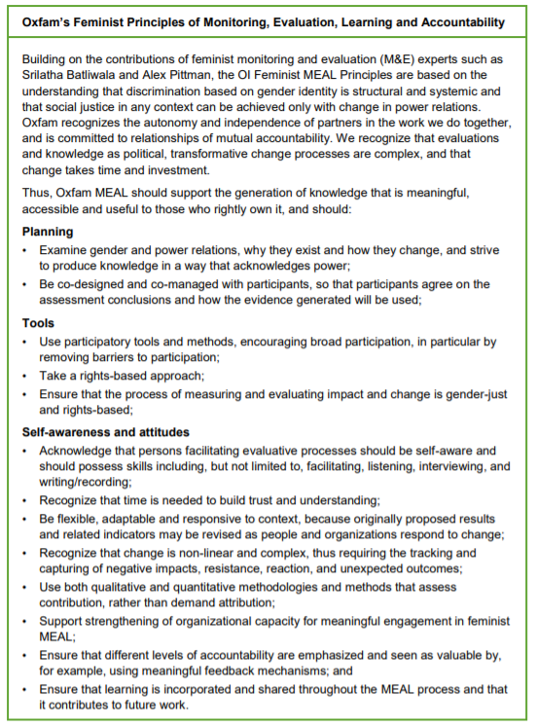

Session 14: Quality Indicators for Gender Equality Outcomes
Session Fourteen

Global Affairs Canada’s RBM Guide:
https://www.international.gc.ca/world-monde/assets/pdfs/funding-financement/results_based_management-gestion_axee_resultats-guide-en.pdf

Annex 14a: Indicators

Global Affairs Canada provides the following elements in their template for partners, and in this session and the next we will focus on the nature of the circled elements in gender transformative programming: indicators and data sources and collection methods.

Expected Result | Indicator(s) | Baseline Data | Targets | Data Sources | Data Collection Methods | Frequency | Responsible
Outcome or results statement | What is being measured? | Where are you starting from? | Where will you end up? | Where or who is the data coming from? | How is it being collected? | How often is this data being collected? | Who is collecting the data?

What is an indicator?

Simply put, an indicator is a signal that shows change has happened. Quality indicators are built in a specific way and have specific attributes, and many of you will be familiar with the GAC definition of an indicator:

- According to GAC, an indicator, also known as a performance indicator, is a means of measuring actual outcomes and outputs. It can be qualitative or quantitative, and is composed of a unit of measure, a unit of analysis and a context. Indicators are neutral; they neither indicate a direction of change, nor embed a target

There are two types of indicators:
Session Fourteen

Quantitative Indicators | - Quantitative indicators are used to measure quantities or amounts.  - They are objectively verifiable. For example: temperature, distance, middle upper-arm circumference, death rate, but also individual knowledge and skills.
Qualitative Indicators | - Qualitative indicators are subjective. They capture experiential information, such as the quality of something, or beneficiaries’ perception of their situation, their opinion or preferences.  - They also would measure an individual’s perception of their own knowledge or skills.

Every indicator has 3 building blocks:

- The unit of measure is the number, percentage, level, ratio, etc.
- The unit of analysis is who or what will be observed: individuals, institutions, social artifacts or social groups
- The context is the set of circumstances that specify the particular aspect of the output or outcome that the indicator is intended to measure.
An indicator must always be developed or selected to effectively capture the level of change of a result (transformative/aware/etc), and must always be gender sensitive, regardless of the level of change. Gender sensitive is the minimum level of gender integration.

What do we mean by this? When we talk about gender transformative results, in order to be effective, we want to measure changes in attitudes and perceptions about the value of women and girls, and their agency and decision making. Most outcomes have multiple indicators and will include some that are quantitative and some that are qualitative.

Gender Sensitive indicators do the following:

- Disaggregate by sex and age
- Disaggregate by other relevant factors of intersectionality
- Use language that describes in gendered detail the unit of analysis
- Use language that incudes gender-related elements of the context

Activity 14.1 Instructions: Quality Indicators for Gender Equality Outcomes
Session Fourteen

- Using the Logic Models and outcome statements created in previous sessions, you are to develop quality indicators for one immediate and one intermediate outcome that capture gender equality changes in an effective way with your problem analysis groups.

- You have 30 minutes to think of your indicators with your groups. Please see Annex 14a for further information on quality indicators for GE outcomes. You will input your indicators directly into the Google Excel Sheet in which your Logic Model lives. There is an added column for you to populate.

- Please see your group assignments and links below.
Group 1 | Group 2 | Group 3
Google Sheet Link:  [insert google sheet link]  Problem Tree MURAL link:  [insert Mural link] | Google Sheet Link:  [insert google sheet link]  Problem Tree MURAL link:  [insert Mural link] | Google Sheet Link:  [insert google sheet link]  Problem Tree MURAL link:  [insert Mural link]
- Populate Participant Names | - Populate Participant Names | - Populate Participant Names

Helpful Note:

- An outcome can have multiple indicators! For example, an outcome related to improved sexual and reproductive health could have an indicator on reduced teenage pregnancy rates, increased household decision making, and reduced incidents of sexual and gender-based violence.
- There are no PERFECT indicators – and this is not an M&E training. Groups should focus on capturing the gender transformative change they’ve described in their outcome statements.

Session 15: Data Collection Tools and Sources for Gender Equality Indicators
Session Fifteen

Note: Sourcing data directly from women and girls is essential to assess change in empowerment and agency. Sourcing data from men and boys is also important to understand the changes in an enabling environment for gender equality, as is data from the community, from service providers and leaders, policy analysis, etc.

Activity 15.1 Instructions: Data Sources and Methodologies

- In your problem analysis groups below, you will have 20 minutes to identify the data sources and methodologies for your project’s indicators. Utilize Annex 15a for examples of data sources and methodologies if you need a starting point!

- You will be put into Zoom break-out rooms, and you are to have a plenary discussion with your group. You do not need to worry about capturing your discussion on an online platform. Just enjoy the discussion with your group!

- Be prepared to share one or two examples.

Group Assignments
Session Fifteen
Group 1 | Group 2 | Group 3
Google Sheet Link:  [insert google sheet link]  Problem Tree MURAL link:  [insert Mural link] | Google Sheet Link:  [insert google sheet link]  Problem Tree MURAL link:  [insert Mural link] | Google Sheet Link:  [insert google sheet link]  Problem Tree MURAL link:  [insert Mural link]
- Populate Participant Names | - Populate Participant Names | - Populate Participant Names

Annex 15a: Data Sources and Data Collection Methodologies
Session Fifteen

Data Sources: “Is this first hand information, or second hand information?”

Primary | - Participants (individuals)  - Intermediaries  - Government documents (policies, program documents, proclamations, etc.)  - Institutional/organizational records  - Photographs or artifacts  - Physical environment
Secondary | - Demographic health survey data  - Human development report  - Global Peace Index  - Peer reviewed research  - Reports from community of practice
Data Collection Methods

- Surveys
- Focus Group Discussions
- Guided Observation
- Conversation with concerned individuals
- Most significant change
- Field visits/observation
- Transect walk
- Critical reviews of official records or other documents
- Individual and key informant interviews
- Official records/secondary data
- Census
- Scientific research

Annex 15b: Resource List of Tools
Session Fifteen

These tools have been shared by participants in previous deliveries of this training program.

- https://learn.tearfund.org/en/resources/publications/footsteps/footsteps_31-40/footsteps_36/the_bead_game/
- https://www.participatorymethods.org/sites/participatorymethods.org/files/all%20together%20now_int%20HIVAIDS.pdf
- https://care.org/wp-content/uploads/2020/05/FP-2013-CARE_CommunityScoreCardToolkit.pdf
- https://www.odi.org/sites/odi.org.uk/files/odi-assets/publications-opinion-files/9809.pdf

Photovoice Resources

- Bisung, E., Elliott, S. J., Abudho, B., Karanja, D. M., & Schuster-Wallace, C. J. (2015). Using Photovoice as a Community Based Participatory Research Tool for Changing Water, Sanitation, and Hygiene Behaviours in Usoma, Kenya. Biomed Res Int, 2015, 903025. doi:10.1155/2015/903025

- Hergenrather, K. C., Rhodes, S. D., Cowan, C. A., Bardhoshi, G., & Pula, S. (2009). Photovoice as Community-Based Participatory Research: A Qualitative Review. American

- Simmonds, S., Roux, C., & Avest, I. t. (2015). Blurring the Boundaries Between Photovoice and Narrative Inquiry: A Narrative- Photovoice Methodology for Gender-Based Research. International Journal of Qualitative Methods, 14(3), 33-49.

- Sutton-Brown, C. A. (2014). Photovoice: A Methodological Guide. Photography and Culture, 7(2), 169-185. doi:10.2752/175145214X13999922103165

Session 16: Accountability - Data for Whom? Using GE Data to Strengthen Programming and Women’s/Girl’s Participation
Session Sixteen
ACCOUNTABILITY mechanisms include crucial information sharing to project or organization stakeholders about the delivery of services, the use of resources, and the achievement of outcomes. This includes project donors, partners and beneficiary or participants communities. Accountability to government or donors is sometimes referred to as ‘upward accountability’, accountability mechanisms targeting beneficiary groups or communities is referred to ‘downward accountability’, and ‘horizontal accountability’ refers to sharing and learning activities with partners, colleagues, peer organizations and stakeholders.

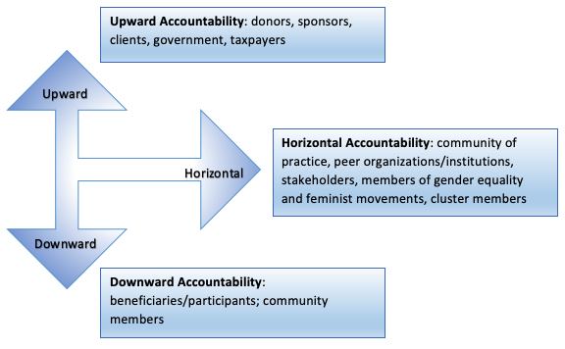

Activity 16.1 Instructions: Accountability Discussion
Session Sixteen

Discussion questions:

Upward Accountability

- What kind of activities does this include?
- Why is this level of accountability important in gender transformative programming?
- How can we use our donor reports to advocate for women’s empowerment and rights-based approaches?
- What is it that we report on? What do we highlight? How do we present our data?

Horizontal Accountability

- What kind of activities does this include?
- Why is this level of accountability important in gender transformative programming?
- How can horizontal accountability reflect and promote feminist principles?
- How can horizontal accountability improve gender transformative programming?

Downward Accountability

  - What kind of activities does this include?
  - Why is downward accountability important? Why specifically for gender transformative programming?
  - What are the benefits? For whom?
  - Do we do it enough? Why not?

Activity 16.1: Instructions - Downward Accountability Discussion
Session Sixteen

- Click on the following Mural link to see the plenary discussion captured: [insert link]

- The facilitator will be capturing the discussion on the Mural page, but feel free to join the page and input your own ideas.

- Discussion Questions:

Downward Accountability

  - What kind of activities does this include?
  - Why is downward accountability important? Why specifically for gender transformative programming?
  - What are the benefits? For whom?
  - Do we do it enough? Why not?

Annex 16b: Downward Accountability Case Study
Session Sixteen

Leading for Peace:
Participant Engagement and Indicator Pathway

Project | Leading for Peace
Organization | Plan International Canada
Duration | 5 years
 | 140,000 beneficiaries (Victims of the armed conflict, with a focus on children, adolescents and youth)
Location | Colombia
Thematic Areas | Peace building; child protection; rights, citizenship and participation; economic empowerment; institutional strengthening (Victims of Armed Conflict Unit)

Activity Objectives

With project participants (children, adolescents, youth and adults):

- Share and have a clear understanding of the objectives of the project
- Share and interpret evaluation results (baseline, midline, endline)
- Agree on actions required to improve programming and achieve expected results
Methodology
Session Sixteen

Part 1: Infographic Video

Step 1: | Based on results from the study (baseline, midline or endline) an infographic video is designed and produced. The video is child and adolescent friendly and explains main results in an easy to understand and dynamic way. It is used for communications campaigns but is also a key piece during the information sharing workshops.
Step 2: | Community members are invited to participate in the information sharing workshop. This is done in every region (Chocó, Valle del Cauca and Nariño) and separate workshops are conducted for different age groups (Children, adolescents, youth and adults) and sex. Between 15-20 people are invited per session.
Step 3: | 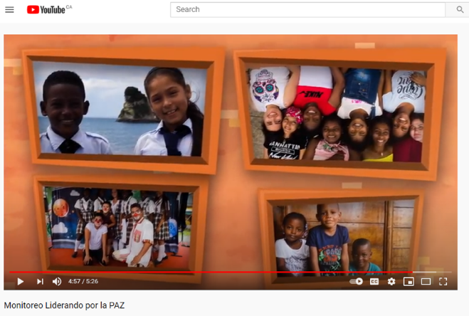  During the workshop, after introductions and ice breakers, the info graphic video is presented to participants. They are then asked to reflect on what was the most interesting thing they saw in the video and why. Methodology changes depending on the age group. Children are asked to draw, adolescents and youth are asked to form groups of three, discuss and right their ideas on a flipchart. For adults it can be done via flipcharts or in a discussion in plenary (mainly for public servants or teachers) with facilitator writing and organizing ideas on post-its.
Step 4: | Results from previous step are shared. For children, drawings are placed on the wall and children are asked to voluntarily explain their drawing. They are also asked to go through the room and choose the drawing(s) that they like and asked to explain why. For youth and adolescents, each group presents the content of the flipchart to the rest of participants. For adults, facilitator moderates a conversation around the main topics identified.
Session Sixteen

Part 2: Indicator Pathway

Not all indicators in the PMF are relevant for all age groups (economic empowerment is only relevant for youth, for example), so only the indicators that are relevant will analyzed with each age group. The methodology changes slightly by age groups but is in essence very similar.

Step 1: | Write the indicator statement on a flipchart and underline the key components. Then ask participants to brainstorm in groups about what each component means to them. Have each component as a title in separate flipcharts, bring the group together and write their suggestions in the flipchart under each component. The facilitator clarifies and expands as required.  Indicator example: % of GBAY victims with adequate knowledge of self-care protective actions and institutional and community-based protection systems  *GBAY: girl and boy adolescents and youth
Step 2: | Once key concepts of the indicator are clarified, on a larger flip chart, include the indicator and value (in this case for the baseline measurement) to the left. On the right include the target figure. Depending on the age group explain these figures further, so for example using a 1-10 scale, participants themselves or objects (marbles/apples) as opposed to percentages. A volunteer is selected to draw a pathway between the baseline figure and the target.  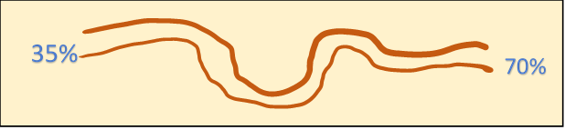
`  Step 3: | Then participants are asked to state what they think should be done or improved to achieve the targets. The facilitator will write the ideas along the pathway.
Step 4: | 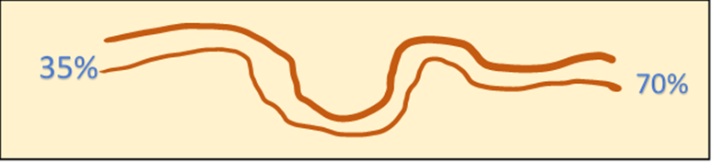  For additional measurements (midline, endline), flipcharts constructed at baseline are re-used. If required, steps 1 and 2 are done again, plus a refresher on the actions proposed to meet the target in the previous exercise. The original flipchart is put on the wall and then the new data (midline, endline) is added.  52%
Step 5: | Facilitator then guides a participatory discussion with the following guiding questions:  - Have we reached our target/objective? Why do you think we have or have not reached our objective?  - What actions (as stated in the pathway) were accomplished/completed? Which were not?  - What do we need to add or improve to reach the proposed objective?
Session Sixteen
Discussion Questions:

      - How is this example empowering to participants?
      - What gender and intersectionality considerations would need to be included in this methodology?
      - What are the implications for implementation (HR, timeline, budget)?

Activity 16.2: Upward and Horizontal Accountability Discussion
Session Sixteen

- Click on the following Mural link to see the plenary discussion captured: [insert link]

- The facilitator will be capturing the discussion on the Mural page, but feel free to join the page and input your own ideas.

- Discussion Questions:

Upward Accountability

  - What kind of activities does this include?
  - Why is this level of accountability important in gender transformative programming?
  - How can we use our donor reports to advocate for women’s empowerment and rights-based approaches?
  - What is it that we report on? What do we highlight? How do we present our data?

Horizontal Accountability

  - What kind of activities does this include?
  - Why is this level of accountability important in gender transformative programming?
  - How can horizontal accountability reflect and promote feminist principles?
  - How can horizontal accountability improve gender transformative programming?

Session 17: Wrap Up
Session Seventeen
Sli.do link: [insert link]

Activity 17.1: Reflection

  - You will explore the training goals and your own personal goals.
  - You will be moved into random groups of 2 or 3 via Zoom break out rooms.
  - In your groups, you will discuss ‘sandwich feedback’ – which includes identifying something positive, some constructive feedback, and then another positive point.
  - You will have 10 minutes to discuss the following:
        - Is it likely that this experience will change the way they work? If yes, how? If no, why not?
        - How could this experience have been made stronger or more helpful?
        - As an individual, what have you gained from this experience?
  - After the 10 minutes, in plenary you will be invited to share reflections or comments (only if you want to). You’ll also have a chance to share your reflections in the training evaluation.

Activity 17.2: Training Evaluation
Session Seventeen

The purpose of this training evaluation is to better understand the degree to which the training was valuable and effective for you, and also to inform and adjust the finalized content and approach.
It should take about 10-15 minutes to complete.
The evaluation will be anonymous and is not a test – your honest and thoughtful feedback is welcome and appreciated. Please don't hesitate to reach out to [input Facilitator’s name(s)] directly if you have any questions or concerns.

Insert Training Evaluation Google Form link OR similar link/form to the program of your organization’s choice.

https://www.equilo.io/gender-analysis
Oxfam GB: A Quick Guide to Monitoring, Evaluation, Accountability and Learning in Fragile Contexts (no date)
Note that some participants may rightly observe that the terms ‘upward’ and ‘downward’ accountability employ a language of hierarchy that implies an associated importance which would be interrogated and rejected by many feminist approaches.
Note that some participants may rightly observe that the terms ‘upward’ and ‘downward’ accountability employ a language of hierarchy that implies an associated importance which would be interrogated and rejected by many feminist approaches.
https://www.youtube.com/watch?v=kqpKjeoB1tE

