Building Capacity and Confidence in Gender Transformative Programming:
A Virtual Learning Experience
Technology Guide

Table of Contents
Table of Contents
Introduction 4
Zoom Meetings 5
Meeting Roles 5
Host, Co-Host and Attendees 5
Setting up a Zoom Meeting 6
Pre-Meeting 6
Screen Viewing Options: 7
Recording the Meeting 8
Screen Sharing 8
Zoom Meeting Screen Share Options 8
Zoom Chat Box 9
Zoom Features 9
Polls 9
Breakout Rooms 9
Dual Monitor Display 13
For More Information 13
Google Suite 14
Google Suite Permissions 16
Advanced Sharing Options 16
Sharing a Google Sheet/Google Doc: 16
Sharing your Google Doc/Sheet with non-Google Users 17
Google Forms Sharing Options 19
Mural 20
Setting up Mural 20
Mural Practice Session 21
Mural Applications to review/highlight 22
Setting up Mural Templates for the GE Training Activities 22
Sharing the Mural link with participants 22
Sli.do 24
Setting up an Account 24
24
Quick Event 24
Scheduled Event 24
Creating a Poll 25
Launching a Poll 25
Best Practices to Consider for Technology Support 26
The Digital Tools 26
Google Suite 26
Table of Contents
Mural 26
Sli.do 26
Key Considerations 26
Zoom 26
Google Suite 27

Introduction
Introduction

This online technical guide is meant to take the user step-by-step through the technology pieces used to support the online delivery of the Gender Equality Training Modules (GETM) and to provide best practices for conducting an online training.

The selection of technologies for the GETM was focused on two elements:

- Accessibility. These technologies are affordable, require minimal bandwidth, and are extremely user-friendly. They are not unlike other platforms available online, and functionalities are simple enough to be familiar to most users, or easily understood with minimal practice and instruction.

- Relevance. The purpose of these virtual platforms is to complement the facilitation of this training, not to be the central focus. A limited number of tools were chosen to satisfy the learning objectives of each session, and the pedagogical objectives of the training, without overwhelming facilitators or participants with multiple interfaces to navigate.

While this guide is specifically focused on the platforms employed in this training, many of the functionalities can be found in other meeting platforms, for example Microsoft Teams. This guide has been developed in 2020 and reflects the current functionality for these platforms. Before a training is delivered, facilitators and technical support staff should familiarize themselves with the most recent versions of these software packages.

Zoom Meetings
Zoom Meetings

Zoom helps businesses and organizations bring their teams together through a cloud platform for video, voice, content sharing and chat functions.

Learn more about Zoom here: https://explore.zoom.us/about

For this Gender Equality Training, Zoom Meetings is utilized as the primary platform to conduct the training. The Zoom Meetings function was chosen because of its ability to create a collaborative and interactive learning environment as it has a variety of features necessary to facilitate an engaging training environment online including, but not limited to:

  - Ability for participants to share audio and video;
  - A chat box to interact with all participants and facilitators;
  - Gallery view of participants’ videos;
  - Screen Sharing abilities for facilitators and participants;
  - Breakout rooms, controlled centrally
  - Participant functionalities like hand-raising, polling, etc.

Meeting Roles

Host, Co-Host and Attendees

- The Host of the meeting is the user whom the meeting is scheduled under. They have full permissions to manage the meeting, co-host(s), and attendees. There can only be one host of a meeting. The host can do things like stop and start the meeting, mute panelists, stop panelists' video, remove attendees from the meeting and more.

- Co-host(s) share many of the controls as the host, for example: muting panelists, start/stop the recording, etc. The host must assign co-hosts. This can be done when everyone is logged into the call.

- Attendees are the participants in the meeting. In a Zoom Meeting, attendees will have control over their own interactions within the meeting space (vs. in a Zoom Webinar where they are participants with limited functionality to communicate). This means that they can put themselves on/off mute, turn on the video, share their screen – in other words participate fully in the Meeting but without the same controls over the Meeting as a Host/Co-Host.

    - The following support document from the University of New Brunswick, College of Extended Learning, provides step-by-step instructions for participants/attendees on how to use Zoom: https://www.unb.ca/cel/_assets/documents/credit/zoom-support-user-guide.pdf

For the purpose of this training, the technology support person (TSP) and/or supporting facilitator should be the Host of the Zoom meetings for this training. This means, the TSP should “own” the Zoom meeting invites where they ensure to start each meeting. Once the host starts each Zoom meeting, the host (the TSP) should make the facilitator (or co-facilitator) a co-host. This will allow the facilitator to assume different host controls (muting panelists, accepting attendees into the meeting, etc.).

Setting up a Zoom Meeting
Zoom Meetings

Pre-Meeting

Prior to booking a Zoom meeting in your organization’s shared account, please ensure that the meeting does not interfere with an already scheduled meeting. Navigate the meeting tab to view the scheduled meeting dates and times and schedule the Zoom meetings for your training sessions accordingly.

Step 1: Schedule the Webinar

Topic | Enter the name of the meeting in the “Topic Field”
Description | Enter a description of the meeting
When | Enter the date and time of your meeting
Duration | Enter the duration of the meeting (the duration of each training session will be up to the organizers of this training)
Video | Set host to “on”
Audio | Set to “both”

Click schedule.

Step 2: Configure the Meeting

Invitations:
- Invite the facilitator(s) for the training (this is who the TSP will make as co-hosts once the meeting(s) have started)

- Invite the attendees: copy the registration URL or copy the whole invitation—the invitation can be inserted into an email copy for folks to access, or the Meeting URL can be populated in the “location” field

Step 3: Starting the Zoom meeting

On meeting day, the host should log in and start the meeting about 15 minutes early (might be earlier depending on the needs that day for the training/prior set-up). The facilitator(s) should also join at this time. This will allow for the host to assign the co-hosts, start sharing screen and generally get everything set up prior to the attendees joining.
Note: decide what works best for your team on who holds the accompanying PowerPoint, and who controls other virtual pieces such as Mural and Sli.do. We’ve found it’s easiest for the lead facilitator to own the PowerPoint and share their screen when the PowerPoint is in use, however, we have the TSP own the other virtual components such as Mural, Sli.do, Google Sheets/Docs, etc.

Screen Viewing Options:
Zoom Meetings

Attendees will be able to see either the shared screen (with the PowerPoint) with the presenter video or gallery view with all attendee video screens when the screen is not being shared (see examples below).

Attendee view with screenshare enabled:
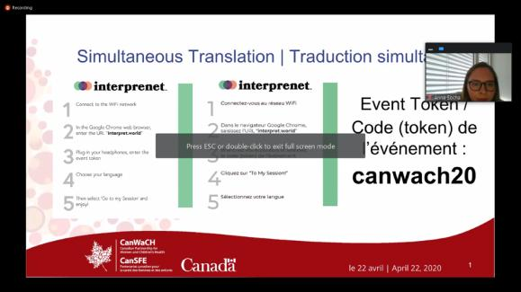

Attendee view with screenshare disabled:
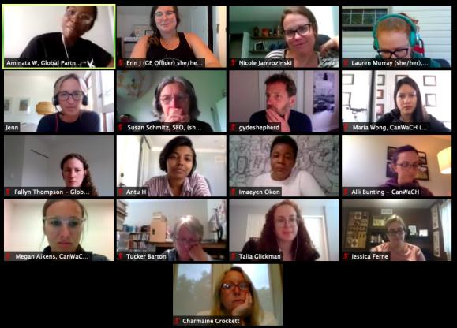

Recording the Meeting
Zoom Meetings

Decide with the facilitator/organization if recording the training session will be required. If yes, this option can be selected during to occur automatically in the set-up of the meeting, to verify that the video is recording, look at the top left-hand side of the screen – there will be a little red dot and the word Recording. If the meeting is not recording, the tool bar at the bottom of the screen will have the option to record. The host or co-host can initiate recording. If it is decided to not record, simply de-select this option during set-up or turn off recording when the meeting is started. The intention to record the session should always be made clear before the training to all participants, including an explanation of how the recording will be used.

Screen Sharing

The Share your Screen feature will be initiated by either the facilitator or the TSP (depending on what you decide works best for you) who will use this to present the slides. This option can be found at the bottom of the Zoom Meeting screen (see below).

Once share screen is selected, you will be able to decide what screen to share (see below). Select the screen/desktop view that has the PPT – this will only allow attendees to see the PPT and nothing else on that screen. Within this selection, there are basic and advanced options for sharing screen as well as the option to share computer sound. Use whichever option works best for the type of training being conducted.

Zoom Meeting Screen Share Options

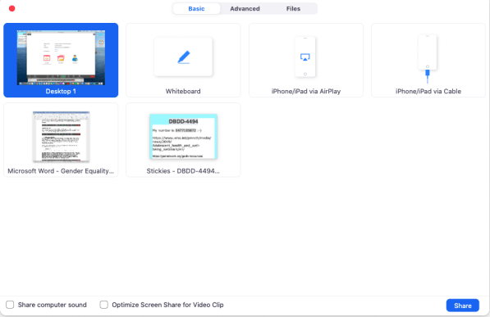

Zoom Chat Box
Zoom Meetings

During the meeting, hosts/co-hosts and attendees can initiate conversations in the chat box. Encourage participants to ask questions directly in the meeting if they relate to the training content (for example coming off mute and addressing the facilitator) but the TSP should be monitoring the chat box for any questions/problems to either flag to the facilitator, and or to address in regard to possible problems with the technology and troubleshoot as required.

After the meeting, the chat box file is saved along with the recordings of the meeting (if recorded) and can be downloaded as a .txt file.

Zoom Features

Polls

Polls are a great way to collect information from the attendees during the meeting. Polls can be configured ahead of time by selecting the polling option in the meeting (see below). The polling feature for meeting allows for single choice or multiple-choice polling questions. Poll questions and answers can be pre-populated in Zoom or added during the meeting. There is a character limit of 255 for both the Question and the Answer. Once the meeting is started, the poll can be launched at any time and responses from attendees gathered. Polls can also be conducted anonymously, if you do not wish to collect attendee information with the poll results.

Initiating Polls

Hosts and co-hosts can launch polls but are not able to vote in them. When a poll is ready to be launched, click Polls in the host controls, then click Launch Poll.

Within the poll settings there is the option to:

  - Click the arrow next to the poll name to select a different poll.
  - Click Edit to edit the poll questions. This will open a page in your web browser where you can edit the questions.
  - Click Allow panelists to vote if you would like to include your panelists in the poll.
  - When the polling is finished, click End Poll. You will have the option to share the results or relaunch the Poll.

Breakout Rooms

The host will be able to create the breakout rooms for the training sessions. There are two ways to do this, the first is to pre-create/pre-assign participants to breakout rooms using the web portal. This is helpful if the attendees/group configurations are known in advance. To do this:

      - Sign in to the Zoom web portal.
      - Click Meetings and schedule a meeting.
      - In the Meeting Options section, select Breakout Room pre-assign and click Create Rooms.
Zoom Meetings
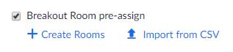

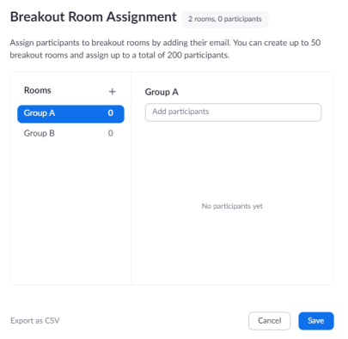
- Click the plus icon beside Rooms to add breakout rooms.

- Hover over the default breakout room name and click the pencil icon to rename it.

- In the Add participants text box, search for participants' name or email address to add them to the breakout room.
Note: You can add internal Zoom users that are in the same account. To pre-assign participants that are external Zoom users, import a CSV file.
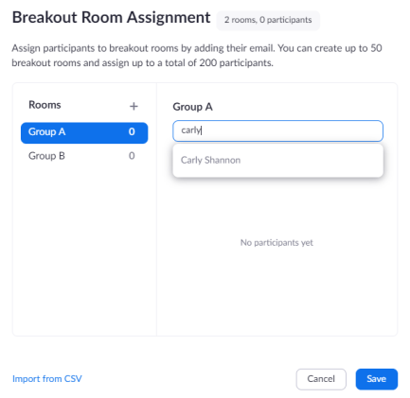
Zoom Meetings

- (Optional) Use these options to edit your breakout rooms and participants:
  - Click and drag a participant's email address to change the order.
  - Hover over a participant's name to see options to move them to another room or remove them from the current room.
  - To delete a breakout room, hover the room name in the left panel and click the trash bin icon.
- Click Save. This is important because throughout the training breakout room configurations will be repeated for different activities.

The second way to create breakout rooms is to do it during the Meeting once it has begun.

- Once all participants are logged in for the Meeting, hit the breakout room button on the panel and create the breakout rooms needed for each session sort participants into the appropriate groups. There are options to add additional groups and rename them as needed. Always save the breakout room configurations for future use.

- Follow the breakout room prompts and based on the pre-assigned groupings as reflected in your Participant Resource Packages, create the number of break-out rooms needed (for example, 3).

Example of Breakout Room Prompt
Zoom Meetings

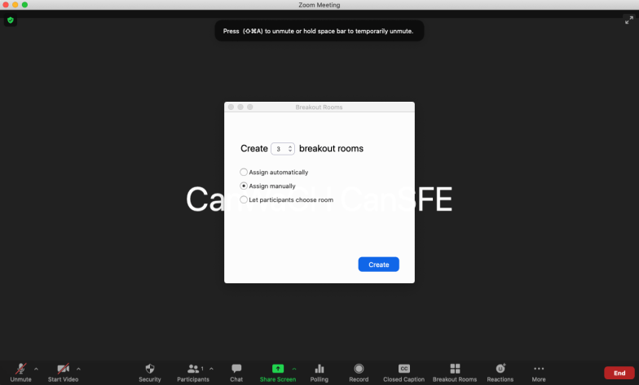

Example of Breakout Room group assignments

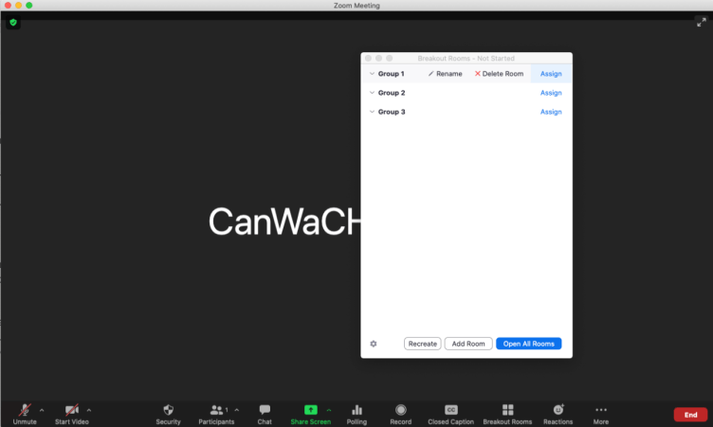

Renaming Breakout Rooms: hover over the default breakout room name and click the pencil icon to rename it.

Assigning participants to Breakout Rooms: hover over the assign prompt and click it to assign attendees to each breakout room/group.
Note: The TSP can move the facilitator(s) to different breakout rooms to ensure the group work is on the right track.
Zoom Meetings
For more help on breakout rooms see the explanation in the Zoom Support centre here.
Note: When you close the breakout rooms to bring participants back to the gallery view/plenary, it will automatically give participants a 60 second countdown until they are automatically bumped from their breakout rooms to the group. Consider broadcasting a message to breakout rooms notifying them of the time they have left in their group work (e.g., “10 minute” warning, “5 minute” warning, etc.).

Dual Monitor Display

After joining or starting a meeting, a Zoom window will be visible on each monitor. The meeting controls and participant's video will display on one monitor, while the other monitor will just display participants' video.

When screen sharing is enabled, one screen will display what is being shared (i.e., the PowerPoint) while the other screen will have the gallery view for attendees and other relevant supporting documents to support the training. This second screen will not be visible to the attendees.

For More Information

Contact Technical Support | https://support.zoom.us/hc/en-us/articles/201362003-Zoom-Technical-Support
Zoom Help Center | https://support.zoom.us/hc/en-us
Getting Started | https://support.zoom.us/hc/en-us/categories/200101697-Getting-Started
Tutorials | https://support.zoom.us/hc/en-us/sections/201740096-Training
Mobile | https://support.zoom.us/hc/en-us/sections/200305413-Mobile

Google Suite
Google Suite

Google Docs and Google Sheets are the Google Suite word processor and spreadsheet programs. These programs allow for real-time collaboration, save changes automatically, and track revision history. Users can insert comments, suggest edits, communicate through a built-in chat, and create templates for future use.
- To learn more about Google Docs, check out HubSpot’s “Ultimate Guide to Google Docs” to learn more: https://blog.hubspot.com/marketing/google-docs
- To learn more about Google Sheets, check out HubSpot’s “Ultimate Guide to Google Sheets” to learn more: https://blog.hubspot.com/marketing/google-sheets

Google Forms is a Google Suite web form and survey tool. To collect data through Forms, users can personalize surveys or quizzes, send respondents the URL, and review the data.

- To learn more about Google Forms, check out HubSpot’s “Ultimate Guide to Google Forms” to learn more: https://blog.hubspot.com/marketing/google-forms

Both Google Docs and Google Sheets are used to create different activities for the Gender Equality Training. Google Docs is used as a group brainstorm collaboration tool to track group discussion and ideas throughout various session activities. Google Sheets is used to build a Logic Model and capture indicators throughout various session activities.

Google Forms is used for daily “pulse check” surveys and the final training evaluation. Create all google suite documents in advance and include their associated links in the relevant Participants Resource Package. Examples below of the documents that are required:

Google Sheet Example
Logic Model Template

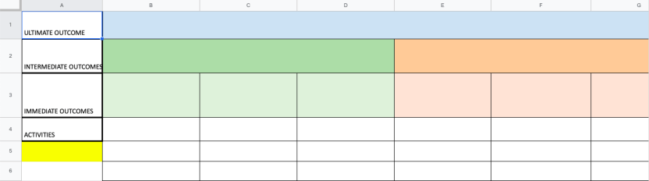

Google Doc Example
Google Suite
MEAL Activity Table

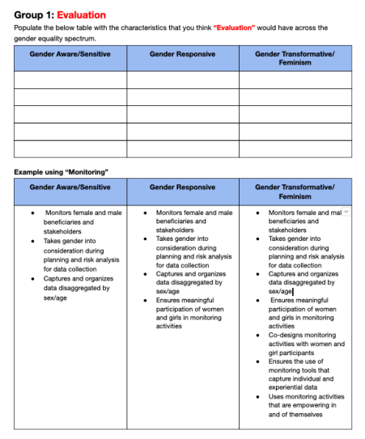
Note: Some activities require multiples of the same templates (depending on how many groups are pre-assigned) and some templates will vary slightly from group to group. See the Facilitator’s Guide for further instructions on the specific requirements needed for each session.

Google Forms Example
Google Suite
Daily Pulse Check

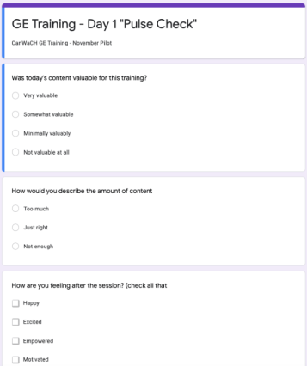

Google Suite Permissions

Identify and manage the access and editing rights of every file.

- “Edit” permissions: allow the person to make changes to the sheet, which are always recorded in the revision history.
- “Commenter” permissions: allow the person to leave comments about data in the sheet, but not change any data.
- “Viewer” permissions: Allows the person to open and view your Google Sheet or Google Doc, but not make edits or leave comments.

Advanced Sharing Options

Open the advanced sharing settings for the Google Sheet or Google Doc by clicking the gear in the upper right corner of the “share with people and groups” dialog box. You’ll see two new

Sharing a Google Sheet/Google Doc:

- Click the “share” button in the upper right corner of the Google Sheet/Doc.
- Type the email address for the person with whom you’d like to share the sheet and assign permissions from the drop down to the right.
- Optionally, add a note and make sure the “Notify people” box is checked.
- Click done to share and send the invitation to that person.

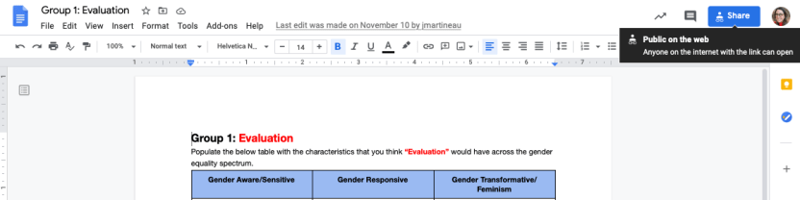
Google Suite

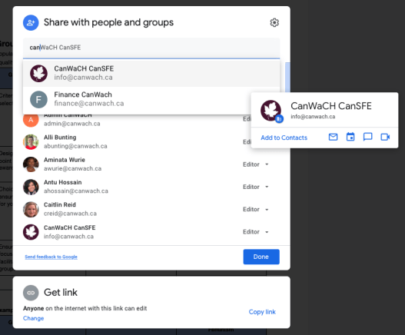

Sharing your Google Doc/Sheet with non-Google Users

If you need to share your Google Sheet/Google Doc with people who don’t have a Gmail address or Google Account, you can continue to click the “Share” button at the top right corner as mentioned above. However, click the “Get Link” option and change it from “Restricted” to “Anyone with the link.” And further change the options from “Viewer” to “Editor”.

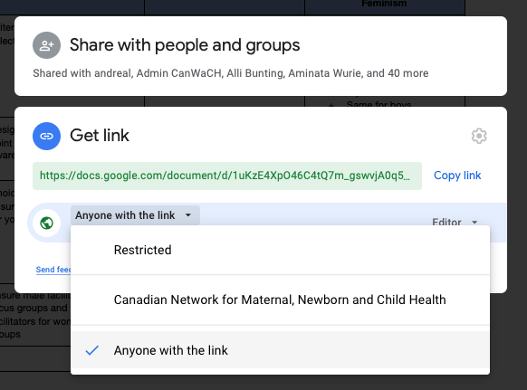
Google Suite

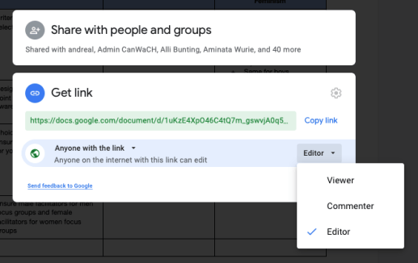

Note: Prior to starting any activity that requires participants to access a Google Sheet or Google Doc, quickly ensure participants are logged out of their personal Gmail accounts. As a facilitator, you only have access to participant’s work emails, therefore you are sharing these Google Sheets and Google Docs to participants via their work emails, and not their personal emails. If participants are accessing these documents through their personal emails, they will not have access to view and edit the documents. If participants are logged out of their personal email accounts, then they should be able to access the Google Sheets/Google Docs seamlessly. If for whatever reason participants are still struggling, just have them request access to each document as they enter the links. Ensure to keep an eye on your email to grant access as requests come through.

Alternatively, if many of your participants have a Gmail account through which they access Google Suite, you can ask all participants to share their Gmail addresses with you and include those in your share list – and this way participants will not have to sign out of their Google Accounts each day they participate in the training.

Alternatively, if many of your participants have a Gmail account through which they access Google Suite, you can ask all participants to share their Gmail addresses with you and include those in your share list – and this way participants will not have to sign out of their Google Accounts each day they participate in the training.

Google Forms Sharing Options
Google Suite

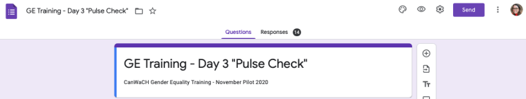
If you need to share your Google Form with participants, you can click the “Send” button at the top right corner.

From there, you can type in the participant email addresses and have the form emailed directly to them. Once you have sent the form to their email, you can continue to copy the link and share the link with participants as well. However, you must directly email this form to participants via this “Send” function in order for them to access the form.
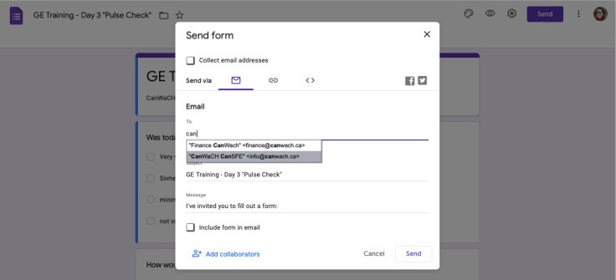

From there, you can add the facilitator(s) as a collaborator so that they’re able to see the participant responses. Click the “Add Collaborators” prompt and then populate the facilitator(s) emails on the next prompt where it says “Add editors”. Hit send so that the facilitators receive notification they’ve been granted collaboration access.
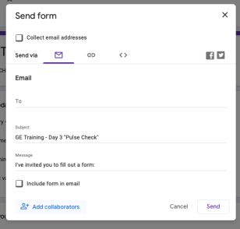
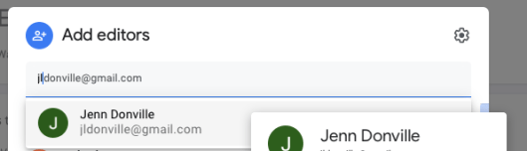

Mural
Mural

Mural.co is a digital, visual collaboration tool that creates a digital workspace for teams to co-create and work together on a shared project. The GETM’s relied heavily on the use of Mural to support collaborative group work for a variety of Module activities. This tool basically allows facilitators to simulate the flipchart and post-it notes that they might use in a face-to-face training for group work and collaboration.

Setting up Mural
Create a Mural account by going to www.Mural.co and signing up. Once the account is set up, take some time to explore the application by creating some test Murals (from scratch or from a template).

You can get a free trial with Mural for 30 days. After 30 days, you will need to purchase a monthly or annual plan, depending on what suits your organization’s needs. Learn more about Mural plans here: https://www.mural.co/pricing

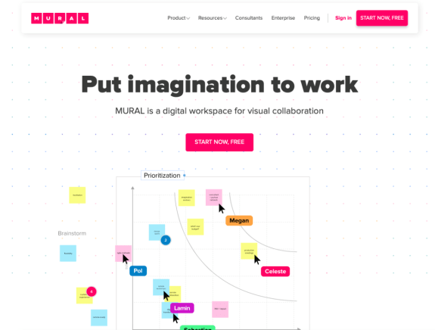

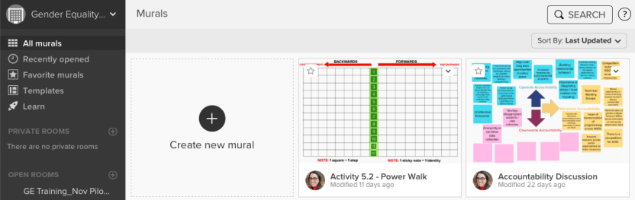

Mural Practice Session
Mural

Set up a Mural Practice session for the training participants to give them an opportunity to explore Mural and learn how to use its features. This will allow participants to practice creating post-it notes, move post-it notes on the screen and write text. Create an introductory question(s) and T-Chart in advance and then give a brief overview of the key pieces’ participants need to use mural effectively that are on the tool bar on the left hand of the Mural Screen. See example below.

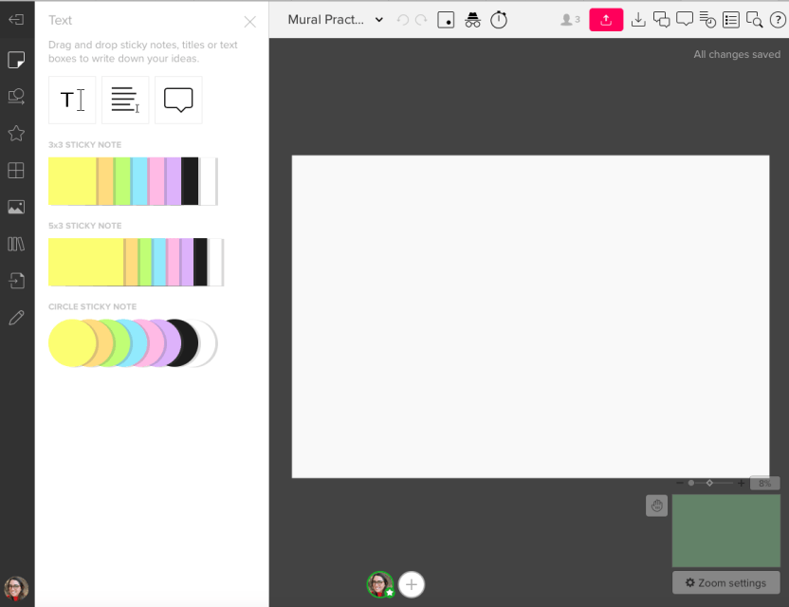

Mural Applications to review/highlight
Mural

In the left-hand tool bar, make sure to highlight the following applications:

Text: The text application allows participants to drag and drop sticky notes, titles or text boxes onto the Mural to write down their ideas.

Shapes and Connectors: This application will be most useful for the Problem Tree exercise. Encourage participants to create a few shapes and connect them with lines/arrows.

Draw: Application that allows for free-hand drawing on the Mural.

Setting up Mural Templates for the GE Training Activities

Make sure to set up all of the Murals needed for every activity in advance. Some activities require multiples of the same template (depending on how many groups are pre-assigned), and some templates vary slightly from group to group. See the facilitator’s guide for further instructions).

Sharing the Mural link with participants

Mural allows you to share a “Visitor” link with participants that grant them the opportunity to access the specific Mural whiteboard and have editing privileges. You can access this link by clicking the pink “Share” button in the top right corner of the specific Mural.

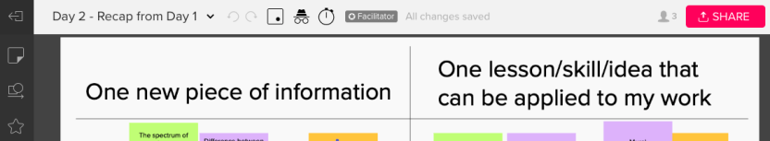

From there, click the second tab in that says, “Visitor Link.” Ensure the permissions are set to “Can Edit” under “Anyone with link, no sign-up required” on the “Visitor Link” tab. Once those permissions are set, you can copy the “Visitor Link” and share that link with participants in the Participant Resource Package and the Zoom meeting chat.
Mural

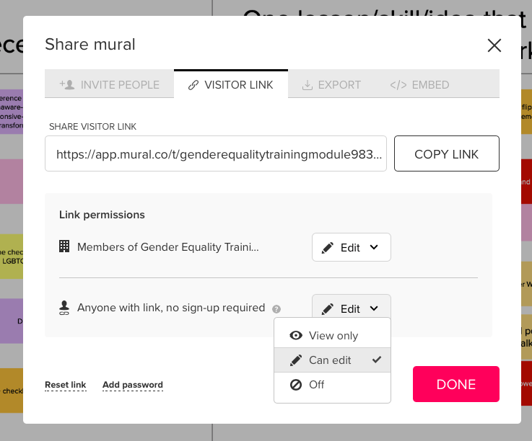

Sli.do
Sli.do

Sli.do is a Q&A and polling platform that is best suited to use for virtual events (trainings, meetings, conferences, etc.) because of its engaging polls and quizzes. It is also extremely user friendly (attendees don’t need an account to participate) and quizzes/polls are easy to set-up and launch.

Setting up an Account

Create a Sli.do account by going to www.Sli.do and signing up. Once the account is set up, take some time to explore the application by creating some test polls. There are two ways to do this, either set up a “Quick Event” or “Scheduled Event”. A basic Sli.do plan is free and allows you unlimited audience Q&A’s and up to 3 polls per event. If you or your organization is looking to use Sli.do more than the basic plans offerings, then you can visit this webpage for information on the different plans.
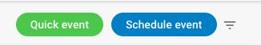

Quick Event

By launching a quick event an immediate QR code/Sli.do poll is launched with an associated event number (this number is important because it is how attendees will find the correct poll). From here, click on the blue plus sign that says create to determine what kind of poll required (multiple choice, open text, word loud, rating, quiz) and to populate it with questions. The Quick Event is best suited for last minute/ad hoc Sli.do quizzes/polls.

Scheduled Event

It is recommended that the Sli.do polls for this training are set up in advance. As such, they can be done by clicking on the “Scheduled Event” option. Here, more detail about the poll (such as title, date, etc.) is asked to pre-populate the poll and it will be saved to launched at a future time. An event # is also generated at this time – it is important to save this # and put it in the slideshow and Participants Resource Package.
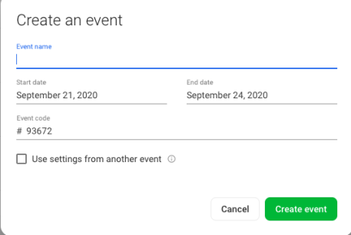

Creating a Poll
Sli.do

Once an Event has been schedule, it is time to decide what type of Poll to create. For this training, the Word Cloud poll is used a couple times, but there are a number of options to choose from. Feel free to adapt this training and choose the poll that best suits your participants needs!

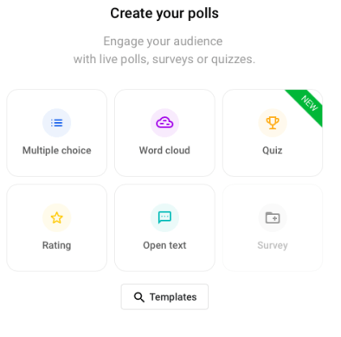

To create your Word Cloud it is as simple as clicking on the Word Cloud Option and typing in the question. Once the question is populated, click “save” to keep it for future use.

Launching a Poll
To launch the poll, go to “Live Polls” and find the poll that you wish to use. To launch the Word Cloud Poll, click on the green play button to activate the poll. Once the poll is activated participants are able to populate their answers. Share the Poll link with participants in their Participant Resource package and/or the Zoom chat box.

To see their answers, click on the three dots directly to the right of the Activate Poll button and select “View Results” If you wish to present the Sli.do results to the group, click on the green “Present Mode” button at the top of the screen.

Best Practices to Consider for Technology Support
Best Practices

The Digital Tools

Build into the Training a 15 - 30-minute overview/practice session with all the tools being used in the Training Modules (especially those that are new to participants like Slid.o and Mural).

Google Suite

Create all the Google Suite templates (docs, sheets, forms) needed for the activities in advance and place the links directly into the Participants Resource Package so attendees have easy access to the tools needed to complete the activities.

Mural

Create all the Mural templates needed for the activities in advance and place the links directly into the Participants Resource Package so attendees have easy access to the tools needed to complete the activities.

Sli.do

Create all the Sli.do quizzes needed for the activities in advance and place the link, event number and QR code directly into the Participants Resource Package so attendees have easy access to the tools needed to complete the activities.

Key Considerations

- It is strongly advised that this training is co-facilitated, and that responsibilities for managing technical support are clearly defined in advance.

- Be ready to adjust and adapt! If some of the links or platforms are not working for participants, or participants are getting fatigued with certain elements (i.e., too much Mural or too many break-out rooms) – work with your co-facilitator to adjust the plan for the next session to mitigate those challenges. This could mean more plenary discussion, it could mean the facilitators take notes in Mural rather than asking participants to all input, etc.

Zoom

Hosting the Meeting

For this training the host of the meeting should be the Technical Support Person (TSP) – this is because they will be managing all technical/administrative aspects of the training on the back end and need the most control over all of the platforms being used to conduct the training. The host of the Meeting will be able to make the Facilitator(s) co-host, which will give them similar levels of control of the Meeting.

For this training, the Facilitator was given the role of co-host because they were not primarily responsible for managing the technical/administrative side of the Meeting as they were focused on delivering the training and facilitating. This allows the facilitator to focus on engaging actively with participants and focus on training content.
Best Practices

Attendee Participation

Encourage attendees to turn on their camera for the majority of the training session. This not only fosters a sense of community but allows for deeper engagement/interaction with the Facilitator and other training attendees.

When there is group conversation/participation required, the TSP should stop sharing the screen so that the meeting reverts back to gallery view and all attendees can see each other’s video screens and the Facilitator. This is important because some of the content of the Training is sensitive and asks participants to share individual experiences and personal reflections. Having gallery view for these more intimate moments of the training is important to foster a sense of inclusivity and participation.

Meeting Day

The Host (TSP) and Co-Host(s) (Facilitator(s)) should be prepared to log-in about 15 - 30 minutes early. During this time, they will be able to run through any last-minute logistics, troubleshoot any problems and get everything set up prior to the attendees joining.

Screen Sharing

Throughout the training it will be up to the discretion of Host and co-Host to stop sharing the PPT screen and revert the attendee viewer mode back to gallery view. Note that when all screen-sharing or presentations are stopped, the meeting view will automatically revert to the gallery view of participants. See Tip 4. under Attendee Participation for more information about appropriate timing to stop screen sharing.

Dual Monitor Display

It is highly recommended that whoever is sharing the PowerPoint presentation on Zoom uses dual monitors for the training session. The dual-monitor display feature allows the video layout and screen share content to be placed on two separate monitors/screens. Gallery or speaker view can be displayed on one monitor while the other monitor displays a content share. This is useful for PPT presentations and hiding notes from the participants.

Google Suite

Ensuring all participants can access the Google Docs/Sheets:

Prior to starting any activity that requires participants to access a Google Sheet or Google Doc, ensure participants are logged out of their personal Gmail accounts. As a facilitator, you only have access to participant’s work emails, therefore you are sharing these Google Sheets and Google Docs to participants via their work emails, and not their personal emails. If participants are accessing these documents through their personal emails, they will not have access to view and edit the documents. If participants are logged out of their personal email accounts, then they should be able to access the Google Sheets/Google Docs seamlessly. If for whatever reason participants are still struggling, just have them request access to each document as they enter the links. Ensure to keep an eye on your email to grant access as requests come through.
Best Practices

Alternatively, if many of your participants have a Gmail account through which they access Google Suite, you can ask all participants to share their Gmail addresses with you and include those in your share list – and this way participants will not have to sign out of their Google Accounts each day they participate in the training.

Ensuring all participants can access the Google Forms:

Ensure you send the Google Form to participants via email using the “Send” function. You can type in the participant email addresses and have the form emailed directly to them. Once you have sent the form to their email, you can continue to copy the link and share the link with participants as well. However, you must directly email this form to participants via this “Send” function in order for them to access the form.

https://explore.zoom.us/about
https://blog.hubspot.com/marketing/google-suite

