Building Capacity and Confidence in Gender Transformative Programming
A Virtual Learning Experience

Module 1 – Resource Package

Table of Contents of Contents
Table of Contents
Training Principles 2
Session 1: Introduction 4
Activity 1.1 Instructions: Our Participation 4
Session 2: Gender 101 5
Key Terms 5
Activity 2 Instructions: Concepts and Terminology 5
Activity 2.1 - Concepts and Terminology 6
Annex 2a: Terminology Word Quiz – Activity 6
Annex 2b: Terminology Word Quiz Answer Key 9
Session 3: Gender Equality and Change—Understanding Transformative Change 12
Activity 3.1 - Illustrating Gender Transformative Concepts 12
Annex 3a: Explanations for Gender Transformative Concepts – Worksheet 12
Annex 3b: Explanations for Gender Transformative Concepts 14
Activity 3.2 - Illustrating Gender Transformative Concepts Group Work Instructions 16
Group Assignments 16
Activity Instructions 17
Session 4: Gender Diversity 18
Key Messages 18
Annex 4a: Important Definitions 20
LGBTTTQQIAA Guide 22
The Gender Unicorn 23
Annex 4b: LGBT+ Inclusion in International Development Programming 24
Annex 4c: Tools 26
Session 5: Intersectionality 27
Activity 5.1 Instructions: Our Identities 27
Activity 5.2 - Power Walk Activity 28

Training Principles

Principles of behaviour help to set the tone for your training. These are often developed in a participatory manner – asking everyone in the training to contribute to a list that outlines the kind of tone they expect from each other, from the facilitator, and from themselves. For a training on Gender Equality, it is especially important to set a tone of respect, inclusion, and acceptance.
These often include the following:

- Participation: You are your own best resource. Much of the content of the training will be coming from you. Each one of you brings a wealth of experience to the program. The workshop can only be successful if it is a two-way process and if everyone participates fully. Give everyone a chance to contribute and encourage others to do so.

- Respect Others: Respect each other, yourselves, and the trainer. Do not speak when someone else is speaking. Listen actively. The trainer will be facilitating the discussions with your assistance.

- Support an Inclusive Environment: Participants in this training must support an environment of inclusion, must respect diversity in all its forms, including gender diversity, religious diversity, ethnic and cultural diversity, social and economic diversity. Discrimination or exclusion of any kind will not be accepted.

- Agree to Disagree: During this workshop everyone must feel free to express opinions and concerns. Please see frank discussions about politics as healthy exchanges rather than personal attacks. There will be a tolerance of differences in approaches and strategies. Everyone should contribute to a safe/non-judgemental environment.

- Punctuality: Arrive on time to each workshop session. Arriving late is a sign of disrespect to the trainer and to your fellow participants.

- Minimize Disturbances: Cell phones should be turned off at the beginning of the workshop and should remain off until the end except during breaks. Avoid side conversations – if you are unclear about the topic being discussed or the instructions, please ask the facilitator to clarify.

- Ask Questions: There are no stupid questions. If you do have a question you don’t want to ask in front of others, ask it privately during a break. Please do not think any question you have is unimportant.

Session 1: Introduction
Session One

Activity 1.1 Instructions: Our Participation

- Click on the Sli.do link to join the “word cloud poll”. Sli.do link: [facilitators can create their own Sli.do and input link here]
- Think about three examples that describe the way they participate in group settings. For example, you could describe yourself a quiet, respectful and eager.
- Once in the Sli.do word cloud, populate 1 example at a time where prompted.
- You will have 3 minutes to independently brainstorm and populate your responses. Feel free to type more than 3 examples!
- Once you’re done populating your own examples, return to the Zoom call. The final word cloud will be screenshared by the hosts.

Note: Take it slow! Use this activity to become familiar with Sli.do and feel free to ask any question to the facilitator(s)!

Session 2: Gender 101
Session Two

Key Terms

SEX | The physical and biological characteristics that distinguish male, female, and intersex people. These include things like reproductive organs, hormones, chromosomes, etc.
GENDER | The socially constructed characteristics of women, men, girls, boys and gender diverse people– including the norms, roles, behaviours, activities, attributes, power and relationships that exist between them. These characteristics vary from society to society and are not fixed.

Activity 2 Instructions: Concepts and Terminology

- Independently, you are going to take 10 minutes and complete Annex 2a: Terminology Word Quiz.
- This quiz will not be marked as it is intended to make sure we’re all on the same page.
- You can use Annex 2b to check your work and test your own understanding.

Activity 2.1 - Concepts and Terminology

Annex 2a: Terminology Word Quiz – Activity

 | MATCH | TERM
 |  | Gender
 |  | Gender equality
 |  | Gender unaware/blind
 |  | Gender neutral
 |  | Gender responsive
 |  | Empowerment
 |  | Sex
 |  | Gender equity
 |  | Gender sensitive
 |  | Gender aware
 |  | Gender transformative

Session Two
DEFINITION
A. | A multidimensional social process that enables people to gain control over their lives. It often challenges existing power allocations and relations to give disadvantaged groups more power. With respect to women’s health, this concept has often meant, for example, increasing education opportunities and access to relevant information to enable women to make informed decisions about their health, improve self-esteem and equip them with communication and negotiation skills.
B. | Refers to equal chances or opportunities for women, men, girls, boys and gender diverse people, to access and control social, economic, and political resources, and protects these opportunities under law (i.e. health services, education or voting rights).
C. | The socially constructed characteristics of women, men, girls, boys and gender diverse people– including the norms, roles, behaviours, activities, attributes, power and relationships that exist between them. These characteristics vary from society to society and are not fixed.
D. | A policy or program that ignores gender norms, roles and relations and very often reinforces or aggravate gender-based discrimination.
E. | A policy or program that addresses the causes of gender-based health inequities by including specific ways to shift harmful gender norms, roles and relations with explicit intentions to change unequal power relations. The focus goes beyond improving the condition of women, girls and gender diverse individuals and seeks to improve their social position (i.e. how they are valued in society).
F. | A policy or program that acknowledges the impact of gender norms, roles and relations but does not go beyond this surface-level acknowledgement to include remedial action.
G. | The physical and biological characteristics that distinguish male, female, and intersex people. These include things like reproductive organs, hormones, chromosomes, etc.
H. | Refers to the different needs, preferences and interests of men, women, girls, boys and gender diverse people, which may mean that different treatment is needed to ensure equality of opportunity. Its overall objective is to reduce unjust and avoidable inequality between individuals that affects health status, access to health services and contributions to the health workforce.
I. | A policy or program that seeks to improve the daily conditions of women, girls and gender diverse people by addressing practical gender issues and needs. These policies or programs don’t address gender relations or improve the social position of girls, women and gender diverse individuals (i.e. how they are valued in society).
J. | A policy or program that goes beyond identifying gender issues or work under the “do no harm” principle to integrate measures for promoting gender equality and women’s empowerment, foster women’s inclusion and provide equal opportunities for women and men to derive social and economic benefits. Women and men’s experiences become fundamental elements in the design, implementation and monitoring evaluation processes or programs/policies.
K. | A policy or program that does not respond to gender-specific needs of individuals but seeks to do no harm in the way that messages/programming is framed. They fail to acknowledge the role of gender in their theory of change and by ignoring socio-economic and political gender inequalities they might, often unintentionally, reinforce inequalities.

Annex 2b: Terminology Word Quiz Answer Key
Session Two

MATCH | TERM | DEFINITION
C | Gender | The socially constructed characteristics of women, men, girls, boys and gender diverse people– including the norms, roles, behaviours, activities, attributes, power and relationships that exist between them. These characteristics vary from society to society and are not fixed.
B | Gender Equality | Refers to equal chances or opportunities for women, men, girls, boys and gender diverse people, to access and control social, economic, and political resources, and protects these opportunities under law (i.e. health services, education or voting rights).  This refers to the equal rights, responsibilities and opportunities of women and men and girls and boys. Equality does not mean that women and men will become the same but that women’s and men’s rights, responsibilities and opportunities will not depend on whether they are born male or female. Gender equality implies that the interests, needs and priorities of both women and men are taken into consideration, recognizing the diversity of different groups of women and men. Gender equality is not a women’s issue but should concern and fully engage men as well as women. Equality between women and men is seen both as a human rights issue and as a precondition for, and indicator of, sustainable people-centered development.
D | Gender Unaware/Blind | A policy or program that ignores gender norms, roles and relations and very often reinforces or aggravate gender-based discrimination.
K | Gender Neutral | A policy or program that does not respond to gender-specific needs of individuals but seeks to do no harm in the way that messages/programming is framed. They fail to acknowledge the role of gender in their theory of change and by ignoring socio-economic and political gender inequalities they might, often unintentionally, reinforce inequalities.
J | Gender Responsive | A policy or program that goes beyond identifying gender issues or work under the “do no harm” principle to integrate measures for promoting gender equality and women’s empowerment, foster women’s inclusion and provide equal opportunities for women and men to derive social and economic benefits. Women and men’s experiences become fundamental elements in the design, implementation and monitoring evaluation processes or programs/policies.
A | Empowerment | A multidimensional social process that enables people to gain control over their lives. It often challenges existing power allocations and relations to give disadvantaged groups more power. With respect to women’s health, this concept has often meant, for example, increasing education opportunities and access to relevant information to enable women to make informed decisions about their health, improve self-esteem and equip them with communication and negotiation skills.
G | Sex | The physical and biological characteristics that distinguish male, female, and intersex people. These include things like reproductive organs, hormones, chromosomes, etc.
H | Gender Equity | Refers to the different needs, preferences and interests of men, women, girls, boys and gender diverse people, which may mean that different treatment is needed to ensure equality of opportunity. Its overall objective is to reduce unjust and avoidable inequality between individuals that affects health status, access to health services and contributions to the health workforce.
F | Gender Sensitive | A policy or program that acknowledges the impact of gender norms, roles and relations but does not go beyond this surface-level acknowledgement to include remedial action.
I | Gender Aware | A policy or program that seeks to improve the daily conditions of women, girls and gender diverse people by addressing practical gender issues and needs. These policies or programs don’t address gender relations or improve the social position of girls, women and gender diverse individuals (i.e. how they are valued in society).
E | Gender Transformative | A policy or program that addresses the causes of gender-based health inequities by including specific ways to shift harmful gender norms, roles and relations with explicit intentions to change unequal power relations. The focus goes beyond improving the condition of women, girls and gender diverse individuals and seeks to improve their social position (i.e. how they are valued in society).

Session 3: Gender Equality and Change—Understanding Transformative Change
Session Three

Activity 3.1 - Illustrating Gender Transformative Concepts

Annex 3a: Explanations for Gender Transformative Concepts – Worksheet

What is transformative change?
Transformative change is defined as deep structural change achieved by addressing the root causes of gender equality.
Condition vs. Position | - Condition is the state of somebody’s being—it refers to the features of their physical or emotional state.  - Position is a person’s state in relation to other things or compared to someone else. The environment is needed to describe one’s position.  For example, the position of a “cup of coffee” is in your hands or on a table; but the condition of a “cup of coffee” is that it’s dark roast, it’s steaming hot, and it’s 10ounces. To describe the condition of the “cup of coffee” you don’t need to know where it is, but you need to understand its features. To describe the position of the “cup of coffee” you need to know where it is located—and that is in relation to other items.
Practical vs. Strategic Needs | - Practical needs describe those needs that are related to survival and safety: i.e. access to immediate needs like food, water, shelter, work, etc.  - Strategic needs or interests describe those elements that are required to improve one’s position: they often involve decision making power or control over resources.
Access to vs.  Control over resources | - Access refers to the ability to use resources, and even benefit from them (for example, access to cash or transportation, healthcare because there is a healthcare clinic nearby)  - Control over resources refers to the decision-making power attached to how and when those resources are used, by whom, etc.
Session Three

Annex 3b: Explanations for Gender Transformative Concepts
Session Three

What is transformative change?
Transformative change is defined as deep structural change achieved by addressing the root causes of gender equality.
Condition vs. Position | - Condition refers to a person’s state of being. While improving the conditions/daily needs of women and girls is beneficial it is more of a short-term solution because there has been no attempt to address social norms, attitudes, behaviours or social systems in which these conditions exist. As a result, unequal gender and power relations will still persist despite the outward appearance or improvement of women/girls’ daily needs.  - Position refers to the value or status of women and girls in society. This concept is representative of gender transformative change because it seeks to transform the inherent structures that influence power dynamics that effect their social position/value/status in society. This will ultimately shift unequal power relations that influence both visible and invisible structures/norms that impact women’s social position.
Practical vs. Strategic Needs | - Practical needs are the needs of women or men that relate to responsibilities and tasks associated with their traditional gender roles. Responding to practical needs can improve the quality of life but does not challenge gender divisions or men’s and women’s positions in society. Practical needs generally involve issues of condition or access, i.e. access to immediate needs like food, water, shelter, work, etc.  - Strategic needs concern the position of women and men in relation to each other in a given society. Strategic interests may involve decision making power or control over resources. Addressing strategic gender interests assists women and men to achieve greater gender equality and change existing gender roles and stereotypes. Gender interests generally involve issues of position, control and power and relate to status in society, i.e. access to employment, inheritance, mobility, political or social participation – based on gender.
Access to vs. Control over resources | - Access in this case indicates that unequal power dynamics are still prevalent, as nothing is done to transform the power dynamics and structures that serve to reinforce gendered inequalities that come with accessing resources. While gender inequalities might be lessened with policies that give women and other marginalized identities accessing resources it isn’t truly transformative change because they are not able to actively control and make decisions regarding the resources without interference from governing bodies/other people in positions of power and access can easily be revoked.  - Control over resources is the concept that illustrates transformative change because this concept is about transforming power dynamics by shifting the power to groups/individuals ensuring the ability to make their own choices about when/how/where to use resources vs. only having access.
Session Three

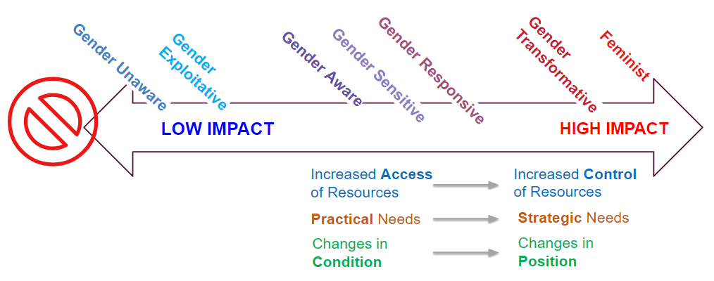

Activity 3.2 - Illustrating Gender Transformative Concepts Group Work Instructions
Session Three

Group Assignments

Group 1  Condition vs. Position | Group 2  Practical vs. Strategic | Group 3  Access to vs. Control Over Resources
Mural link: Facilitators to create and insert Link | Mural link: Facilitators to create and insert Link | Mural link: Facilitators to create and insert Link
- Participant Names | - Participant Names | - Participant Names

Activity Instructions
Session Three

- For this activity, participants will be divided into 3 groups: 1) Conditions vs Position; 2) Practical vs Strategic Needs; 3) Access vs Control. Each group will have access to their own Mural link (see the table above), each with their own their own virtual whiteboard.
- Participants will be moved into Zoom break-out rooms according to the group assignments listed. Each group member will each enter their assigned mural link and together, they will have 25 minutes to agree how they can, without words, illustrate their assigned concept. Using the virtul whiteboard tool, they can draw a picture, use symbols or create an idea tableau that shows how this concept illustrates gender transformative change. Participants will also think about how their concept relates to power and what kind of power (see definitions of power in the “Dig In” box below).
- After 15 minutes, participants will be brought back to plenary. Each group will have an opportunity to briefly show and discuss the group’s illustration and explain:
  - why this concept is important to understanding gender equality; and
  - how this concept is illustrative of gender transformative change.

Dig in! Explore how these concepts have a relationship to power:

Power over people, resources and decisions
Power to act and to realize one’s aspirations
Power with others that comes out of cooperation and collaboration
Power within that comes from a sense of self-worth and self-knowledge

Session Three

Remember! This activity is your first-time using Mural. Take time to play around with Mural’s many interactive features! Have fun playing around and engaging with your group members. Take time to get comfortable with this platform. Don’t hesitate to reach out to your facilitator(s) if you have any questions or need any support!

Note: see Annex 3b for a full explanation of these concepts.

Session 4: Gender Diversity

Key Messages
- Understanding the complexities that exist within gender identity and expression is an important step to unpacking the impact of power and gender
- When talking about gender and gender diversity, the way that power is distributed drives the nature of discrimination which maintains unequal power structures.
Importantly, discussions of power still typically revolve around binary gender norms – power inequality between men and women, boys and girls, typically with cisgendered men and boys as the powerholders. As a result:
- People whose gender identity and expression are gender non-conforming (meaning they are not cis-gendered), often have limited power or influence. They lack the opportunities and freedom to participate and contribute to decisions that affect their lives either because they are not seen or acknowledged, or because they are actively discriminated against.
- Because the power structures that reinforce gender inequality are based on a binary and cisgender understanding of gender, movements for greater gender equality have historically used binary language in their work. While this is in response to discrimination framed against one half of a perceived binary (females), it often excludes gender non-conforming individuals from the conversation and from the movement.
Where does that leave us? Language that includes the two traditional binary categories (male/female; men/women) is still important for several practical and strategic reasons:
- most people associate their sex and gender identity with one of the two traditional binary categories for sex and gender;
- from a medical and scientific perspective, data that includes binary sex disaggregation is essential;
- advocates for gender justice need to employ language that meets discrimination where it lives - and much of that is still overwhelmingly within a binary understanding of gender.
However, while of course we need to include these traditional binary categories, and attempting to eliminate gender-distinguishing language can undermine movements for gender justice, we must include ‘men’ and ‘women’ as two categories within a multiplicity of gender identities, rather than the two options within a binary system. And within this multiplicity, language should be incorporated to reflect the purpose and context of the initiative or work. For example, it may be appropriate for some social studies to use ‘feminine presenting’ as a category where discrimination within service provision is being examined.
Remember! As practitioners and professionals looking to advance gender equality, our challenge is to reflect gender in all its diversity in our work. Inclusion needs to be embedded in our work on the grounds of both ethics and effectiveness. While it might not be possible in every circumstance to push for broad spectrum, systemic change, the importance of identifying opportunities for incremental change is paramount. And these opportunities are already being identified by development practitioners around the world. Below, you will find a list of resources and research that showcase these efforts and provide tools to support gender inclusive development. These include resources such as legal frameworks and analysis, guiding principles, checklists, and an LGBTI Index to guide monitoring and evaluation.

Annex 4a: Important Definitions

Ally | A person who confronts heterosexism, sexism, homophobia, biphobia, transphobia and heterosexual privilege in themselves and others out of concern for the well-being of 2SLGBTQ+ people.
Asexuality | Generally characterized by not feeling sexual attraction or a desire for partnered sexuality. Asexuality is distinct from celibacy, which is the deliberate abstention from sexual activity.
Bisexual | A person whose primary sexual and affectional orientation is toward people of the same and other genders, or towards people regardless of their gender.
Cisgender | The prefix cis- means "on this side of" or "not across." A term used to call attention to the privilege of people who are not transgender.
Cross Dresser | A word to describe a person who dresses, at least partially, as a member of a gender other than their assigned sex; carries no implications of sexual orientation.
Drag | An artform and important part of queer culture that allows people to express themselves through makeup, performance, attire, dance, and music. Drag is often a way for a person to explore gender, whether through a critical or playful lens. A person of any gender can perform as a Drag King, Queen, or Thing.
Gay | Session Four  A sexual orientation toward people of the same gender.
Gender Expression | How one expresses oneself, in terms of dress, mannerisms and/or behaviors that society characterizes as "masculine" or "feminine."
Genderqueer | A person whose gender identity and/or gender expression falls outside of the dominant societal norm for their assigned sex, is beyond genders, or is some combination of them.
Heterosexuality | A sexual orientation in which a person feels physically and emotionally attracted to people of a gender other than their own.
Homosexual/Homosexuality | An outdated term to describe a sexual orientation in which a person feels physically and emotionally attracted to people of the same gender.
Intersex | People who, without medical intervention, develop primary or secondary sex characteristics that do not fit “neatly” into society's definitions of male or female. Many visibly intersex people are mutilated in infancy and early childhood by doctors to make the individual’s sex characteristics conform to society’s idea of what normal bodies should look like. Intersex people are relatively common, although society's denial of their existence has allowed very little room for intersex issues to be discussed publicly.
Lesbian | A woman whose primary sexual orientation is toward people of the same gender.
2SLGBTQ+ | Abbreviation for Two Spirit, Lesbian, Gay, Bisexual, Transgender, Queer (or Questioning), and the plus represents those gender identities that aren’t included in the acronym.
Pansexual | Terms used to describe people who have romantic, sexual or affectional desire for people of all genders and sexes.
Nonbinary | A gender identity that embraces full universe of expressions and ways of being that resonate with an individual. It may be an active resistance to binary gender expectations and/or an intentional creation of new unbounded ideas of self within the world.
Queer | This can include, but is not limited to, gay, lesbian, bisexual, transgender, intersex and asexual people. This term has different meanings to different people. Some still find it offensive, while others reclaim it to encompass the broader sense of history of the gay rights movement. Can also be used as an umbrella term like LGBT, as in "the queer community."
Sexuality | The components of a person that include their biological sex, sexual orientation, gender identity, sexual practices, etc.
Sexual Orientation | An enduring emotional, romantic, or sexual attraction. Sexual orientation is fluid. Asexuality is also considered a sexual orientation (See above definition of asexuality).
Transgender | Used most often as an umbrella term, some commonly held definitions: 1. Someone whose gender identity or expression does not fit (dominant-group social constructs of) assigned birth sex and gender. 2. A gender outside of the man/woman binary. 3. Having no gender or multiple genders.
Transsexual | A person who lives full-time in a gender different than their assigned birth sex and gender. Some pursue hormones and/or surgery while others do not. Sometimes used to specifically refer to trans people pursuing gender or sex confirmation.
Transvestite | This is an outdated and problematic term due to its historical use as a diagnosis for medical/mental health disorders. Cross Dresser has replaced transvestite, see above definition.

LGBTTTQQIAA Guide
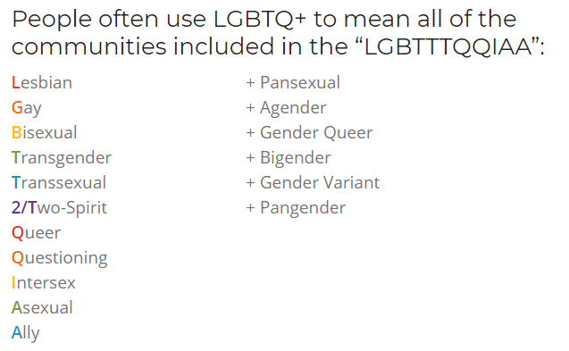

The Gender Unicorn
Session Four

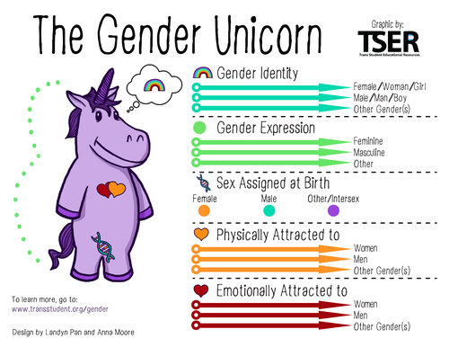

Annex 4b: LGBT+ Inclusion in International Development Programming
Session Four
Learn more: https://cansfe.ca/wp-content/uploads/2021/06/Beyond-the-Binary-A-Guidance-for-Inclusion-of-LGBTI-People-in-Development-Activities.pdf

Engaging LGBT+ Communities

EXPERTISE ABOUT LGBTI POPULATIONS | LGBTI people are themselves the best experts in their own lives. This is particularly true given the general lack of data about LGBTI populations. Because LGBTI people have faced attempts by others to define and characterize them, LGBTI communities have become primary sources of information about their own lived experience. Communities should be consulted regarding questions of how to describe, refer to, define, and classify LGBTI individuals.
PROGRAM/RESEARCH DESIGN AND IMPLEMENTATION | LGBTI people can help identify needs and priorities of LGBTI people and assess what interventions might meet those needs.
DEVELOP LGBTI SPECIFIC MATERIALS | LGBTI people can assist in the creation or review of materials targeting the LGBTI community.
OUTREACH AND VISIBILITY | After LGBTI organizations become familiar with your programs, they can provide referrals and enhance outreach efforts.
ADVOCACY | Local LGBTI organizations are familiar with the issues relevant to advocacy priorities related to LGBTI people, and have often formulated their own strategy for achieving advocacy goals. LGBTI organizations can help guide others who want to support these goals.
JOINT PROGRAMMING | Engaging in workshops, panels, sign-on letters, joint publications, and other joint programming can provide excellent opportunities to establish working relationships with LGBTI communities.
SAFE SPACE | LGBTI people are often in need of safe spaces for meetings, programs, and organizational sponsorships.
Safety, Security, and Do No Harm

Understand Risks Faced by LGBTI Communities | - Development activities may pose risks to individual LGBTI people as well as LGBTI communities. Raising the public visibility of LGBTI people, the spaces they occupy, and the issues that concern them may result in elevated risks. In some contexts, legal standards may constrain attempts to publicize, communicate or have meetings regarding LGBTI issues.  - On the other hand, many LGBTI communities have found that avoiding visibility results in isolation and vulnerability. For these communities, higher levels of visibility can help ward off attempts to target them. Establishing visible relationships with other sectors of society, domestically and internationally, has been a source of protection and accountability. Accordingly, one cannot assume that visibility is risky and discretion is more safe.
Rely on Local Communities to Assess Risks and Select Responses | - The best method to accurately assess the vulnerabilities of LGBTI people and the risks associated with particular activities is to consult with local LGBTI communities and organizations.  - LGBTI advocates recognize the need to work in coalition with allied individuals and organizations. As part of this, LGBTI communities have experience in advising others about potential risks and recommending strategies.
Observe Already-Existing Ethical Principles and Development Practices  Session Four | - Development practitioners should not lose sight of already-existing principles that may help guide the assessment of risks and benefits. Well-developed research ethical standards regarding human subject research provide guidance about the privacy, confidentiality and security of human subject data.  - Organizational policies regarding diversity, professional conduct, and organizational mission can often serve as guiding principles when assessing risks and benefits.

Annex 4c: Tools

CanWaCH. Beyond the Binary: A Guidance for Inclusion of LGBTI People in Development Activities. https://cansfe.ca/wp-content/uploads/2021/06/Beyond-the-Binary-A-Guidance-for-Inclusion-of-LGBTI-People-in-Development-Activities.pdf

Egale. LGBTQI2S Glossary of Terms.
https://egale.ca/awareness/glossary-of-terms/

Global Affairs Canada: The human rights of lesbian, gay, bisexual, transgender, queer, 2-spirit and intersex persons.
https://www.international.gc.ca/world-monde/issues_development-enjeux_developpement/human_rights-droits_homme/rights_lgbti-droits_lgbti.aspx?lang=eng

IPPF Humanitarian. LGBTIQ+ Inclusion in Humanitarian Action (2019).
https://www.ippf.org/sites/default/files/2019IPPFHumanitarian_LGBTICapabilityStatement.pdf

Park, Andrew and Lucas Ramon Mendos. Guiding Principles on the Inclusion of Lesbian, Gay, Bisexual, Transgender, and Intersex (LGBTI) People in Development Policy and Programs (November 2018).
https://www.rfsl.se/wp-content/uploads/2018/11/RFSL_Guiding-Principles_final_digital.pdf

DCHA/DRG/HR. Suggested Approaches for Integrating Inclusive Development Across the Program Cycle and in Mission Operations (July 2018).
https://usaidlearninglab.org/sites/default/files/resource/files/additional_help_for_ads_201_inclusive_development_180726_final_r.pdf

Lee Badgett, M.V. and Randall Sell. A Set of Proposed Indicators for the LGBTI Inclusion Index (March 2019).
https://www.undp.org/content/undp/en/home/librarypage/hiv-aids/lgbti-index.html
Session Five

Session 5: Intersectionality

Activity 5.1 Instructions: Our Identities

- Let’s reflect on our own identities. Participants will think about some words they would use to describe their identity.

- They will populate 1 example at a time to the Sli.do “word cloud poll”. [facilitator inserts link]

- Participants will have 3 minutes to independently brainstorm and populate their responses. They can type as many responses as they’d like!

- The final word cloud will be screenshared by the hosts.

Session Five

Activity 5.2 - Power Walk Activity
Session Five

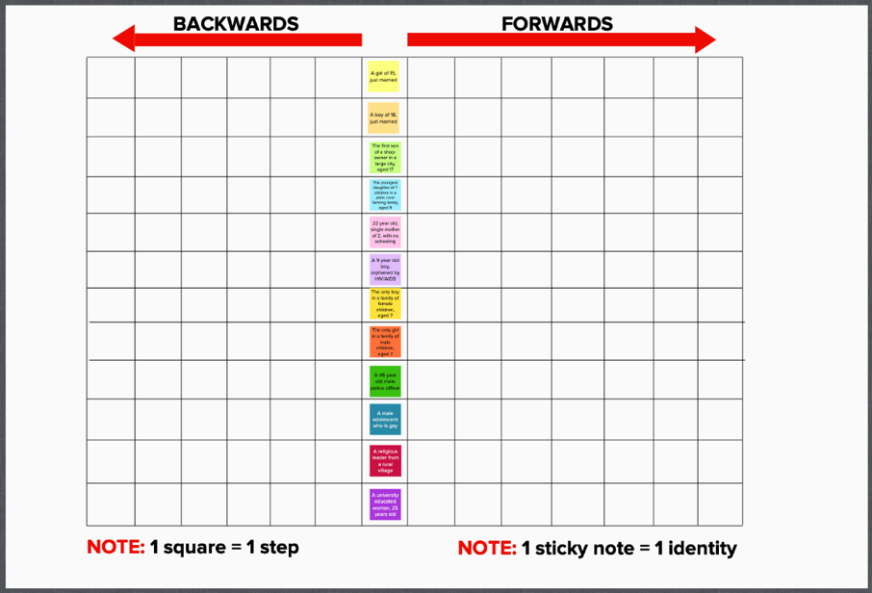
Activity Instructions
Session Five

- Not all participants will be active players. Active players will be assigned a “Power Walk Identity” (see below).
- Participants will login to Mural [facilitators insert link]. They should see a graphic that looks like this. ----------------------->
Each sticky note has a different identity written on it.
- The facilitator is going to read out the “Power Walk Statements,” one statement at a time.
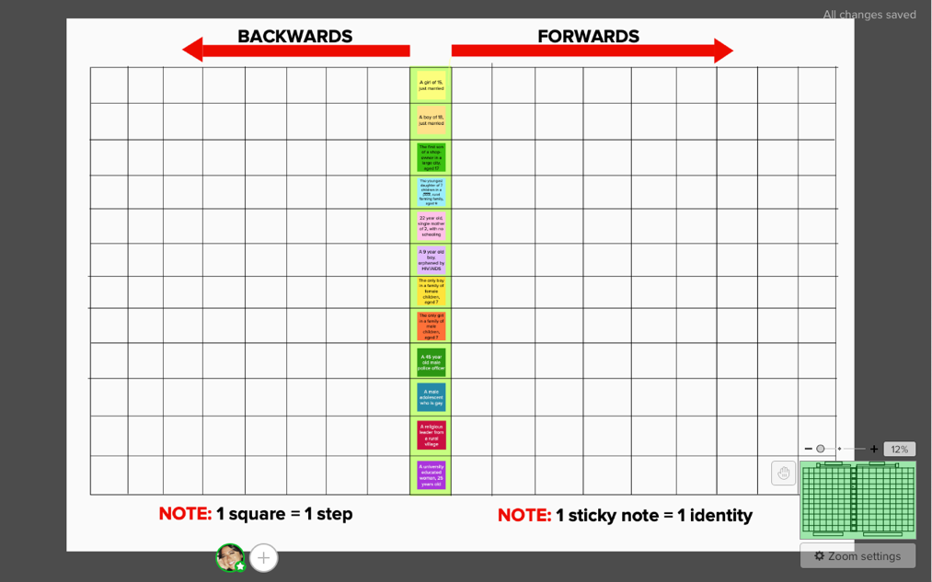
- If the statement is likely to be true for a participant’s power walk identity, they should move their assigned sticky note on MURAL one space forward on the grid.
- If the statement is likely to be false for their identity, they should move their assigned sticky note on MURAL one space backward on the grid.
- If they are unsure, keep the sticky note in the same place.

Tip! If you’re an active player, zoom out so that you can see the full whiteboard!

Zoom features

Active Participants | Observers
Facilitators associate an identity with the name of a particopant  - XX (A boy of 18, just married)  - XX (The first son of a shop-owner in a large city, aged 17)  - XX (A male religious leader from a rural village)  - XX (The youngest daughter of 7 children in a religiously conservative family, aged 9)  - XX (Single mother of 2, with no schooling, aged 22)  - XX (Urban young female who is blind)  - XX (Female foreign head of a local NGO)  - XX (9 year old boy orphaned by HIV/AIDs)  - XX (Transgender woman who belongs to a racial minority, aged 40)  - XX (A girl of 15, just married) | Facilitators lists here names of participants who will observe the activity  - XX  - XX  - XX

 | Power Walk Statements
1 | “I will choose who and when I marry”
2 | “I am likely to receive equal attention and time from my teachers in school”
3 | “I can walk safely on my own at night”
4 | “I can access primary health services if/when I need them”
5 | “I do not need permission to go to the doctor/health clinic.”
6 | “My family prioritizes my education”
7 | “I am encouraged to speak my opinion”
8 | “I expect to participate in community decision-making when I am older”
9 | “When resources are low my health and well-being is my family’s priority”
10 | “It is expected that I will attend and complete school”
11 | “I can afford the basic necessities in life/provide for my family”
12 | “I do not want children – I am able to access contraception easily and with no stigma”
13 | “I do not want children – I share household decision making power with my partner and we are in agreement about using contraception to prevent pregnancy”
14 | “I am not afraid that people in my life might physically hurt me”
15 | “I have never felt degraded, controlled, humiliated or intimidated by someone’s words or actions towards me”

Adapted from: https://www.ndi.org/sites/default/files/Sample-Workshop-Groundrules.pdf
World Health Organization https://www.who.int/health-topics/gender#tab=tab_1
World Health Organization https://www.who.int/health-topics/gender#tab=tab_1
World Health Organization https://www.who.int/health-topics/gender#tab=tab_1
https://www.who.int/gender-equity-rights/knowledge/glossary/en/
World Health Organization https://www.who.int/gender/mainstreaming/GMH_Participant_GenderAssessmentScale.pdf
Rutgers https://www.rutgers.international/sites/rutgersorg/files/Manuals/Rutgers-GTA-guide-to-theory.pdf
Gender and Environment Resource Centre https://genderandenvironment.org/2015/08/stop-being-so-sensitive-the-shift-from-gender-sensitive-to-gender-responsive-action/
World Health Organization https://www.who.int/gender-equity-rights/knowledge/glossary/en/
World Health Organization https://www.who.int/gender-equity-rights/knowledge/glossary/en/
https://www.who.int/gender-equity-rights/knowledge/glossary/en/
World Health Organization https://www.who.int/gender/mainstreaming/GMH_Participant_GenderAssessmentScale.pdf
http://downtozeroplatform.com/dtz/files/Plan%20Netherlands%20Gender%20Equality%20Programma%20Criteria.pdf
http://downtozeroplatform.com/dtz/files/Plan%20Netherlands%20Gender%20Equality%20Programma%20Criteria.pdf
Economic and Social Commission for Western Asia
CEDPA: Mobilizing for Equity: Gender and Reproductive Health Considerations http://www.nzdl.org/gsdlmod?e=d-00000-00---off-0cdl--00-0----0-10-0---0---0direct-10---4-------0-0l--11-en-50---20-about---00-0-1-00-0--4----0-0-11-10-0utfZz-8-10&cl=CL2.19&d=HASHf0f5085aa2803c9757ee6b.12.3&gt=1
CEPDA: Mobilizing for Equity: Gender and Reproductive Health Considerations http://www.nzdl.org/gsdlmod?e=d-00000-00---off-0cdl--00-0----0-10-0---0---0direct-10---4-------0-0l--11-en-50---20-about---00-0-1-00-0--4----0-0-11-10-0utfZz-8-10&cl=CL2.19&d=HASHf0f5085aa2803c9757ee6b.12.3&gt=1
CEPDA: Mobilizing for Equity: Gender and Reproductive Health Considerations http://www.nzdl.org/gsdlmod?e=d-00000-00---off-0cdl--00-0----0-10-0---0---0direct-10---4-------0-0l--11-en-50---20-about---00-0-1-00-0--4----0-0-11-10-0utfZz-8-10&cl=CL2.19&d=HASHf0f5085aa2803c9757ee6b.12.3&gt=1
Economic and Social Commission for Western Asia
CEDPA: Mobilizing for Equity: Gender and Reproductive Health Considerations http://www.nzdl.org/gsdlmod?e=d-00000-00---off-0cdl--00-0----0-10-0---0---0direct-10---4-------0-0l--11-en-50---20-about---00-0-1-00-0--4----0-0-11-10-0utfZz-8-10&cl=CL2.19&d=HASHf0f5085aa2803c9757ee6b.12.3&gt=1
CEPDA: Mobilizing for Equity: Gender and Reproductive Health Considerations http://www.nzdl.org/gsdlmod?e=d-00000-00---off-0cdl--00-0----0-10-0---0---0direct-10---4-------0-0l--11-en-50---20-about---00-0-1-00-0--4----0-0-11-10-0utfZz-8-10&cl=CL2.19&d=HASHf0f5085aa2803c9757ee6b.12.3&gt=1
CEPDA: Mobilizing for Equity: Gender and Reproductive Health Considerations http://www.nzdl.org/gsdlmod?e=d-00000-00---off-0cdl--00-0----0-10-0---0---0direct-10---4-------0-0l--11-en-50---20-about---00-0-1-00-0--4----0-0-11-10-0utfZz-8-10&cl=CL2.19&d=HASHf0f5085aa2803c9757ee6b.12.3&gt=1
CEPDA: Mobilizing for Equity: Gender and Reproductive Health Considerations http://www.nzdl.org/gsdlmod?e=d-00000-00---off-0cdl--00-0----0-10-0---0---0direct-10---4-------0-0l--11-en-50---20-about---00-0-1-00-0--4----0-0-11-10-0utfZz-8-10&cl=CL2.19&d=HASHf0f5085aa2803c9757ee6b.12.3&gt=1
https://lgbt.ucsf.edu/glossary-terms
Outsaskatoon.ca
https://ok2bme.ca/resources/kids-teens/what-does-lgbtq-mean/
https://www.doyoutools.org/breaking-the-box

