Inclusion of Women and Girls with Disabilities into Health and Gender Equality Programming

Participant Package - Webinar 1

MODELS OF DISABILITY, BARRIERS TO INCLUSION,

DISABILITY DEFINITIONS

The three models of disability
Defining ‘disability’ is central to work on disability inclusion. How people conceptualise disability influences how they behave towards people with disabilities, how they frame their problems and needs, and how programmes are developed in response. Currently most development programmes ignore people with disabilities - or treat them as a special case. Women and girls with disabilities tend to experience compounded exclusion, based on their disability and gender.

There are three predominant models of disability representing different approaches:
- The Medical Model
- The Charity Model
- The Social / Human-Rights model

It is the power relations regarding the role of society, professionals and people with disabilities that in essence defines the difference between each of these models.

Traditionally, disability has been conceptualised using either the medical or charity model. Collectively these models are referred to as the ‘individual approach’ because both focus on the person with an impairment as being (or having) the ‘problem’. These models are behind programmes that target people with disabilities as separate groups needing specialist or dedicated services, chosen on their behalf by ‘experts’. This is characterised by development of isolated initiatives such as provision of prosthetics/orthotics, habilitation/rehabilitation or speech therapy programmes; or the setting up of specialist income-generating projects or vocational training centres, where these are not linked to any particular mainstream programme.

By contrast, the social / human rights model promotes the assumption that people with disabilities should participate in all development activities since they are members of communities. But it also pays attention to the fact that those activities may need to be adapted for accessibility and inclusion. It means different social agents taking responsibility for understanding what barriers might exist and how to mitigate them so that people with disabilities are included as stakeholders in all mainstream work and looking for ways to support their participation in community life.

Everyone has a right to basic services such as health, reproductive health, education and income generation. But the needs of people with disabilities have traditionally been treated as separate and specialised which has put them outside mainstream development, with little voice or power when it comes to the design of programmes or interventions. The UN Convention on the Rights of Persons with Disabilities challenges this narrow approach. The emphasis for inclusion under the social / human rights model is placed on society reducing barriers and promoting opportunities for participation rather than on expecting people with disabilities to ‘fit in’ as best they can. Persons with disabilities should be seen as people with the same basic needs and rights as others, able to choose how and when they participate and are supported to achieve that.

Each model represents a different perspective on what ‘disability’ is conceptually, and therefore how development and health experts approach disability in their work. Attitudes and power relations regarding the role of society, professionals and persons with disabilities are at the heart of the difference between each of the approaches. The extent to which persons with disabilities are included in programmes – or not – is a direct result of the approach adopted.

In summary - the first two models, medical and charity approaches focus on barriers to participation being with the individual with an impairment who needs to be “fixed” or will be long-term dependent. The third model, known as the ‘social’ or ‘human rights’ model, focuses on barriers being with society’s view of persons with disabilities and how this leads to the exclusion of the individual with an impairment.

Medical Model (individual approach)

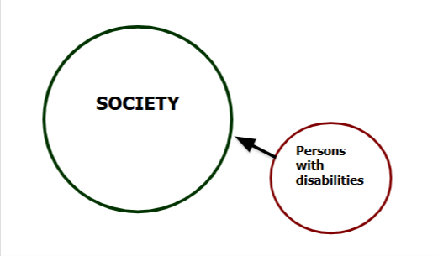
Disability is a ‘problem’ in the person

Activities "fix" persons with disabilities, who are "sick", so they can join "normal" society.
- Focuses on a person’s impairment as the obstacle
- Seeks to "cure" or "improve" individuals to "fit" them into society
- Leads to segregated services resulting in exclusion from the mainstream with the rationale that this means better, specialised services can be provided
- Decision making is in the hands of specialists or professionals with little or no regard to the rights of individuals
- Expensive, tends to benefit relatively few;
- People with disabilities play a passive role in the development and implementation of disability policy and practice
Activities implemented under the medical model will put the focus on trying to “fix” or “cure” the person’s impairment with the intention that once fixed, they will be able to join in “normally” with the community around them. This leads to persons with disabilities receiving segregated services such as special education in separate schools, or medical rehabilitation as the main or only intervention, which are often expensive to deliver and therefore only available to the relatively few people who are direct beneficiaries of projects.

Charity Model (individual approach)

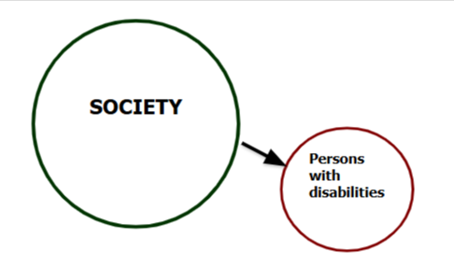

Disability is a ‘problem’ in the person

Activities "help" persons with disabilities who are "helpless" and outside "normal" society.
- Regarded as "unfortunate", "dependent" or" helpless"
- Persons with disabilities are seen as needing pity and charity, often with roots in traditional understandings that impairments result from sin, ill-favour or curse
- Assumes people with impairments cannot contribute to society or support themselves
- Provides them largely with money or gifts, such as food or clothing
- Persons with disabilities become long-term recipients of welfare and support throughout their lives
- Aid is provided by specialist organisations not mainstream development organisations and service providers
Activities implemented under the charity model focus on trying to help individual persons with disabilities who are seen as being helpless or unable to do things for themselves. This often takes the form of direct aid such as cash transfers, or specialist education and employment programmes. It promotes the idea that persons with disabilities are long-term welfare recipients and reinforces the idea that they are outside ‘normal’ society and unfit to make productive contributions to communities.

Social/human rights Model (rights-based approach)

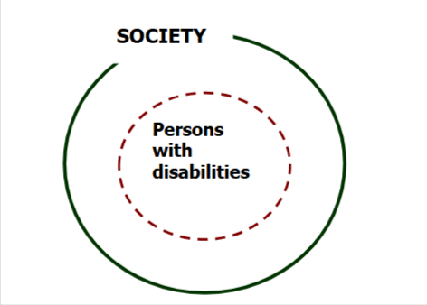

Disability results from barriers in society

Activities focus on inclusion, recognising explicitly that persons with disabilities are a normal part of all communities.
- Sees disability as the social consequences of impairment
- Regards persons with disabilities as part of society, rather than as separate
- People with impairments are disabled by society denying their rights and opportunities
- Persons with disabilities’ rights are the same as non-disabled persons e.g., education, health, for loving relationships etc
- Leads to inclusive approaches to education, employment and other services by encouraging the participation of persons with disabilities in mainstream programming
- Activities focus on identifying and removing attitudinal, access and institutional barriers that block inclusion
- Underpinned by national and international legislation including the UN Convention on the Rights of Persons with Disabilities (CRPD)
Activities implemented under the social/human rights focus on the removal of barriers and the balancing of power dynamics (including through the empowerment of persons with disabilities) to achieve greater equality.

Barrier analysis

A barrier analysis will help identify some of the underlying access, institutional, and attitudinal causes of exclusion. The purpose of conducting a barrier analysis is to highlight the barriers that underlie the exclusion from services and interactions that some people experience. By understanding and recognising the barriers, over time systemic changes to attitudes, behaviour, policies and laws can happen and inclusion will increase.

Access Barriers

People with disabilities encounter access barriers in areas such as:
- Public transport
- Hospitals and clinics
- Schools and housing
- Shops and marketplaces
- Places of worship
- Media and communications
- Public information systems

There are two main categories of access barriers:

- Physical barriers. Most people think of physical barriers in the access barriers category – e.g., a health clinic is inaccessible for wheelchair users if it has steps and narrow doorways. It’s relatively easy to identify these – in consultation with persons with disabilities – once aware. It is important that toilets, hand-washing facilities and refreshment areas are physically accessible to all in buildings too.

- Communication barriers. Communication can also be disabling for those with sensory impairments – e.g., for Deaf people if there’s no sign language or communication adaptations; for those with visual impairments if large print textbooks are not available, for people with intellectual impairments when people use language they do not understand. Poor communication can have devastating results where important public health education campaigns happen (e.g., HIV and AIDS, Covid-19 precautions, safe sex practices). Students with hearing, visual or intellectual impairments are unlikely to access vital information unless their access requirements have been met.

These barriers are grouped together as: Access (or Environmental) barriers.

Physical barriers are often easiest to identify – for example steps, narrow pathways, uneven surfaces, toilets with no supporting handrails. But communication barriers are just as significant to identify for those with sensory or communication impairments.

Institutional Barriers
Some barriers exclude or segregate people with disabilities from areas such as:
- Legal system
- Health service provisions
- Education policies
- Employment laws
- Health service provisions
- Social services
- Humanitarian / development agency policies
- Belief systems and religion
Many of the services people take for granted are ‘no-go’ areas for people with disabilities because of laws and policies that cause discrimination to them. For example, lack of official recognition of sign language can mean that schools are unable to teach deaf children where it is their main language and there is no support for sign language interpreter training. Having to pay copyright fees to print books in Braille may limit the number of texts available to students with visual impairments who use Braille.

In many countries legislation still permits forced sterilization or termination of pregnancies in young women with cognitive or psycho-social impairments and may continue to promote institutionalization without consent.

If young people with disabilities make it through the education system and acquire qualifications the lack of willingness amongst employers to implement reasonable accommodation measures may preclude them from taking up work. There are examples of physically impaired people qualifying as teachers but then being banned from getting jobs in schools because of the school’s inadequate interpretation of “fitness to work” criteria commonly written into Job Descriptions. Also reports of deaf people unable to open bank accounts to start businesses because banks refuse to allow communication support into meetings with bank staff – saying it will break their strict confidentiality codes. Even where legislation is in place if the terms of reasonable accommodation are not specified and not enforced then people with disabilities will remain excluded from the workforce.

These barriers are grouped together as: Institutional barriers.

Institutional barriers are some of the most difficult to identify. Without a proactive search for them, they won’t be as immediately evident. That’s because they’re often linked to social and cultural norms and written into policies and legislation. The way to start identifying them is to focus on sectors in which you work, and try to map the legal, cultural, and social practices that might need addressing. Consulting with local persons with disabilities (including their representative organizations – OPDs) will be an essential part of helping identify them.

Attitudinal Barriers
Prejudice, discrimination and stigma cause the biggest problems for people with disabilities – but it is often the least recognized barrier when considering disability inclusion. Persons with disabilities are often assumed to be one or more of the following:
- Incapable/inadequate
- Of low intelligence
- In need of a ‘cure’
- Needing ‘special’ services or support
- Cursed by ‘bad spirit’
- Inspirational/ exceptional
People who make these judgments treat people with disabilities as superfluous or superhuman. They either fail to respond to the individual – with all their inherent personality, strengths and weaknesses – or they assume they have ‘superhuman’ abilities to cope with their impairment.

Non-disabled people can respond with fear, pity, repulsion, or a sense of superiority. These assumptions and emotions are often reinforced by the media and important cultural influencers in societies. Negative language reflects and can reinforce prejudices. Persons with disabilities wish to change the language used by non-disabled people about them – especially language that is offensive and inaccurate.

These barriers are grouped together as: Attitudinal barriers.

Attitudinal barriers are the most important to identify – time and time again they are the main reason preventing progress on disability inclusion. Negative attitudes and assumptions have led to people with disabilities- especially girls and women with disabilities who face gender-based discrimination as well - believing themselves to be worthless, dependent and in need of support. This cycle of charity and dependency can be difficult to break.

In discussions with people with disabilities and their families, if time is taken to understand their challenges, most report the biggest barriers they face are attitudinal ones. Most people in society who don’t know them assume the biggest barriers they face are access ones, especially physical access barriers – if they have considered at all that there are barriers faced by them in society.

Intersectional learning points on barriers:
- Many barriers to inclusion relate to each other. Access barriers are often linked to policies of institutions, which are made up by individuals with their belief systems. Attitudinal barriers are cross-cutting and exist almost everywhere.

Persons with disabilities

LGBTQI+ community

Younger women
Programme intervention
- Institutional barriers are sometimes subtle. They may seem normal and more easily accepted because they come from institutions and governments. But it doesn’t mean they cannot be changed.
- There is a link between social norms (common values and beliefs), individual action (such as discrimination based on prejudice and stereotyping) and institutional action (driven by individuals’ belief systems and prejudices). Interventions must consider all these factors and how they influence one another.
- Intersecting characteristics (such as age, gender, ethnicity, disability, sexual orientation or location) can increase barriers to inclusion. Women with disabilities are an at-risk group (as women) within another at-risk group (persons with disabilities), and their needs and demands have often been seen in the context of disability only. That makes it difficult to identify and address the causes for the multiple discrimination, most of all in gender-based violence contexts. Men with disabilities can also marginalize women with disabilities. Barriers accumulate over the life course, creating more marginalisation in older age.
- This means that development interventions that aim to be inclusive, but only address certain exclusionary factors, such as age, gender, ethnicity, disability, sexual orientation or location, will leave many women, such as older women, women with disabilities, indigenous women or lesbians, facing barriers to inclusion based on their gender.
- Large numbers of people face numerous barriers. It is tempting to focus on supporting individuals to meet their needs. However, a needs-based approach is less likely than a rights-based approach to overcome barriers necessary to bring about lasting change, that is, changes to institutional systems and social norms.
- Based on a detailed barrier analysis, interventions need to find a balance in addressing access, institutional and attitudinal barriers. They also need to find a balance between supporting individuals and bringing about broader change (changing social norms).

Defining disability

The United Nations Convention on the Rights of Persons with Disabilities (CRPD) defines disability as including “those who have long-term physical, mental, intellectual or sensory impairments, which in interaction with various barriers may hinder their full and effective participation in society on an equal basis with others.” Article 1 – Purpose

The CRPD is based upon the social/human rights model creating opportunities for participation not expecting persons with disabilities to ‘fit in’ to ill-adapted programmes as best they can. Persons with disabilities are a normal part of all communities with the same basic needs and individual aspirations as peers. They should be able to choose how and when they participate and be supported to make their own contributions.

DEFINING DISABILITY

An impairment is characterised by:
- Problems in body function or structure
- Conditions caused by disease or injury that affect a person’s functioning or appearance, e.g. lacking part of or all of a limb; or a limb, organ or system that doesn’t fully function
- Long-term or short-term problems
- Single or multiple problems

Use impairment when you want to describe what makes an individual different from others (i.e. the physical, sensory, cognitive, or mental health problem(s) they have), perhaps when you are planning for specific access requirements.

Disability is characterised by:
- The results of limitations imposed on people with impairments
- Those limitations prevent their full and active participation in society
- Attitudinal, environmental and institutional barriers prevent inclusion

Use disability when you want to describe the affect or impact that an impairment has on an individual’s opportunity to carry out activities of daily living.

Impairment + barriers = disability

What are some of the main causes of impairments?
- Some impairments are congenital due to genetic factors
- Other impairments can be caused by an injury or illness before birth
- Others can be caused by injury or illness after birth
- A child or adult can have multi-impairments from one or more causes
How do impairments affect children and adults?
- Physical impairment affects body movement and/or appearance
- Sensory impairment affects sight, hearing, speech, smell, taste, sensation/feeling, physical balance
- Neurological impairment affects the nervous system, speech, motor skills, vision, memory, muscles, learning abilities
- Intellectual impairment affects cognitive functioning and behaviour
- Mental illness affects thinking, moods, ability to relate and capacity for coping with life

Power analysis

Power takes many forms - visible, invisible, and hidden - and operates formally through institutions and rules, and informally through relationships and social norms. However, the effects of power are found in every part of our lives: how issues are framed, decisions made, in the ways particular people are valued or marginalised, where resources are used and who/what is prioritised, and how people regard themselves, can participate and have choices, and to shape their own lives and destinies.

Table 1: Four forms of power
Power over:  Often associated with negative power: oppression or repression, denying people freedom of movement, of speech, of action; often found in conflict and crises, but also in every-day life.  e.g. difficulty of securing a job or housing on the basis of names associated with an ethnic or religious minority; difficulties for same-sex couples to get married and/or adopt children; prescribed clothing and/or hairstyles, especially for women in public life; loss of legal capacity especially for persons with disabilities, especially women. Can also be positive in context of safety & protection: laws for safety of citizens (driving, child protection) but needs to have legitimacy and accountable scrutiny; or having power over resources and assets | Power to:  Ability to decide and carry out actions, to resist oppression or create something new; decision making within the household, community, and more broadly; potential of every individual to shape their life.  e.g. woman’s power to leave an abusive husband, or to go to work; a young person to decide when to marry and what profession to learn, a person with disabilities to decide to live on their own.
Power with:  Ability to find common ground among different interests and to act collectively, based on solidarity and mutual support, building collective strength; building and making use of networks.  e.g. organisations of persons with disabilities, women’s associations, young persons’ clubs and organisations | Power within:  Knowledge, individual capabilities, sense of dignity, self-esteem and self-belief to imagine and make changes in their lives; personal dignity is often identity-based, linked with culture and/or religion which influence thoughts and actions
Adapted from Tools for Analyzing Power, Inclusion and Exclusion,
How then, does the power analysis relate to the models of disability? The individual models of disability represent a position of power, where non-disabled society assumes superiority (power over). When people engage with persons with disabilities on the basis of medical- and/or charity-model-thinking, they are taking an ableist perspective where the focus is impairment-based, and assumptions are made and actions taken based on what they believe is best for persons with a disability. These individual model approaches are ones in which non-disabled society has power over persons with disabilities as providers of support, for example, money, clothes, food; or professional opinions, for example working as health professionals, making referrals to the medical sector, or by creating special education or livelihoods programmes based on assumed impairment needs. In these situations, persons with disabilities rarely get the power to decide and act for themselves. Even consultations with persons with disabilities may be directed or led in a way that aligns to medical and charity model expectations by limiting participation to assessing impairment needs.

Being aware of the influences of power, alongside barrier analysis, is very important throughout the project cycle: in the situation analysis, during designing and implementing disability inclusive projects as well as in MEAL processes. As the example below shows, assumptions are often made in relation to barriers and power which directly affect outcomes.

Case Study 1: Life skills programmes and planning for power differences

What happened:
An organisation designed Life Skills training programmes for adolescents and young persons, particularly to help them prepare for transitioning to work. The organisation was keen to include adolescents with disabilities.

The challenge:
In adapting the training, a lot of effort went into issues of accessibility (environmental barriers). However, the power within was underestimated for adolescents with disabilities with the effect that during many group-work exercises, these adolescents rarely participated. They lacked the confidence and power to share their opinions and/or their experience, while their peers without disabilities didn’t have the maturity and/or sensitivity to be curious and take the time to engage them (attitudinal barriers). Inadvertently, adolescents without disabilities held some power over their peers with disabilities when it came to reaching consensus and making decisions.

The solution:
Both adolescents with and without disabilities would have benefited from preparatory sessions to support them before participating in a joint training programme. Being aware of the potential power differences ahead of delivering this training would have improved participation.

Below is a table that outlines a general barrier analysis in the context of SRH with reference to power dynamics, along the socio-economic model.

Table 2: General Barriers and Power Analysis: Example SRHR
LEVEL | ATTITUDINAL  BARRIERS | ENVIRONMENTAL BARRIERS | INSTITUTIONAL BARRIERS
Individual | Lack of self-confidence and self-esteem:  Limited Power within  Affects negotiating skills and power in relationships; consent to and having safe sex; asking for information on SRH, requesting advice, screening, treatment etc  Limited Power to and with | Lack of accessible information and infrastructure in private and public life: see all barriers at following levels | Lack of support:  see all barriers at following levels
Individual |  | Particularly these barriers become more solid in the context of conflict, disaster and other crises; or sometimes, previously improved situations reverse to barriers being put up again
Family/ partner level | Overprotection:  - Worried about potential promiscuity of children (especially boys with intellectual disabilities) or sexual violence against girls with disabilities, therefore, keep information on SRH away from them  - Prefer/condone sterilization of mostly girls to “prevent violence” and/or prevent passing on disability  Indifference:  - Consider youth asexual and therefore don’t need sexual reproductive information and/or contraceptive methods  - Select menstrual management and contraceptive methods that are most convenient to carer (incl hysterectomy)  - May discourage girl/woman from having children because are considered unfit to be mothers  - May encourage girl/youth to have children for purpose of care (child=future carer of disabled mother) even without husband  - Considered unable (unworthy) of making decisions over own body: pregnancy, family planning – coerce youth/persons into invasive, irreversible methods  - Considered unnecessary investment in SRH  - Sexual violence tolerated |  | Tendency to promote early marriage of girls to transfer “burden of care” and /or to “normalise” girls through fulfilling a social norm  Tendency to promote early marriage to much older man as his carer; at times as second or third wife, in effect as cheap domestic worker  These tendencies become more pronounced during and directly after conflict and crises  Results in Power Over
Community | - Sexual violence tolerated: belief, girl/woman should be grateful for a man to provide sex despite her disabilities; value of girl/woman too low to warrant judicial efforts | - Lack of safe, accessible public toilets  - Lack of accessible informational material  - Lack of accessible public transport to SRH services  Results in Power Over | - Lack of consultation with girl/woman in case of violence – decisions (if any) made for/over her  - Lack of consultation on SRH needs and access  - Lack of investment and prioritization of safety and access of women and girls to services
Service providers | - Consider youth asexual and therefore don’t need sexual reproductive information and/or contraceptive methods  - Negative perception on pregnant women/girls with disabilities resulting in verbal abuse, lack of support incl communication during pregnancy, child birth and post-delivery maternal care  - Lack of willingness to communicate and consult with youth/persons about menstrual management, contraceptive methods; may also coerce parents/carers about invasive, irreversible interventions | - Lack of accessible information on contraception, safe sex and STDs  - Lack of inclusive communication in health centres and facilities  - Lack of adaptable equipment such as examination tables, Gyn chairs etc  - Lack of accessible infrastructure of health facilities | - Lack of health personnel trained in disability relevant to SRH  - Youth/persons may not be considered for screening for cancer, STD and other SRH issues  - May not receive treatment, medication for SRH-related problems and diseases  - Unlikely to promote research and disaggregated data on SRH and disability  Results in Power Over
Government | - Lack of interest in disability (incl data, research)  - Lack of commitment to address specific needs as rights, particular financial investment | Across:  Results in Power Over | - Lack of budget/investment in training of health personnel on disability and inclusion  - Lack of budget allocation for/ investment in accessible informational material and equipment, accessible infrastructure  - Lack of inclusive health campaigns with representation of persons with disabilities  - Lack of inclusive policies on access to health: prevention and treatment; legal capacity as a human right  - Lack of promoting inclusive research and data

Ideally, such barrier and power analyses are conducted with persons with disabilities. Keep in mind that:
- The more specific and nuanced you want to investigate barriers in a particular context, the more attention you must pay to the experiences of diverse persons with different impairment types, genders, age and other relevant identity factors.
- The more attention you pay to intersecting identities, the more attention you also need to pay to power dynamics and how barriers may amplify. Keep in mind that everybody comes with their own biases, including staff, and also persons with disabilities.

Additional information on SRHR and young persons with different impairments
- For blind participants: Children learn a lot by observing others. They imitate what they see from their peers and adults, and from this they learn the rules about non-verbal behaviour. Children who are blind miss this kind of information. They don’t see that couples in romantic relationships hold hands, or kiss. They don’t know what men/boys or other girls physically look like. They also can’t compare their own bodies to others. This may make them feel insecure about their own body and about sexuality in general.
- In training modules there is often a lot of visual information about puberty, the reproductive system and contraceptive methods. You will have to find a way to make it accessible to girls that are blind or have low vision.: The first step is to describe in depth what is seen in the pictures. You can involve the group by asking them to describe what they can see.
- Secondly, dolls or scale models of male and female genitals will be very helpful physical aids. Perhaps these scale models could be borrowed from a health service nearby, or from a school or university. Let everyone touch the scale models, not only the girls who are blind, otherwise they may feel awkward. The same standard applies when you talk about the use of condoms. Let everyone touch and feel the condoms, so that they all can experience and understand.
- For deaf participants: Deaf boys and girls learn a lot about relationships from observation. They also see images regarding sexuality and relationships in the media, but they may miss out on the context and setting because this information is not accessible to them and they may not yet have developed appropriate language and vocabulary to discuss issues. As a result, their understanding of sex and sexuality may be unrealistic. It is important that appropriate language and vocabulary are clearly explained to young deaf people with accurate explanations given for the difference between relationships and sexuality shown in the media, and in real life (important for all children and young persons in all their diversity!).
- For deaf children or children with other speech difficulties, touch is a part of everyday communication. They are used to touching and being touched to make connections with others. As a result, it is often more difficult for them to make a distinction between functional and intimate touch. This topic can be very well addressed during the consent sessions, for example by using a specific case story about a deaf boy or girl.
- Make sure that the deaf participants can follow the discussions in the group and are able to share their own experiences and ask questions as much as they want to. In this scenario it is always best to prepare the ground by ensuring young deaf people have the chance to learn about sex and sexuality from suitably experienced local sign language users, rather than relying entirely on sign interpreters. Local sign language users will help the young people to build their language capacity appropriately before going into mixed group discussions. When using sign interpreters make sure they are fully briefed before sessions so they are aware of the vocabulary that will be required.
- For participants with physical impairments: Boys and girls with physical impairments may feel insecure because their body functions or looks different to other boys and girls of their age. It is important that they build up their self-confidence and realise that they are beautiful as they are.
- Children with physical disabilities that need support in self-care (washing, getting dressed, going to the bathroom) are often used to other people seeing them naked and touching their body. As a result of that, it may be more difficult for them to indicate their physical boundaries. In the group sessions, make sure that the children with physical disabilities can participate in the interactive exercises. Make sure that they can ask their questions. You may want to involve a resource person with a physical impairment who can explain how she is accessing Sexual Reproductive Health Services and how she is dealing with the barriers she comes across.
- For participants with intellectual impairments: The physical development process of children with intellectual disabilities is often like or similar to that of their peers. Their social and emotional development is often a bit slower. So there may be a discrepancy between the development of their body and their social and emotional skills at various points in their lives. It is, however, very important that they learn how to make decisions about their sexuality and how to protect themselves from unwanted sex, sexual diseases and pregnancy. Parents often find it difficult to talk about sex and relationships with their children with intellectual impairments.
- The question is how to make sure that children with intellectual disabilities can equally participate in the youth clubs on these topics. There is not a simple answer to this. It may depend on the individual participant. Children with mild intellectual impairments may very well participate as long as they have access to materials, and explanations written or spoken in plain language. But for children with more severe intellectual impairments it is worthwhile to consider organising specific group meetings on this topic. This will give you, as a facilitator, the opportunity to completely tailor the meetings towards their specific needs, and the girls with disabilities may feel more at ease with peers who also have an intellectual impairment. Involve support workers, who have experience in working with people with intellectual disabilities in the training and those with learning disabilities who are experienced in supporting young people in this area. They can help you to bring the message across in an effective way.

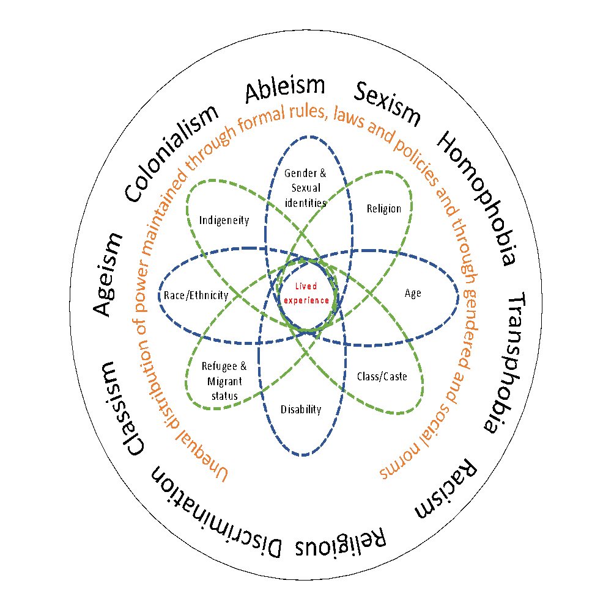
Intersectionality recognises that people do not fall neatly into single social groups. Each individual can self-identify with, or be identified by others as, belonging to many different social categories. These identities are layered and intersect and are derived from historical norms, social relations, and different structures of power. Each of these identities can impact on how individuals interact with and are viewed by society. One or more of these identities can lead to greater power and privilege, or to discrimination and exclusion, sometimes simultaneously.

Intersectionality recognizes that harms and violations associated with disability, race/ethnicity, age, gender and/or other identities cannot be understood sufficiently by studying and addressing them separately or in parallel.
Intersectionality demonstrates how forms of oppression such as racism, sexism, ableism and ageism overlap, producing distinctive modes of discrimination and exclusion. For example, an adolescent girl from a minority ethnic group who recently migrated to the city in search of better education and income generating opportunities may also have a disability.
All these different identities define how others see and interact with her and may frequently reinforce each other in creating greater barriers to fulfilling her rights, perpetuating even greater and potentially unique experiences of discrimination. However, self-identification and identification by others may not always align, and as an organisation we need to be careful not to make assumptions about how people identify and what their needs and priorities are, so that we can tackle exclusion, and really are inclusive and empowering.

Gender in the context of disability – why is a gender perspective so important?
- All over the world, people tend to live longer and so the number of older people rises. Women tend to live longer than men. So, the number of women with disabilities is likely to be higher in many populations than the number of men with disabilities. Many older women who are disabled may lack access to services/support. As life expectancy increases, this challenge will become more evident across more countries.
- Many women become disabled because of gender discriminatory practices, for example early and child marriage, early pregnancy and female genital mutilation, poorer access to health services and good nutrition. Therefore, gender equality and empowerment of women can reduce the female disability prevalence rate, (meaning: disability being widespread among women and girls).
- Strategies that only focus on the disability don’t necessarily result in better gender equality among people with disabilities.
- Women and girls with disabilities are discriminated differently from men: ie: women are at higher risk of sexual violence, forced sterilization, forced abortion, and are more likely to contract HIV/AIDS, among other reasons. Therefore, if interventions are more targeted, that is better think of how women and girls with disabilities are affected by discrimination, it will result in more effective and efficient advocacy. It will also help implement and monitor the application of the Convention on the Rights of Persons with Disabilities, which clearly states that gender equality is a principle (Articles 3) and must be applied to all following Articles.
- Evidence indicates that greater gender equality in education and employment make a real contribution to development and economic growth. In other words: if women and girls are better educated, they will have better jobs or businesses, know more about health and therefore help the well-being of their families, communities and countries. Promotion of gender equality and empowerment of women with disabilities is necessary for the achievement of the disability inclusive development.
- To advance the rights of women with disabilities in society and development, it is essential that their perspectives be included in all aspects of work for women’s empowerment. All work on disability must incorporate a gender perspective. Without the meaningful participation of women with disabilities in discussing what disability means to them, and how full inclusion can be achieved, the goal of “nothing about us without us” cannot be achieved.
- Combining gender and disability mainstreaming is based on a human rights perspective regarding women with disabilities. But it is also cost and time effective, and that is a very good reason to implement it together instead of thinking those social issues are separate.

Source: Addressing gender in the context of disability, UN Women, www.un.org/disabilities/documents/hlmdd/hlmdd_unwomen.doc

Why is it so difficult to address both gender and disability equality simultaneously?
Challenge of multiple and overlapping discrimination

- Women with disabilities are an at-risk group (as women) within another at-risk group (persons with disabilities), and their needs and demands have often been seen in the context of disability only. That makes it difficult to identify and address the causes for the multiple discrimination, most of all in the context of gender-based violence. Men with disabilities also marginalize women with disabilities.
- Gender and disability have been addressed separately by the women’s movement and the disability movement, and there has been a huge gap between the two movements. The feminist movement, despite talking about all women, has largely so far not included women with disabilities. On the other hand, the disability movement has also failed to consider multiple discriminations against women with disabilities. The disability movement’s efforts have focused mainly on persons with disabilities as one large homogeneous group (where all people think, do, and need the same) and its fight against the same discrimination suffered by all its members.
- Legislation and practices, like laws and binding policies, often deal with either gender-based discrimination or disability-based discrimination. But often they do not make the link between the two, which creates a gap.
- Gender and disability indicators enable us to gather real and accurate data about the living conditions of women with disabilities. But when governments or organisations create gender policies and disability policies such indicators are not developed. If there are no indicators before undertaking and implementing actions to foster equality it is not possible to monitor change. And then chances are that it will not be noticed, or it will not happen at all.

Source: Gender and Disability Mainstreaming Training Manual, BMZ/GIZ
http://womenenabled.org/pdfs/mapping/DIWA%20Gender%20and%20Disability%20Mainstreaming%20Training%20Manual.pdf

Further resources:

- UN Women, Intersectionality Resource Guide and Toolkit

Adapted from Coe S. and Wapling L. “Travelling Together”, World Vision International, 2022 https://www.wvi.org/disability-inclusion/publication/travelling-together
Pettit, J. (2013) Power Analysis – A Practical Guide, Sida; www.sida.se/publications
A theory developed by Professor Kimberle Williams Crenshaw – see for example: Crenshaw, Kimberlé W. On intersectionality: Essential writings. The New Press, 2017.
Buggenini, P; JASS (2002), Tools for Analyzing Power, Inclusion and Exclusion; https://justassociates.org/all-resources/tools-for-analyzing-power-inclusion-and-exclusion/
Developed by Lisa VeneKlasen and Valeries Miller – see for example A New Weave of Power, People and Politics, 2002

