Session 1: Barrier and Power Analyses
Learning Objectives | By the end of the session, participants should  - Understand the concept of barriers to disability inclusion - access (environmental), institutional, and attitudinal  - Be able to identify different barriers e.g. SRHR  - Be able to transfer the principles of barrier analysis to other sectors  - Understand the link between barrier and power analyses
Key Messages | - Understanding that it is barriers and power dynamics are responsible for excluding diverse persons with disabilities, not the specific impairments  - Understanding that there is some overlap between the barriers and that, therefore, a nuanced identification and analysis is needed so that barriers can be identified and removed
Facilitator’s Notes | - Make sure you have a good personal understanding of the barriers and 4 powers before delivering the sessions  - Be prepared to probe extensively (but in a friendly way) when participants suggest barriers so that you can help them develop a nuanced identification of them  - Make sure you have very specific barrier examples for a selection of sectors to refer to, and their link to power dynamics  - Prepare a whiteboard (on Mural or Zoom) with three “brick wall” designs and explanation about the types of barriers for group breakout rooms. Make sure breakout room technical settings allow participants access and permission to edit.
Duration | 90 min
Activities | - Barrier analysis  - General explanation of access, institutional, and attitudinal barriers to disability inclusion (10 mins)  - Small group work: Identification of barriers for women with disabilities in accessing quality SRHR services (30 mins)  - Discussion of small group work results (15 min)  - Power analysis  - Reminder of 4 Powers (10 mins)  - Small group work: 4 powers in SRHR (15 mins)  - Discussion of small group work results and link with barriers (10 min)
Resources | Powerpoint presentation (facilitator); Participant handout
Technology | PowerPoint presentation; Zoom Whiteboard or Mural

Activity 1: Barrier Analysis

Information:
This session explores the components of barrier and power analyses, how they are linked and how they affect the exclusion/inclusion of diverse persons with disabilities. Barrier and power analyses are the core tools for inclusion. The more detailed and in-depth these analyses are conducted the clearer it becomes for participants (and their organisations) on the steps to take to remove barriers and achieve inclusion.

Process:
- Provide participants with the following general information about what is meant by barriers so that they are reminded of the link to the social/human rights and empowerment model of disability.

Many people believe that having an impairment is the full definition of “disability”. This is not the full picture. The concept of barriers is used by disability activists to explain how a person can be disabled - , not because of their impairment but because of the access (environmental), institutional and attitudinal barriers preventing them from participating in society. Therefore, barrier analysis supports a rights-based approach. It includes identifying these barriers people face to realising their rights and working to remove these by changing attitudes, behaviour, policies and laws, to rebalance power and resources throughout a community to everyone’s benefit.
Recognising these barriers also helps identify issues faced by diverse people with disabilities, older people, women and other marginalised groups, and to understand how barriers can build up and have a compounding effect when multiple identities intersect.

Access (Environmental) barriers limit or prevent a person from fully participating in social, political, occupational and recreational activities and accessing infrastructure and services. A sub-category is Communication/information barriers that include inaccessible communication systems which prevent persons with disabilities from accessing information or knowledge.

Institutional barriers include laws, policies, and strategies or institutionalized practices that systematically discriminate against groups of people and prevent them from participating equally. Such institutional policies and procedures are strongly influenced by social norms.

Attitudinal barriers are negative attitudes and stereotypes that persist in communities. Their roots are often found in cultural or religious beliefs, unawareness, prejudice, stigma and bias. They lead to the unequal distribution of power, discrimination (including over-protection) and exclusion. Family members or those who are friends of persons with disabilities may also face “discrimination by association”. Attitudinal barriers link closely with the other barriers, especially institutional barriers, because policies and laws, regulations and practices are developed by people who live within social norms and therefore come with their bias. Attitudinal barriers are essential to address for meaningful inclusion of persons with disabilities in any form of programming work.

- Explain that everyone will work in small groups on an exercise in break-out rooms for participants to practice barrier analysis in the context of Sexual Reproductive Health and Rights. Each group will look at one type of barrier and consider:

“What are the ________ barriers to accessing SRH services for persons with disabilities?”

Tell participants to remember to apply an intersectional lens, e.g. consider teenage girls and boys, young women and men, non-binary or trans persons with disabilities, and different impairment types.

- Provide the breakout room link and access to a Mural or Zoom Whiteboard and assure participants that the explanation about the types of barriers are presented there as a reminder.

Access Barriers  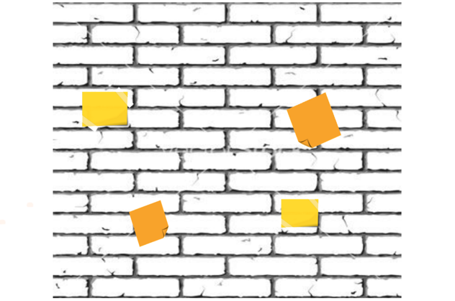 | Institutional Barriers | Attitudinal Barriers

- Divide participants into 3 groups and assign each a break-out room with one barrier wall.

- Break-out 1: please go to the Wall: Access (Environmental) Barriers.
Take a “sticky note” and write ONE specific access (environmental) barrier on it and attach it to one brick. Be as detailed and specific as you can. Add more stickies: one sticky for each concrete and specific barrier; consider intersectional factors and different impairments. Go through the whole access process from the home of a person with disability to the end of leaving the service.

- Break-out 2: please go to the Wall Institutional Barriers.
Take a “sticky note” and write ONE specific institutional barrier on it and attach it to one brick. Be as detailed and specific as you can. Add more stickies: one sticky for each concrete and specific barrier; consider intersectional factors and different impairments.

- Break-out 3: please go to the Wall Attitudinal Barriers.
Take a “sticky note” and write ONE specific attitudinal barrier on it and attach it to one brick. Be as detailed and specific as you can. Add more stickies: one sticky for each concrete and specific barrier; consider intersectional factors and different impairments.

Emphasise to participants:
- Sometimes it is difficult to clearly assign a barrier to one of the three.
- If you are in doubt if it is one of “your” assigned barriers or another, don’t worry. Write it down anyway, and we will discuss together when we come back to plenary together

- Tell participants they have 30 minutes in their breakout rooms to identify as many barriers as possible.

- After 30 minutes, bring back all participants and ask them to present their walls with the identified barriers to the entire group
- Discuss together where there may have been doubts.
- Make sure the barriers are very specific and concrete and suggest alternatives if they aren’t specific enough
- Check if a range of intersectional factors have been integrated

Activity 2: Power Analysis

Information:
In gender work, power analysis is a common tool. You may be familiar with it from work and training around gender. Power dynamics also are large regarding disability inclusion in communities and particularly important for an intersectional perspective.

Process:
- Explain to participants that power dynamics are closely linked to barriers because they are reflected in the attitudes and behaviour towards persons with disabilities. Analysing power dynamics should therefore go hand in hand with barrier analysis.

- Present the 4 powers using the Powerpoint presentation (slide 17).

- Ask participants how the power analysis relates to the models of disability? Give them some minutes to brainstorm. Check against the explanation (slide 19).

Emphasise that being aware of the influences of power, alongside barrier analysis, is very important throughout the project cycle: in the situation analysis, during designing and implementing disability inclusive projects as well as in MEAL processes.

- Present participants with the scenario in slide 20 and ask them to identify barriers and any of the 4 powers.

- Present the answer

In adapting the training, a lot of effort went into issues of accessibility | Access (environmental) barrier
During many group-work exercises, the adolescents with disabilities rarely participated. |  | Power to
They lacked the confidence to share their opinions and/or their experience |  | Power within/to
Their peers without disabilities didn’t have the maturity and/or sensitivity to be curious and take the time to engage them. | Attitudinal barriers
Adolescents without disabilities were dominant when it came to reaching consensus and making decisions. |  | Power over

- Ask participants if they have any suggestions on how the training could have been better prepared and discuss options. Present solution in slide 21.

- Remind participants that the handout will provide a table with more detailed examples of barriers and related power dynamics in the context of SRHR.

