Session 2: Intersectionality
Learning Objectives | - Exploration of the impact of disability, gender and age across the life cycle  - Understanding how opportunities offered or denied at key life stages to persons with disabilities compound and negatively impact inclusive programming outcomes
Key Messages | Key learning outcomes for participants – by the end of the ‘Chances of Life’ participants should:  - become aware of how disability can exacerbate poverty through lack of opportunities;  - appreciate why girls and boys with disabilities and their families can be so hard to identify;  - see how gender inequality impacts on opportunities, particularly for females;  - see how other exclusion factors impact on opportunities;  - realise that if agencies do not actively seek to include females and males with disabilities in its work then it will potentially contribute to increasing opportunity gaps between persons with disabilities and their families, and families without persons with disabilities.  Ensure the conclusion of the activity highlights these key points for participant reflection:  - Without conscious programming intervention, intersecting factors of gender and age compound multiple negative outcomes for persons with disabilities as they progress throughout the life cycle .  - The compounding lack of opportunities of programming interventions creates larger gaps between persons with and without disabilities as they progress through the life cycle .  - Agencies (often unconsciously) reinforce and increase the exclusion of persons with disabilities when they do not pro-actively include persons with disabilities in all their mainstream activities – especially girls and women with disabilities.
Facilitator’s Notes | - This activity requires confidence and high levels of interactivity with the Mural (or similar software) slide. Ensure as facilitator you are fully comfortable and confident with the slide and interactivity needed (moving objects across the screen and allocating “control” of the objects to the 4 volunteers) and that this activity is pre-prepared and ready to work before the session starts.  - It’s important that people volunteer for their roles. In some situations, religious or traditional beliefs may preclude some from participating. Be aware and respect that. In some cultures, even to imagine being a person with a disability can be seen as "tempting fate".  - The four activity volunteers should leave their cameras on. Encourage all other participants to also leave their cameras on (if feasible) to encourage engagement and participation in their observer roles. This will help recreate the “in-person” training room experience. When cameras are off it can create greater passivity in the observer roles. Part of the success and strength of this activity is engagement by everyone in the group, not just the four volunteers.  - If short of time, select which life stages will be most relevant to your areas of work (after the first stage). A minimum of 5 different stages (including stage 1) are recommended.
Duration | 60 minutes
Activity | The “Chances of Life”
Technology | Mural (or similar software)

Process:
- Ask for four volunteers from among the group (ideally, two men and two women), willing to participate within the webinar for about 40 minutes. One will represent each of the following:

- male without disability
- male with disability
- female without disability
- female with disability

- Assign each volunteer a role. Explain you’ll be telling a life story, taking the characters on a journey from birth to older age. As you reach each significant life event, you’ll ask them to respond as they think their character (or their family) would react.

They’ll need to take:

- two steps forward for a very positive, very likely opportunity or very successful experience;
- one step forward for a positive, likely opportunity or successful experience;
- one step back for a not-so-positive, no-so-likely opportunity or not-so-successful experience;
- two steps back for a negative, very unlikely opportunity or unsuccessful experience.

Once your volunteers understand what they’ll be required to do, reinforce they are representing that person-type, and they should respond accordingly. Encourage them to avoid thinking about specific impairments or basing decisions on their own life experiences – or what they personally would desire to see happen. Their response should be based on what they think is currently accurate for the culture and situation in the scenario, not what it ought to be.

- Explain to the whole group that after each life stage and volunteers’ responses, they will be given time and opportunity to react and comment. If there’s disagreement, the group should decide by consensus and the volunteer may be asked to alter their move. As facilitator you have ultimate say over whether or not the response seems fair. If there is no consensus or if you believe the response has been too positive/negative (i.e. more based on what ought to happen rather than what is likely to happen) then you can ask the volunteer to alter their move accordingly (call it ‘the hand of fate’!).

The facilitator’s role is to assess when to intervene and comment to clarify reasons for decisions and to bring out and discuss any prejudicial points. The specific impairment is not relevant to the main point of this exercise, so try not to focus on this too much. It won’t alter the essence of the activity.

- Explain how this will be facilitated in the Mural (or similar software) technology - NB this needs to be pre-prepared before the session.

Show the Mural (reproduced below). The four volunteers will each be given control of an “object” of the character they are representing that they can move backwards and forwards - left and right across the screen, using the template as the distance for each step. The rest of the group can make comments either using the chat box or by asking for the microphone to say what they think. The grid is below.
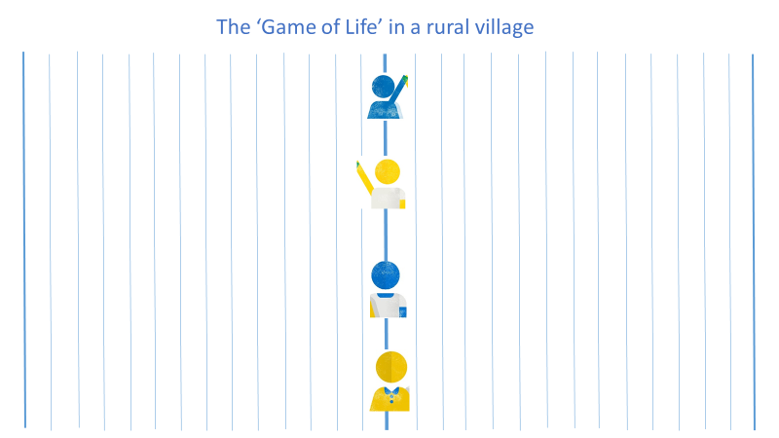

- Set the scene for the story. Since you want to emphasise links between disability and poverty, place the story in a ‘rural’ village where their agencies might work. Describe it in as much detail as you can, explaining that income poverty levels are generally quite high, although most families have land and access to safe water. For entrepreneurs, opportunities exist in the nearby town where there are also health and educational facilities. You may wish to choose a geographical location to help people imagine the village (for example an East African village, a South Asian village).

- Start with the first life event, as if telling a story…

Life Chance 1
"One fine day, after a long wait of nine months, your character is born. You are the first-born in your family. How does your family feel when they see who you are? Make your moves."

Say to everyone else that these four babies are all first-born children, all born in the same village, and all born on the same day.

Note what might happen:

- family is very happy (boy without a disability is born), two steps forward;
- quite happy (boy with a disability / girl without a disability), one step forward;
- not happy (boy with a disability), one step back;
- very unhappy (girl with a disability), two steps back.

- Once the 4 volunteers have made their moves, ask for comments and suggestions from the rest of the group.

Typical points that might be made (or you may wish to draw out if participants have not made them) in this stage are:

- Culture affects whether girls or boys are more valued when they are born. First born males are more likely to be embraced by their families than girls, as boys are viewed as productive members of society.
- Families may be very shocked if they discover their child has a disability – whether that’s a girl or a boy, although due to gender norms in the culture boys with disabilities are mainly better placed than girls with disabilities to be accepted within the family.
- This is the point when in many poor communities, the male partner may be more inclined to abandon the family altogether – blaming the woman for the child’s disability and leaving her to struggle on as best she can. If lucky, she may return to her own parents but it will put added strain on the whole household.
- Parents (especially the mother) may be subject to stigma from their wider families and communities leading them to hide/deny their child’s impairment (for as long as possible) or even to hide the child itself. Witchcraft or divine “punishment” are often cited as reasons for impairments – these beliefs lead to stigmatisation of the girls and boys with disabilities and their families.

- As facilitator, conclude the discussion and make final agreements about each character’s steps. Then move to the next life stage.

- Repeat points 6 – 8 for the following 7 life stages (see facilitator notes if there are time constraints).

Life Chance 2
“Your organisation has established a nutrition and immunization programme for under 5s in your village. How likely is it that your character will be included in it?”

Typical points that might be made (or you may wish to draw out if participants have not made them) in this stage are:

- Children with disabilities may not be brought for attendance because the families do not want the community to know about their child. This could be compounded for girl children.
- It may become increasingly difficult for caregivers (usually women) to bring their child with an impairment to a clinic that is relatively far from home. Children with behavioural or mobility difficulties, could find the journey difficult, especially where public transport is overcrowded and inaccessible.
- In some cases, the birth of children with disabilities are not officially registered due to stigma or negative assumptions about their future. This could mean they are not called for vaccination or feeding programmes because they are not known about.
- Belief by family/community the child with disabilities is “not worth” feeding or immunising the child – can lead to further impairments, compounding issues. At its most extreme this can lead to extreme neglect – and potentially even infanticide.

Life Chance 3
“You are now about 5-6 years old, and it’s time to start thinking about school. How likely is it that you will be able to start at primary school? Make your moves.”

Typical points that might be made (or you may wish to draw out if participants have not made them) in this stage are:

- Access to primary education is the basic right of every child. The SDGs acknowledge the important role education plays in Goal 4 which says that by 2030 the world should have inclusive and equitable quality education for all. A lot of progress has been made toward Universal Primary Education – globally net attendance reached 87% in 2019 with around four in five children attending primary school reaching completion. But 58 million children remain out of school, over half of whom are girls (54%). There has been little improvement in out of school rates since 2007.
- Countries that have adopted universal primary education, are seeing significant improvements in the enrolment rates of girls and boys without disabilities. For example net enrolment rates increased from less than 41% in 2000 to 94% in 2010 in Burundi; from 27% to 64% in Niger and from 42% to 76% in Guinea. Whilst gender disparity has been significantly reduced, it remains a problem for girls even in regard to enrolment .
- Boys with disabilities may start school – especially if they are first-born children. However, they are likely to face some barriers such as: distance to school; physical access; attitudes of teachers, other students, the families of other students not wanting their children to be taught (or make friends with) the boys or girls with disabilities.
- Girls with disabilities are least likely to be sent to school. Even with universal primary education families incur costs to send their children to school – for example school uniforms, transport, and books. For girls and boys with disabilities these opportunity costs are often higher because of the need to accompany children to school, to pay for adapted teaching and learning materials or assistive technology. Families can often feel “there is no point” in making the financial investment needed to send girls with disabilities to school because they are unlikely to achieve very much. But families may also be more protective over girls with disabilities and unwilling to send them into an environment which could be difficult for them.
- Fears around violence against girls and boys with disabilities is another reason why they may be reluctant to go to school. Girls and boys with disabilities are 3.7 times more likely than children without disabilities to be victims of any sort of violence, 3.6 times more likely to be victims of physical violence, and 2.9 times more likely to be victims of sexual violence. Girls and boys with mental or intellectual impairments appear to be among the most vulnerable, with 4.6 times the risk of sexual violence than girls and boys without disabilities.

Life Chance 4
“Your character is now about 12-13 years old. How likely is it that you have completed primary school education, will enter and complete secondary school education with a qualification? Make your moves.”

Typical points that might be made (or you may wish to draw out if participants have not made them) in this stage are:

- Inclusion in schools and classrooms. Even if children with disabilities start education, the chances of them staying in schools and learning to a decent standard is not high. There are multiple, compounding barriers they face. Some of them are access (environmental) barriers - the school itself might have some accessible features but not all (e.g. toilets and hand-washing facilities, school meal areas – it is not just steps and classrooms). Access barriers exist linked to school attendance but often not thought about (e.g. roads and pathways to the school, transport to/from school). Many of them are attitudinal barriers from multiple sources – teachers and school management (who may lack training or believe children with disabilities should be educated in ‘special’ schools), parents of children without disabilities who don’t want their children educated or associating with children with disabilities (due to cultural myths and beliefs around contamination).
- Menstrual hygiene management brings additional challenges – access to toilets, supplies etc
- Families may feel they don’t have, or cannot justify, the resources to continue taking their child to school each day – especially when their child is not learning and experiencing horrific exclusion and discrimination within the boundaries of a place that should be safe for them. Plan West Africa researched the experience of children with disabilities in 6 countries in West Africa in their 2013 “Outside the Circle” report and identified some shocking findings. Other reports published since have consistently found similar issues in a wide range of geographical contexts.
- Gender issues will emerge quite strongly at this stage. The difference between girls and boys without disabilities succeeding in education should be clear in the choices made. For example, boys without disabilities are more likely to go on to complete secondary school education than girls without disabilities. Gender disparity remains a considerable challenge at secondary education level with girls in sub-Saharan Africa and South and West Asia continuing to experience considerable disadvantage in terms of secondary enrolment compared to boys. .
- It is not just the physical accessibility of schools that determines if girls and boys with disabilities succeed in education. Teaching methodologies that are inclusive are needed. Family willingness to continue supporting girls and boys with disabilities in education is also important (see above). If a family is in poverty, they may not feel they can/want to continue to support their child who is living with a disability through education unless there are clear benefits.
- Most importantly, the attitudes of everyone in the education system towards girls and boys with disabilities will determine if going to school will enable them to learn. Research studies have found negative and discriminatory attitudes towards girls and boys with disabilities from many different stakeholder groups – teachers, school management, Ministry of Education, parents of children without disabilities in the school (which impacted the attitudes of children without disabilities towards their disabled class-mates). Discrimination is multi-layered and reinforcing. With that level of stigma and discrimination, would families continue to push their child to a place where they experience so much exclusion and don’t learn?
- Comprehensive sexuality education. If the school provides this at secondary school level, is it accessible to and inclusive of girls and boys with disabilities?

Life Chance 5
“You are now about 18 years old, like to keep busy and want to make some money. You try to get a job. How easy will it be for you to find one?”

Typical points that might be made (or you may wish to draw out if participants have not made them) in this stage are:

- The impact of opportunities in your life to-date now starts making a big difference. If you have no education or qualifications, it will be harder to get work. The work available to you is likely to be unskilled manual work and because of your disability employers may simply assume you cannot do it.
- Employers often have false negative views of what young people with disabilities can do and achieve in the workplace, so they don’t offer opportunities – even if they are qualified.
- Many persons with disabilities will look to establish their own businesses. However, discriminatory attitudes may affect how well they succeed. For example, banks may refuse to offer loans to young persons with disabilities, or the banks themselves may be inaccessible. Communities may hold such negative beliefs about disability that people refuse to buy from them. For example, people may believe having their clothes made by a person with a disability will bring “bad luck”.
- Overall opportunities for women with disabilities will be significantly less even than for men with disabilities because of the combined impact of gender and disability discrimination. Young women with disabilities are much less likely even than young men with disabilities to be hired for formal employment, to be given promotions, equal pay, or access to training opportunities. They are less likely to be given access to credit and they will find it difficult to participate in economic decision-making .

Life Chance 6
“You have reached late adolescence/young adulthood. "Now you are at the age you’d like to get married, or form a relationship. How much do you think this will be possible for you to have a relationship that you are content with? Make your moves."

- Depending on culture men may have more freedom to marry or form relationships than women.
- The pressure to marry will be felt by all our characters so it is likely that everyone will be in some form of relationship. However, young women with disabilities may be much more likely to be in a relationship that is exploitative and potentially abusive.
- Women and girls with disabilities are at much greater risk than their non-disabled peers of ‘physical, psychological, sexual or financial violence, neglect, social isolation, entrapment, degradation, detention, denial of health care and forced sterilization and psychiatric treatment’. They are twice as likely as women without disabilities to experience domestic violence along with other forms of gender-based violence and the abuse they experience tends to be for longer and result in more severe injuries
- Men with disabilities may also be victims of abuse – especially those that rely on personal support to carry out daily living activities.
- It should also be noted that children who live with adults with disabilities and are expected to fulfil a ‘caring’ role may also be at risk of abuse.

Life Chance 7
“How likely is it that you will become a parent? Make your moves?"

Check if the women with disabilities take two steps back, or are instructed to do so by the group. Why did this happen? They may say it’s because most women with disabilities are physically unable to have children, a common myth.

Two steps back may well be an accurate response for a different reason, women with disabilities often don’t have children because society thinks they can’t or shouldn’t.

Typical points that might be made (or you may wish to draw out if participants have not made them) in this stage are:

- Many people falsely assume that people with disabilities do not (or cannot) have sex.
- There are false beliefs stemming from this that lead to abusive and exploitative practices against women with disabilities in particular – e.g. that HIV positive men can be “cured” by having sex with someone who is a virgin – thereby increasing the risk that women with disabilities will be raped because men assume they will not have had sex.
- In some countries it is still common practice to forcibly sterilise women of reproductive age with cognitive or mental health impairments without their consent; or to force them to have abortions if they are pregnant.
- In reality most women with disabilities will be able to have children and go on to have children and build families in similar ways to non-disabled young women
- Unfortunately, women with disabilities often cannot get access to pre-natal care from health clinics due to barriers (access and attitudinal). Sexual and Reproductive Health services and campaigns are rarely designed with persons with disabilities in mind and tend to be inaccessible leaving persons with disabilities at increased risk of disease. A lack of access to maternal health programmes may also mean disabled mothers lack information about vaccinations, nutrition and hygiene measures leaving their children at increased risk of disease.

Life Chance 8 (if there is time)
"You are now very old in your village – you are in your 50s and you are still alive! You have a lot of experience of life and have fought hard to achieve it. You want to help your community by becoming involved in local politics. How likely are you to achieve this goal?"

Typical points that might be made (or you may wish to draw out if participants have not made them) in this stage are:

- At this point men will likely be the ones who get involved in community politics. Some women become local leaders but it is still less common.
- Overall, persons with disabilities in general will be less likely than women without disabilities to become local leaders because of the stigma and discrimination they have faced throughout their lives. It’s unlikely they would see themselves as potential community leaders. However, some persons with disabilities do make it as local leaders (likely their impairments are not too severe and are acquired later in life perhaps) – most likely men.
- In general persons with disabilities will be so far behind at this point in their lives that they have become almost invisible to communities. Women with disabilities in particular face huge challenges in older age when they may lack the capacity to maintain even a basic level of living.

- Ask the group to reflect on the final positions of everyone in the group – remind everyone that these four characters were all born on the same day in the same village:

- Who is in the best position now? Who is in the worst place?
- Volunteers, what do you think your character has been feeling through this journey? How does that make you feel?
- Does any of this surprise anyone?
- Highlight the point that each stage essentially represents the opportunities that each character has at key points in their life. NGO work is focused on increasing opportunities at key points for people living in poverty.
- Don't forget the man without a disability at the front of the exercise is regarded as living in poverty – this is a poor community which has NGO assistance. Given the way the scenario has ended, what does this imply for persons with disabilities?
- The most powerful way to end this session is to ask the group to look once again at where the characters are placed in relation to each other. The lack of opportunities in life for the characters with disabilities have compounded through their lives. Recall that this was all taking place in a rural location where general levels of poverty are quite high. Even though the characters without disabilities are well ahead of the characters with disabilities, they’re by no means wealthy - ask the group, who does your agency currently focus its efforts on in a village like this?

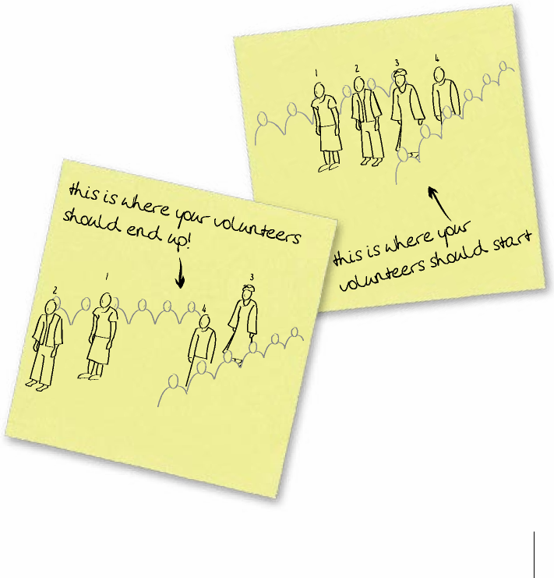

1 = female without disability | 2 = male without disability | 3 = female with disability | 4 = male with disability
- Conclude the activity by making the following points:

- Including persons with disabilities is important for achieving poverty reduction. This activity has shown how and why people with disabilities are especially vulnerable to extreme poverty. Despite the fact that vulnerable people with disabilities and their families will be present in all areas targeted by INGOs, their issues are rarely discussed within the international development community.
- Recall that all the characters started in the same place but the woman with a disability ended up in a worse position than when she started. She has gone backwards. This is a very good illustration of what we mean when we say that the opportunity gap increases for persons with disabilities as the rest of the community moves forward. Without specific attention persons with disabilities – especially women with disabilities - end up worse off in relation to their peers.
- Disability inclusion directly fits the inclusive values of many NGOs and other agencies. There are girls and women with disabilities in every community in which your NGO/agency will be working.

Adapted from Coe S and Wapling L “Travelling Together”, World Vision International, 2022
This data comes from https://data.unicef.org/topic/education/primary-education/ (2021)
Source: Kuper, H., Monteath-van Dok, A., Wing, K., Danquah, L., Evans, J., Zuurmond, M. and Gallinetti, J. 2014. The impact of disability on the lives of children: cross-sectional data including 8,900 children with disabilities and 898,834 children without disabilities across 30 countries. PLoS ONE, Vol. 9, No. 9, p. e107300.
Jones L., et al. 2012, ‘Prevalence and risk of violence against children with disabilities: a systematic review and meta-analysis of observational studies’, The Lancet, 280. Note, the study reflects data from 18,374 children with disabilities from high-income countries – Finland, France, Israel, Spain, Sweden, the United Kingdom, and the United States – rather than low-income and developing countries where Plan International works.
https://plan-international.org/publications/outside-circle
Source: Education for All Global Monitoring Report, 2000-2015: Achievements and challenges. UNESCO, 2015
Source: O’Reilly (2003) Employment barriers for women with disabilities. The Right to Decent Work of Persons with Disabilities. Skills Working Paper No. 14. Geneva: ILO.
Ortoleva, S., & Lewis, H. (2012). Forgotten sisters – A report on violence against women with disabilities: an overview of its nature, scope, causes and consequences (Northeastern public law and theory faculty research papers series no. 104-2012). Northeastern University. See document online
op.cit.
Hughes, K., Bellis, M. A., Jones, L., Wood, S., Bates, G., Eckley, L., McCoy, E., Officer, A. (2012). Prevalence and risk of violence against adults with disabilities: a systematic review and meta‐analysis of observational studies. The Lancet, 379(9826), 1621–1629. See document online

